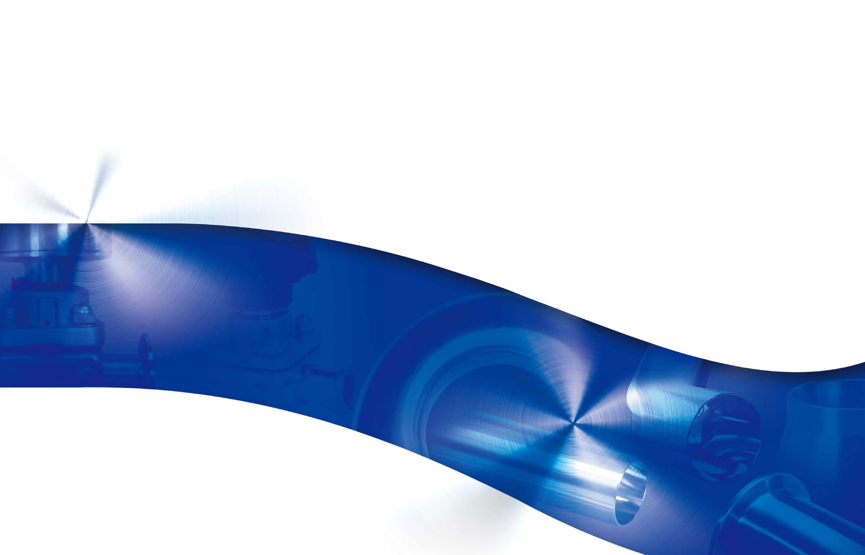
Select Stainless Sales, LLC

Select Stainless Sales, LLC
19B-1 Ransier Drive West Seneca, New York 14224 TEL: +1-716-671-2326 FAX: +1-716-671-2327
www.select-stainless.com
2017. July

Index
Page

TRI-CLAMP FITTINGS
1

WELD FITTINGS
2

BEVEL SEAT DIN 11851

3
TUBE OD FITTINGS

I-LINE SECTION
4
CLAMPS
TRI-CLAMP FITTINGS TRI-CLAMP ADAPTERS
TRI-CLAMP FITTINGS AND GASKETS

WELD FITTINGS TUBE
WELD FITTINGS

SPANNER
BEVEL SEAT UNION DIN 11851 UNIONS TUBE OD FITTIINGS
03
04-08
09-10
11

13-16
17
18

20
20-21
22-23
24

25-27

5 | VALVES | CHECK VALVE 3A SIGHT GLASS  PNEUMATIC ACTUATOR  BUTTERFLY VALVE W/12 POSITION GRIP HANDLE CONTROL BOX  PNEUMATIC DIVERT VALVE BALL VALVE  BALL VALVE ACTUATOR DIAPHRAGM VALVE PARTS LIST  PNEUMATIC/MANUAL DIAPHRAGM VALVE SAMPLE COCK VALVE  PLUG VALVE STRAINERS | 29  30  31  32-33  34  35-36  37-38  39  40  41-43  44  45  46
6 | TECHNICAL INFORMATION | TECHNICAL INFORMATION PNEUMATIC DIVERT VALVE OPERATING MANUAL | 47-49  50  51-54

7 BPE FITTINGS
BPE Items

55-69

70-74

1 2

CLAMPS

13MHH
HEAVY DUTY SINGLE PIN CLAMP
SIZE | øA  in. mm |  | øB  in. mm
1/2"-3/4" | 0.787 | 20 | 1.110 | 28.2
A37 | 1.094 | 27.8 | 1.457 | 37
1 1/2" | 1.748 | 44.4 | 2.110 | 53.6
2" | 2.276 | 57.8 | 2.638 | 67
2 1/2" | 2.811 | 71.4 | 3.173 | 80.6
3" | 3.307 | 84 | 3.701 | 94
4" | 4.331 | 110 | 4.803 | 122
6" | 6.118 | 155.4 | 6.709 | 170.4
8" | 8.071 | 205 | 8.661 | 220
DN250 | 10.121 | 257 | 10.709 | 272
DN300 | 12.126 | 308 | 12.717 | 323

13MHP
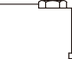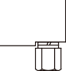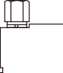 HIGH PRESSURE BOLTED CLAMP

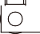1/2"~3/4"
L
ØB
ØC
ØA
ØB
ØC
ØA
ØB

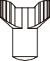
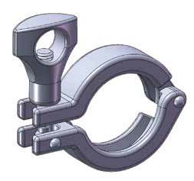
TRI-CLAMP FITTINGS
1/2"~3/4"

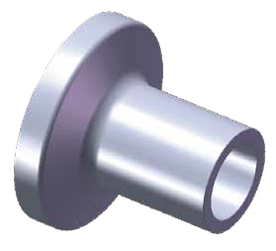

1.0"~12"
L

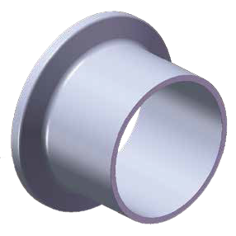

SIZE | øA  in. mm |  | øB  in. mm
1/2"~3/4" | 0.787 | 20 | 1.102 | 28
1"~11 /2 " | 1.706 | 43.32 | 2.047 | 52
2" | 2.222 | 56.44 | 2.579 | 65.5
2 1/2" | 2.738 | 69.54 | 3.110 | 79
3" | 3.054 | 77.56 | 3.642 | 92.5
4" | 4.286 | 108.86 | 4.744 | 120.5
6" | 6.220 | 158 | 6.693 | 170
8" | 8.760 | 222.5 | 9.350 | 237.5
10" | 10.165 | 258.2 | 10.740 | 272.8
12" | 12.165 | 309 | 12.898 | 327.6

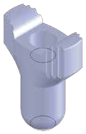WING NUT FOR CLAMP
32
ØC
ØA ØB

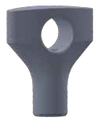

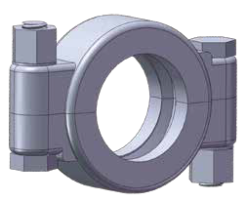

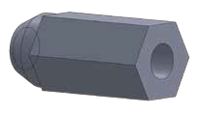
32

14MPW
WELDING FERRULE 14WMP 14MMP 14AMP
SIZE |  | in. | øA |  | mm | in. | øB |  | mm | in. | øC |  | mm | in. | L |  | mm | in. | L | mm | in. | L |  | mm
1/4" |  | 0.154 |  | 3.9 |  | 0.250 |  | 6.35 |  | 0.992 |  | 25.2 |  | 0.500 |  | 12.7 |  |  |  |  | 1.125 |  | 28.6
1/2" |  | 0.370 |  | 9.4 |  | 0.500 |  | 12.7 |  | 0.992 |  | 25.2 |  | 0.500 |  | 12.7 |  |  |  |  | 1.125 |  | 28.6
3/4" |  | 0.620 |  | 15.75 |  | 0.750 |  | 19.05 |  | 0.992 |  | 25.2 |  | 0.500 |  | 12.7 |  |  |  |  | 1.125 |  | 28.6
1" |  | 0.870 |  | 22.1 |  | 1.000 |  | 25.4 |  | 1.988 |  | 50.5 |  | 0.500 |  | 12.7 |  |  |  |  | 1.125 |  | 28.6
1 1/2" |  | 1.370 |  | 34.8 |  | 1.500 |  | 38.1 |  | 1.988 |  | 50.5 |  | 0.500 |  | 12.7 |  |  |  |  | 1.125 |  | 28.6
2" |  | 1.870 |  | 47.5 |  | 2.000 |  | 50.8 |  | 2.520 |  | 64 |  | 0.500 |  | 12.7 |  |  |  |  | 1.125 |  | 28.6
2 1/2" |  | 2.370 |  | 60.2 |  | 2.500 |  | 63.5 |  | 3.051 |  | 77.5 |  | 0.500 |  | 12.7 |  |  |  |  | 1.125 |  | 28.6
3" |  | 2.870 |  | 72.9 |  | 3.000 |  | 76.2 |  | 3.583 |  | 91 |  | 0.500 |  | 12.7 |  |  |  |  | 1.125 |  | 28.6
4" |  | 3.835 |  | 97.4 |  | 4.000 |  | 101.6 |  | 4.685 |  | 119 |  | 0.622 |  | 15.8 |  |  |  |  | 1.125 |  | 28.6
6" |  | 5.782 |  | 146.86 |  | 6.000 |  | 152.4 |  | 6.570 |  | 166.87 |  |  |  |  |  | 0.846 |  | 21.5 | 1.500 |  | 38.1
8" |  | 7.782 |  | 197.66 |  | 8.000 |  | 203.2 |  | 8.570 |  | 217.67 |  |  |  |  |  | 0.846 |  | 21.5 | 1.500 |  | 38.1
10" |  | 9.732 |  | 247.2 |  | 10.000 |  | 254 |  | 10.570 |  | 268.47 |  |  |  |  |  | 0.846 |  | 21.5 | 1.500 |  | 38.1
12" |  | 11.732 |  | 298 |  | 12.000 |  | 304.8 |  | 12.570 |  | 319.27 |  |  |  |  |  | 0.846 |  | 21.5 | 1.500 |  | 38.1

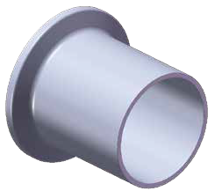 HEAVY WALL TANK FERRULE SA479
L
SIZE | øA  in. mm |  | øB  in. mm |  | øC  in. mm |  | L  in. mm
1/2" | 0.321 | 8.15 | 0.502 | 12.75 | 0.992 | 25.2 | 2.126 | 54
3/4" | 0.575 | 14.6 | 0.750 | 19.05 | 0.992 | 25.2 | 2.126 | 54
1" | 0.870 | 22.1 | 1.161 | 29.5 | 1.988 | 50.5 | 1.626 | 41.3
11/2" | 1.370 | 34.8 | 1.677 | 42.6 | 1.988 | 50.5 | 1.626 | 41.3
2" | 1.870 | 47.5 | 2.193 | 55.7 | 2.520 | 64 | 1.752 | 44.5
21/2" | 2.370 | 60.2 | 2.709 | 68.8 | 3.051 | 77.5 | 1.752 | 44.5
3" | 2.870 | 72.9 | 3.224 | 81.9 | 3.583 | 91 | 1.815 | 46.1
4" | 3.835 | 97.4 | 4.256 | 108.1 | 4.685 | 119 | 2.126 | 54
6" | 5.758 | 146.25 | 6.193 | 157.3 | 6.570 | 166.87 | 2.500 | 63.5

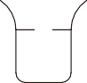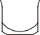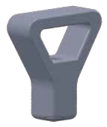13MHH-11

35.6
39
39.2
42.2
42.5
ØB
13MHH-13
13MHH-14
H17

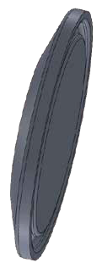
16AMP SOLID END CAP
L
ØD1
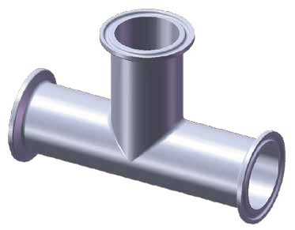
ØD
T
L1

L
ØA
SIZE | øA  in. mm |  | L  in. mm
1/2"-3/4" | 0.984 | 25 | 0.25 | 6.35
A37 | 1.339 | 34 | 0.25 | 6.35
1" | 1.988 | 50.5 | 0.25 | 6.35
11 /2" | 1.988 | 50.5 | 0.25 | 6.35
2" | 2.520 | 64 | 0.25 | 6.35
21 /2" | 3.051 | 77.5 | 0.25 | 6.35
3" | 3.583 | 91 | 0.25 | 6.35
4" | 4.685 | 119 | 0.311 | 7.9
6" | 6.570 | 166.87 | 0.437 | 11.1
8" | 8.571 | 217.7 | 0.437 | 11.1
10" | 10.571 | 268.5 | 0.437 | 11.1
12" | 12.571 | 319.3 | 0.437 | 11.1

7MP

2KMP
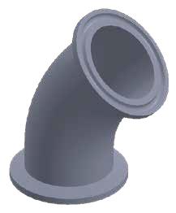
TRI-CLAMP 45° ELBOW
T

ØD
ØD1
L
SIZE | øD  in. mm |  | øD1  in. mm |  | L  in. mm |  | T  in. mm
1/2" | 0.500 | 12.7 | 0.992 | 25.2 | 0.780 | 19.8 | 0.065 | 1.65
3/4" | 0.750 | 19.05 | 0.992 | 25.2 | 0.969 | 24.6 | 0.065 | 1.65
1" | 1.000 | 25.4 | 1.988 | 50.5 | 1.122 | 28.5 | 0.065 | 1.65
11/2" | 1.500 | 38.1 | 1.988 | 50.5 | 1.437 | 36.5 | 0.065 | 1.65
2" | 2.000 | 50.8 | 2.520 | 64 | 1.750 | 44.45 | 0.065 | 1.65
21/2" | 2.500 | 63.5 | 3.051 | 77.5 | 2.059 | 52.3 | 0.065 | 1.65
3" | 3.000 | 76.2 | 3.583 | 91 | 2.374 | 60.3 | 0.065 | 1.65
4" | 4.000 | 101.6 | 4.685 | 119 | 3.000 | 76.2 | 0.083 | 2.1
6" | 6.000 | 152.4 | 6.570 | 166.87 | 4.626 | 117.5 | 0.109 | 2.77

TRI-CLAMP EQUAL TEE

2CMP
L
SIZE | øD  in. mm |  | øD1  in. mm |  | ød  in. mm |  | ød1  in. mm |  | L  in. mm |  | L1  in. mm |  | T  in. mm |  | t  in. mm
11 /2"*1" | 1.988 | 50.5 | 1.500 | 38.1 | 1.988 | 50.5 | 1.000 | 25.4 | 5.500 | 139.7 | 2.625 | 66.68 | 0.065 | 1.65 | 0.065 | 1.65
2"*1" | 2.520 | 64 | 2.000 | 50.8 | 1.988 | 50.5 | 1.000 | 25.4 | 7.000 | 177.8 | 2.874 | 73 | 0.065 | 1.65 | 0.065 | 1.65
2"*11/2" | 2.520 | 64 | 2.000 | 50.8 | 1.988 | 50.5 | 1.500 | 38.1 | 7.000 | 177.8 | 3.000 | 76.2 | 0.065 | 1.65 | 0.065 | 1.65
21/2"*11/2" | 3.051 | 77.5 | 2.500 | 63.5 | 1.988 | 50.5 | 1.500 | 38.1 | 7.000 | 177.8 | 3.250 | 82.55 | 0.065 | 1.65 | 0.065 | 1.65
21/2"*2" | 3.051 | 77.5 | 2.500 | 63.5 | 2.520 | 64 | 2.000 | 50.8 | 7.000 | 177.8 | 3.750 | 95.25 | 0.065 | 1.65 | 0.065 | 1.65
3"*11/2" | 3.583 | 91 | 3.000 | 76.2 | 1.988 | 50.5 | 1.500 | 38.1 | 7.500 | 190.5 | 3.500 | 88.9 | 0.065 | 1.65 | 0.065 | 1.65
3"*2" | 3.583 | 91 | 3.000 | 76.2 | 2.520 | 64 | 2.000 | 50.8 | 7.500 | 190.5 | 4.000 | 101.6 | 0.065 | 1.65 | 0.065 | 1.65
3"*21/2" | 3.583 | 91 | 3.000 | 76.2 | 3.051 | 77.5 | 2.500 | 63.5 | 7.500 | 190.5 | 3.750 | 95.25 | 0.065 | 1.65 | 0.065 | 1.65
4"*2" | 4.685 | 119 | 4.000 | 101.6 | 2.520 | 64 | 2.000 | 50.8 | 8.992 | 228.4 | 4.500 | 114.3 | 0.083 | 2.1 | 0.065 | 1.65
4"*2 1/2" | 4.685 | 119 | 4.000 | 101.6 | 3.051 | 77.5 | 2.500 | 63.5 | 8.992 | 228.4 | 4.250 | 107.95 | 0.083 | 2.1 | 0.065 | 1.65
4"*3" | 4.685 | 119 | 4.000 | 101.6 | 3.583 | 91 | 3.000 | 76.2 | 8.992 | 228.4 | 4.250 | 107.95 | 0.083 | 2.1 | 0.065 | 1.65

7RMP
ØD1
ØD
Ød1 Ød
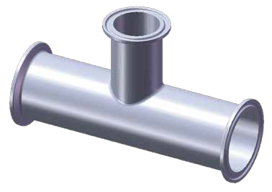
t
SIZE
1/2"
3/4"
1"
1 1/₂"
2"
2 1/₂"
3"
4"
6"
øD
in. mm
0.500 12.7
0.750 19.05
1.000 25.4
1.500 38.1
2.000 50.8
2.500 63.5
3.000 76.2
4.000 101.6
6.000 152.4
øD1
in. mm
0.992 25.2
0.992 25.2
1.988 50.5
1.988 50.5
2.520 64
3.051 77.5
3.583 91
4.685 119
6.570 166.87
L
in. mm
2.500 63.5
4.748 120.6
4.748 120.6
5.504 139.8
7.000 177.8
7.000 177.8
7.504 190.6
8.992 228.4
13.000 330.2
L1
in. mm
1.250 31.75
2.374 60.3
2.374 60.3
2.752 69.9
3.500 88.9
3.500 88.9
3.752 95.3
4.496 114.2
6.500 165.1
T
in.
0.065
0.065
0.065
0.065
0.065
0.065
0.065
0.083
0.109
mm
1.65
1.65
1.65
1.65
1.65
1.65
1.65
2.1
2.77
T
L1

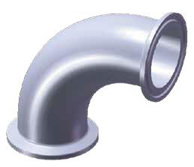L

ØD
ØD1

TRI-CLAMP 90° ELBOW
SIZE | øD  in. mm |  | øD1  in. mm |  | L  in. mm |  | T  in. mm
1/2" | 0.500 | 12.7 | 0.992 | 25.2 | 1.626 | 41.3 | 0.065 | 1.65
3/4" | 0.750 | 19.05 | 0.992 | 25.2 | 1.626 | 41.3 | 0.065 | 1.65
1" | 1.000 | 25.4 | 1.988 | 50.5 | 2.000 | 50.8 | 0.065 | 1.65
11/2" | 1.500 | 38.1 | 1.988 | 50.5 | 2.752 | 69.9 | 0.065 | 1.65
2" | 2.000 | 50.8 | 2.520 | 64 | 3.500 | 88.9 | 0.065 | 1.65
21/2" | 2.500 | 63.5 | 3.051 | 77.5 | 4.250 | 107.95 | 0.065 | 1.65
3" | 3.000 | 76.2 | 3.583 | 91 | 5.000 | 127 | 0.065 | 1.65
4" | 4.000 | 101.6 | 4.685 | 119 | 6.622 | 168.2 | 0.083 | 2.1
6" | 6.000 | 152.4 | 6.570 | 166.87 | 9.874 | 250.8 | 0.109 | 2.77

T
TRI-CLAMP REDUCING TEE

9MP
TRI-CLAMP LONG EQUAL CROSS
T
T
SIZE | øD  in. mm |  | øD1  in. mm |  | L  in. mm |  | L1  in. mm |  | T  in. mm
1" | 1.000 | 25.4 | 1.988 | 50.5 | 4.748 | 120.6 | 2.374 | 60.3 | 0.065 | 1.65
1 1/2" | 1.500 | 38.1 | 1.988 | 50.5 | 5.504 | 139.8 | 2.752 | 69.9 | 0.065 | 1.65
2" | 2.000 | 50.8 | 2.520 | 64 | 7.000 | 177.8 | 3.500 | 88.9 | 0.065 | 1.65
2 1/2" | 2.500 | 63.5 | 3.051 | 77.5 | 7.000 | 177.8 | 3.500 | 88.9 | 0.065 | 1.65
3" | 3.000 | 76.2 | 3.583 | 91 | 7.504 | 190.6 | 3.752 | 95.3 | 0.065 | 1.65
4" | 4.000 | 101.6 | 4.685 | 119 | 8.992 | 228.4 | 4.496 | 114.2 | 0.083 | 2.1

ØD1
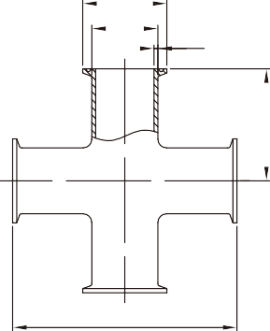
ØD
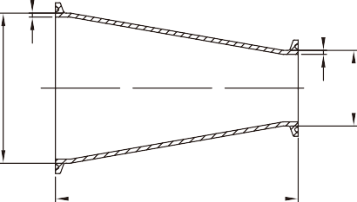
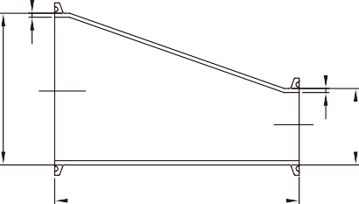
T
L1
t
t

CONCENTRIC 31-14MP ECCENTRIC 32-14MP

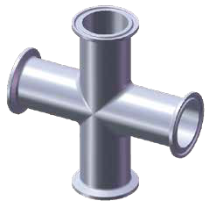
L

28AMP
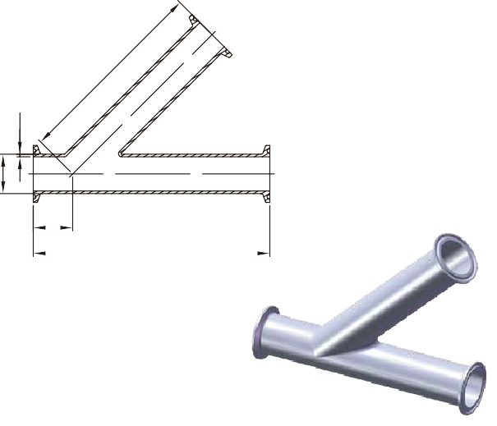
45° LATERAL TC

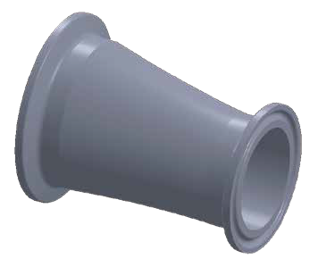
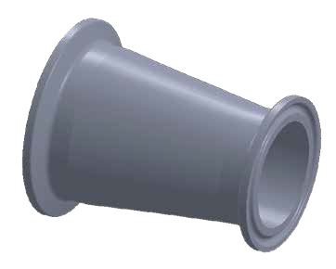
L L
ØD
Ød
ØD
Ød

L1
ØD
T
SIZE | øD  in. mm |  | L  in. mm |  | L1  in. mm |  | L2  in. mm |  | T  in. mm
1/2" | 0.500 | 12.7 | 7.000 | 177.8 | 1.500 | 38.1 | 5.500 | 139.7 | 0.065 | 1.65
3/4" | 0.750 | 19.05 | 7.000 | 177.8 | 1.500 | 38.1 | 5.500 | 139.7 | 0.065 | 1.65
1" | 1.000 | 25.4 | 7.000 | 177.8 | 1.500 | 38.1 | 5.500 | 139.7 | 0.065 | 1.65
11/2" | 1.500 | 38.1 | 8.375 | 212.73 | 2.430 | 61.7 | 7.430 | 188.7 | 0.065 | 1.65
2" | 2.000 | 50.8 | 9.750 | 247.65 | 2.125 | 53.98 | 7.625 | 193.7 | 0.065 | 1.65
21/2" | 2.500 | 63.5 | 11.000 | 279.4 | 2.000 | 50.8 | 9.000 | 228.6 | 0.065 | 1.65
3" | 3.000 | 76.2 | 11.750 | 298.45 | 2.375 | 60.33 | 9.375 | 238.1 | 0.065 | 1.65
4" | 4.000 | 101.6 | 14.062 | 357.17 | 2.640 | 67.06 | 11.312 | 287.3 | 0.083 | 2.1
6" | 6.000 | 152.4 | 19.750 | 501.65 | 4.375 | 111.13 | 15.375 | 390.5 | 0.109 | 2.77

L

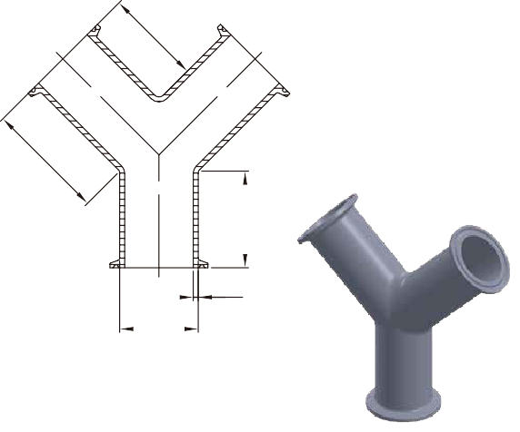
28BMP
90° TRUE Y TC
TRI-CLAMP REDUCERS

L
SIZE | øD  in. mm |  | ød  in. mm |  | L  in. mm |  | T  in. mm |  | t  in. mm
3/4"*1/2" | 0.750 | 19.05 | 0.500 | 12.7 | 2.000 | 50.8 | 0.065 | 1.65 | 0.065 | 1.65
1"*1/2" | 1.000 | 25.4 | 0.500 | 12.7 | 3.000 | 76.2 | 0.065 | 1.65 | 0.065 | 1.65
1"*3/4" | 1.000 | 25.4 | 0.750 | 19.05 | 2.000 | 50.8 | 0.065 | 1.65 | 0.065 | 1.65
1 1/₂"*1/2" | 1.500 | 38.1 | 0.500 | 12.7 | 5.000 | 127 | 0.065 | 1.65 | 0.065 | 1.65
1 1/₂"*3/4" | 1.500 | 38.1 | 0.750 | 19.05 | 4.000 | 101.6 | 0.065 | 1.65 | 0.065 | 1.65
1 1/₂"*1" | 1.500 | 38.1 | 1.000 | 25.4 | 3.000 | 76.2 | 0.065 | 1.65 | 0.065 | 1.65
2"*1/2" | 2.000 | 50.8 | 0.500 | 12.7 | 7.000 | 177.8 | 0.065 | 1.65 | 0.065 | 1.65
2"*3/4" | 2.000 | 50.8 | 0.750 | 19.05 | 6.000 | 152.4 | 0.065 | 1.65 | 0.065 | 1.65
2"*1" | 2.000 | 50.8 | 1.000 | 25.4 | 5.000 | 127 | 0.065 | 1.65 | 0.065 | 1.65
2"*11/2" | 2.000 | 50.8 | 1.500 | 38.1 | 3.000 | 76.2 | 0.065 | 1.65 | 0.065 | 1.65
2 1/₂"*11/₂" | 2.500 | 63.5 | 1.500 | 38.1 | 5.000 | 127 | 0.065 | 1.65 | 0.065 | 1.65
2 1/2"*2" | 2.500 | 63.5 | 2.000 | 50.8 | 3.000 | 76.2 | 0.065 | 1.65 | 0.065 | 1.65
3"*1" | 3.000 | 76.2 | 1.000 | 25.4 | 9.000 | 228.6 | 0.065 | 1.65 | 0.065 | 1.65
3"*11/₂" | 3.000 | 76.2 | 1.500 | 38.1 | 7.000 | 177.8 | 0.065 | 1.65 | 0.065 | 1.65
3"*2" | 3.000 | 76.2 | 2.000 | 50.8 | 5.000 | 127 | 0.065 | 1.65 | 0.065 | 1.65
3"*21/₂" | 3.000 | 76.2 | 2.500 | 63.5 | 3.000 | 76.2 | 0.065 | 1.65 | 0.065 | 1.65
4"*11/₂" | 4.000 | 101.6 | 1.500 | 38.1 | 11.122 | 282.5 | 0.083 | 2.1 | 0.065 | 1.65
4"*2" | 4.000 | 101.6 | 2.000 | 50.8 | 9.122 | 231.7 | 0.083 | 2.1 | 0.065 | 1.65
4"*21/₂" | 4.000 | 101.6 | 2.500 | 63.5 | 7.122 | 180.9 | 0.083 | 2.1 | 0.065 | 1.65
4"*3" | 4.000 | 101.6 | 3.000 | 76.2 | 5.122 | 130.1 | 0.083 | 2.1 | 0.065 | 1.65
6"*3" | 6.000 | 152.4 | 3.000 | 76.2 | 6.500 | 165.1 | 0.109 | 2.77 | 0.065 | 1.65
6"*4" | 6.000 | 152.4 | 4.000 | 101.6 | 6.500 | 165.1 | 0.109 | 2.77 | 0.083 | 2.1

SIZE | øD  in. mm |  | L  in. mm |  | L1  in. mm |  | T  in. mm
1" | 1.000 | 25.4 | 2.500 | 63.5 | 2.938 | 74.6 | 0.065 | 1.65
11 /₂" | 1.500 | 38.1 | 2.500 | 63.5 | 2.938 | 74.6 | 0.065 | 1.65
2" | 2.000 | 50.8 | 3.125 | 79.4 | 3.750 | 95.3 | 0.065 | 1.65
21 /₂" | 2.500 | 63.5 | 3.870 | 98.3 | 4.625 | 117.5 | 0.065 | 1.65
3" | 3.000 | 76.2 | 4.500 | 114.3 | 5.375 | 136.5 | 0.065 | 1.65
4" | 4.000 | 101.6 | 6.000 | 152.4 | 6.000 | 152.4 | 0.083 | 2.1

T
ØD

21MP 22MP
L1
L
ØC
ØB
ØA
NPT
ØD
NPT
ØA1
ØC

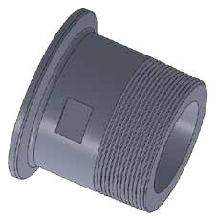
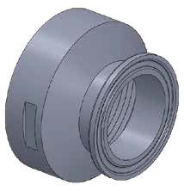

23BMP THERMOMETER CAP
15.8
ØC
NPT
ØB
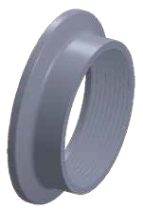
SIZE | øB  in. mm |  | øC  in. mm |  | NPT
1" | 1.000 | 25.4 | 1.988 | 50.5 | 1/2"-14T
1 1/2" | 1.500 | 38.1 | 1.988 | 50.5 | 3/4"-14T
2" | 2.000 | 50.8 | 2.520 | 64 | 3/4"-14T
2 1/2" | 2.500 | 63.5 | 3.051 | 77.5 | 3/4"-14T
3" | 3.000 | 76.2 | 3.583 | 91 | 3/4"-14T
4" | 4.000 | 101.6 | 4.685 | 119 | 3/4"-14T
6" | 6.000 | 152.4 | 6.567 | 166.8 | 3/4"-14T

14MPHR 14MPHRL

L1

L
ØC
ØA
ØB
ØC
ØA1
ØB

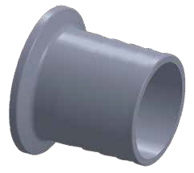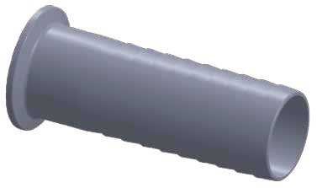

14MPHR/14MPHRL
SIZE | in. | øA |  | mm | øA1 |  |  |  |  |  | in. | øB |  | mm | in. | øB1 |  | mm | in. | øC |  | mm | in. | øD |  | mm | in. | L |  | mm | in. | L1 |  | mm | in. | L2 |  | mm | NPT
 |  |  |  |  | in. | 1" |  | mm | 11/2"  in. mm
1/2"*1/2" | 0.370 |  | 9.4 |  | 0.370 |  | 9.4 |  | 0.370 | 9.4 | 0.500 |  | 12.7 |  |  |  |  |  | 0.992 |  | 25.2 |  | 1.181 |  | 30 |  | 1.772 |  | 45 |  | 1.299 |  | 33 |  |  |  |  |  | 1/2"-18T
3/4"*1/2" | 0.620 |  | 15.75 |  | 0.620 |  | 15.75 |  | 0.620 | 15.75 | 0.750 |  | 19.05 |  |  |  |  |  | 0.992 |  | 25.2 |  | 1.181 |  | 30 |  | 1.772 |  | 45 |  | 1.299 |  | 33 |  |  |  |  |  | 1/2"-18T
3/4"*3/4" | 0.620 |  | 15.75 |  |  |  |  |  |  |  | 0.750 |  | 19.05 |  |  |  |  |  | 0.992 |  | 25.2 |  |  |  |  |  | 1.772 |  | 45 |  |  |  |  |  |  |  |  |  | 3/4"-18T
1"&11/2"*1/4" | 0.125 |  | 3.18 |  |  |  |  |  |  |  | 0.551 |  | 14 |  | 1.500 |  | 38.1 |  | 1.988 |  | 50.5 |  |  |  |  |  | 1.575 |  | 40 |  |  |  |  |  | 0.748 |  | 19 |  | 1/4"-18T
1"&11/2"*3/8" | 0.250 |  | 6.35 |  |  |  |  |  |  |  | 0.709 |  | 18 |  | 1.500 |  | 38.1 |  | 1.988 |  | 50.5 |  |  |  |  |  | 1.575 |  | 40 |  |  |  |  |  | 0.748 |  | 19 |  | 3/8"-18T
1"&11/2"*1/2" | 0.382 |  | 9.7 |  |  |  |  |  |  |  | 0.866 |  | 22 |  | 1.500 |  | 38.1 |  | 1.988 |  | 50.5 |  |  |  |  |  | 1.575 |  | 40 |  |  |  |  |  | 0.748 |  | 19 |  | 1/2"-14T
1"&11/2"*3/4" | 0.620 |  | 15.75 |  |  |  |  |  |  |  | 1.063 |  | 27 |  | 1.500 |  | 38.1 |  | 1.988 |  | 50.5 |  |  |  |  |  | 1.772 |  | 45 |  |  |  |  |  | 0.748 |  | 19 |  | 3/4"-14T
1"&11/2"*1" | 0.870 |  | 22.1 |  |  |  |  |  |  |  | 1.339 |  | 34 |  | 1.500 |  | 38.1 |  | 1.988 |  | 50.5 |  |  |  |  |  | 1.969 |  | 50 |  |  |  |  |  | 0.748 |  | 19 |  | 1"-11.5T
1"&11/2"*11/ 4" | 1.126 |  | 28.6 |  | 0.870 |  | 22.1 |  | 1.370 | 34.8 | 1.500 |  | 38.1 |  |  |  |  |  | 1.988 |  | 50.5 |  | 1.811 |  | 46 |  | 1.969 |  | 50 |  | 1.535 |  | 39 |  |  |  |  |  | 1.2"-11.5T
1"&11/2"*11/ 2" | 1.370 |  | 34.8 |  | 0.870 |  | 22.1 |  | 1.370 | 34.8 | 1.500 |  | 38.1 |  |  |  |  |  | 1.988 |  | 50.5 |  | 2.047 |  | 52 |  | 1.969 |  | 50 |  | 1.535 |  | 39 |  |  |  |  |  | 1.5"-11.5T
1"&11/2"*2" | 1.870 |  | 47.5 |  | 0.870 |  | 22.1 |  | 1.370 | 34.8 | 1.500 |  | 38.1 |  |  |  |  |  | 1.988 |  | 50.5 |  | 2.559 |  | 65 |  | 2.165 |  | 55 |  | 1.535 |  | 39 |  |  |  |  |  | 2"-11.5T
2"*1/4" | 0.125 |  | 3.18 |  |  |  |  |  |  |  | 2.000 |  | 50.8 |  | 2.000 |  | 50.8 |  | 2.520 |  | 64 |  |  |  |  |  | 1.575 |  | 40 |  |  |  |  |  | 0.748 |  | 19 |  | 1/4"-18T
2"*3/8" | 0.250 |  | 6.35 |  |  |  |  |  |  |  | 2.000 |  | 50.8 |  | 2.000 |  | 50.8 |  | 2.520 |  | 64 |  |  |  |  |  | 1.575 |  | 40 |  |  |  |  |  | 0.748 |  | 19 |  | 3/8"-18T
2"*1/2" | 0.370 |  | 9.4 |  |  |  |  |  |  |  | 2.000 |  | 50.8 |  |  |  |  |  | 2.520 |  | 64 |  |  |  |  |  | 1.575 |  | 40 |  |  |  |  |  |  |  |  |  | 1/2"-14T
2"*3/4" | 0.620 |  | 15.75 |  |  |  |  |  |  |  | 2.000 |  | 50.8 |  |  |  |  |  | 2.520 |  | 64 |  |  |  |  |  | 1.969 |  | 50 |  |  |  |  |  |  |  |  |  | 3/4"-14T
2"*1" | 0.870 |  | 22.1 |  |  |  |  |  |  |  | 2.000 |  | 50.8 |  | 2.000 |  | 50.8 |  | 2.520 |  | 64 |  |  |  |  |  | 1.969 |  | 50 |  |  |  |  |  | 0.748 |  | 19 |  | 1"-11.5T
2"*11/2" | 1.370 |  | 34.8 |  |  |  |  |  |  |  | 2.000 |  | 50.8 |  | 2.000 |  | 50.8 |  | 2.520 |  | 64 |  |  |  |  |  | 1.969 |  | 50 |  |  |  |  |  | 0.748 |  | 19 |  | 1 / "-11.5T
2"*2" | 1.870 |  | 47.5 |  | 1.870 |  | 47.5 |  | 1.870 | 47.5 | 2.000 |  | 50.8 |  |  |  |  |  | 2.520 |  | 64 |  | 2.559 |  | 65 |  | 2.165 |  | 55 |  | 1.535 |  | 39 |  |  |  |  |  | 2"-11.5T
2"*21/ 2" | 2.370 |  | 60.2 |  |  |  |  |  |  |  | 2.000 |  | 50.8 |  |  |  |  |  | 2.520 |  | 64 |  |  |  |  |  | 2.362 |  | 60 |  |  |  |  |  |  |  |  |  | 2 / "-8T
2"*3" | 2.870 |  | 72.9 |  |  |  |  |  |  |  | 2.000 |  | 50.8 |  |  |  |  |  | 2.520 |  | 64 |  |  |  |  |  | 2.756 |  | 70 |  |  |  |  |  |  |  |  |  | 3"-8T
2"*4" | 3.843 |  | 97.6 |  |  |  |  |  |  |  | 2.000 |  | 50.8 |  |  |  |  |  | 2.520 |  | 64 |  |  |  |  |  | 2.953 |  | 75 |  |  |  |  |  |  |  |  |  | 4"-8T
21/2"*1" | 0.870 |  | 22.1 |  |  |  |  |  |  |  | 2.500 |  | 63.5 |  | 2.500 |  | 63.5 |  | 3.051 |  | 77.5 |  |  |  |  |  | 1.969 |  | 50 |  |  |  |  |  | 1.378 |  | 35 |  | 1"-11.5T
21/2"*11/2" | 1.370 |  | 34.8 |  |  |  |  |  |  |  | 2.500 |  | 63.5 |  | 2.500 |  | 63.5 |  | 3.051 |  | 77.5 |  |  |  |  |  | 1.969 |  | 50 |  |  |  |  |  | 1.378 |  | 35 |  | 1 / "-11.5T
21/2"*2" | 1.874 |  | 47.6 |  |  |  |  |  |  |  | 2.500 |  | 63.5 |  | 2.500 |  | 63.5 |  | 3.051 |  | 77.5 |  |  |  |  |  | 2.165 |  | 55 |  |  |  |  |  | 1.378 |  | 35 |  | 2"-11.5T
21/2"*21/2" | 2.370 |  | 60.2 |  | 2.870 |  | 72.9 |  | 2.870 | 72.9 | 2.500 |  | 63.5 |  |  |  |  |  | 3.051 |  | 77.5 |  | 3.740 |  | 95 |  | 2.362 |  | 60 |  | 1.969 |  | 50 |  |  |  |  |  | 2 / "-8T
21/2"*3" | 2.870 |  | 72.9 |  |  |  |  |  |  |  | 2.500 |  | 63.5 |  |  |  |  |  | 3.051 |  | 77.5 |  |  |  |  |  | 2.756 |  | 70 |  |  |  |  |  |  |  |  |  | 3"-8T
21/2"*4" | 3.843 |  | 97.6 |  |  |  |  |  |  |  | 2.500 |  | 63.5 |  |  |  |  |  | 3.051 |  | 77.5 |  |  |  |  |  | 2.953 |  | 75 |  |  |  |  |  |  |  |  |  | 4"-8T
3"*1" | 0.870 |  | 22.1 |  |  |  |  |  |  |  | 3.000 |  | 76.2 |  | 3.000 |  | 76.2 |  | 3.583 |  | 91 |  |  |  |  |  | 2.165 |  | 55 |  |  |  |  |  | 1.378 |  | 35 |  | 1"-11.5T
3"*11/2" | 1.370 |  | 34.8 |  |  |  |  |  |  |  | 3.000 |  | 76.2 |  | 3.000 |  | 76.2 |  | 3.583 |  | 91 |  |  |  |  |  | 2.165 |  | 55 |  |  |  |  |  | 1.378 |  | 35 |  | 1 / "-11.5T
3"*2" | 1.870 |  | 47.5 |  |  |  |  |  |  |  | 3.000 |  | 76.2 |  | 3.000 |  | 76.2 |  | 3.583 |  | 91 |  |  |  |  |  | 2.165 |  | 55 |  |  |  |  |  | 1.378 |  | 35 |  | 2"11.5T
3"*21/2" | 2.370 |  | 60.2 |  | 2.370 |  | 60.2 |  | 2.370 | 60.2 | 3.000 |  | 76.2 |  |  |  |  |  | 3.583 |  | 91 |  | 3.150 |  | 80 |  | 2.362 |  | 60 |  | 1.969 |  | 50 |  |  |  |  |  | 2 / "-8T
3"*3" | 2.870 |  | 72.9 |  |  |  |  |  |  |  | 3.000 |  | 76.2 |  |  |  |  |  | 3.583 |  | 91 |  |  |  |  |  | 2.756 |  | 70 |  |  |  |  |  |  |  |  |  | 3"-8T
3"*4" | 3.843 |  | 97.6 |  |  |  |  |  |  |  | 3.000 |  | 76.2 |  |  |  |  |  | 3.583 |  | 91 |  |  |  |  |  | 2.953 |  | 75 |  |  |  |  |  |  |  |  |  | 4"-8T
4"*1" | 0.870 |  | 22.1 |  |  |  |  |  |  |  | 4.000 |  | 101.6 |  | 4.000 |  | 101.6 |  | 4.685 |  | 119 |  |  |  |  |  | 2.165 |  | 55 |  |  |  |  |  | 1.378 |  | 35 |  | 1"-11.5T
4"*11/2" | 1.370 |  | 34.8 |  |  |  |  |  |  |  | 4.000 |  | 101.6 |  | 4.000 |  | 101.6 |  | 4.685 |  | 119 |  |  |  |  |  | 2.165 |  | 55 |  |  |  |  |  | 1.378 |  | 35 |  | 1 / "-11.5T
4"*2" | 1.870 |  | 47.5 |  |  |  |  |  |  |  | 4.000 |  | 101.6 |  | 4.000 |  | 101.6 |  | 4.685 |  | 119 |  |  |  |  |  | 2.165 |  | 55 |  |  |  |  |  | 1.378 |  | 35 |  | 2"-11.5T
4"*21/2" | 2.370 |  | 60.2 |  |  |  |  |  |  |  | 4.000 |  | 101.6 |  | 4.000 |  | 101.6 |  | 4.685 |  | 119 |  |  |  |  |  | 2.362 |  | 60 |  |  |  |  |  | 1.378 |  | 35 |  | 2 / "-8T
4"*3" | 2.870 |  | 72.9 |  | 2.870 |  | 72.9 |  | 2.870 | 72.9 | 4.000 |  | 101.6 |  | 4.000 |  | 101.6 |  | 4.685 |  | 119 |  | 3.740 |  | 95 |  | 2.756 |  | 70 |  | 2.047 |  | 52 |  | 1.378 |  | 35 |  | 3"-8T
4"*4" | 3.843 |  | 97.6 |  |  |  |  |  |  |  | 4.000 |  | 101.6 |  |  |  |  |  | 4.685 |  | 119 |  |  |  |  |  | 2.953 |  | 75 |  |  |  |  |  |  |  |  |  | 4"-8T
6"*4" |  |  |  |  | 3.843 |  | 97.6 |  | 3.843 | 97.6 | 4.000 |  | 101.6 |  |  |  |  |  | 4.685 |  | 119 |  | 4.724 |  | 120 |  | 2.953 |  | 75 |  | 2.126 |  | 54 |  |  |  |  |  | 4"-8T

HOSE ADAPTER
SIZE | øA  in. mm |  | øA1  in. mm |  | øB  in. mm |  | øC  in. mm |  | L  in. mm |  | L1  in. mm
1/2"*1/2" | 0.374 | 9.5 | 0.500 | 12.7 | 0.539 | 13.7 | 0.992 | 25.2 | 1.496 | 38 | 4.488 | 88.9
3/4"*3/4" | 0.622 | 15.8 | 0.750 | 19.05 | 0.843 | 21.4 | 0.992 | 25.2 | 1.496 | 38 | 4.488 | 88.9
1"*1" | 0.811 | 20.6 | 0.850 | 21.6 | 1.000 | 25.4 | 1.988 | 50.5 | 1.693 | 43 | 4.488 | 88.9
11/2"*11/2" | 1.307 | 33.2 | 1.323 | 33.6 | 1.500 | 38.1 | 1.988 | 50.5 | 1.693 | 43 | 4.488 | 88.9
2"*2" | 1.811 | 46 | 1.823 | 46.3 | 2.000 | 50.8 | 2.520 | 64 | 2.311 | 58.7 | 4.488 | 114.3
21/2"*21/2" | 2.311 | 58.7 | 2.323 | 59 | 2.500 | 63.5 | 3.051 | 77.5 | 2.343 | 59.5 | 4.488 | 114.3
3"*3" | 2.835 | 72 | 2.823 | 71.7 | 3.000 | 76.2 | 3.583 | 91 | 3.094 | 78.6 | 4.488 | 114.3
4"*4" | 3.843 | 97.6 | 3.823 | 97.1 | 4.000 | 101.6 | 4.685 | 119 | 3.366 | 85.5 | 4.488 | 139.7

14RMP
ROLL ON FERRULE (EXPANDING)
SIZE | øA  in. mm |  | øB  in. mm |  | øC  in. mm |  | L  in. mm
1" | 1.004 | 25.5 | 1.161 | 29.5 | 1.988 | 50.5 | 0.752 | 19.1
11/4" | 1.256 | 31.9 | 1.429 | 36.3 | 1.988 | 50.5 | 0.846 | 21.5
11/2" | 1.504 | 38.2 | 1.677 | 42.6 | 1.988 | 50.5 | 1.126 | 28.6
2" | 2.004 | 50.9 | 2.193 | 55.7 | 2.520 | 64 | 1.311 | 33.3
21/2" | 2.504 | 63.6 | 2.709 | 68.8 | 3.051 | 77.5 | 1.374 | 34.9
3" | 3.004 | 76.3 | 3.224 | 81.9 | 3.583 | 91 | 1.437 | 36.5
4" | 4.004 | 101.7 | 4.256 | 108.1 | 4.685 | 119 | 1.500 | 38.1

1.0"

L
ØC
ØA
ØB
1.25"~4.0"
ØC
ØA ØB

Ferrule Gasket
(EPDM、Silicone、Viton、PTFE、BUNA)
PLAIN TYPE 13PG
SIZE | øA  in. mm |  | øB  in. mm
1/2" | 0.390 | 9.9 | 0.858 | 21.8
3/4" | 0.642 | 16.3 | 0.858 | 21.8
A37 | 0.610 | 15.5 | 1.299 | 33
1.0" | 0.894 | 22.7 | 1.969 | 50
1.25" | 1.161 | 29.5 | 1.988 | 50.5
1.5" | 1.413 | 35.9 | 1.969 | 50
2.0" | 1.913 | 48.6 | 2.500 | 63.5
2.5" | 2.413 | 61.3 | 3.000 | 76.2
3.0" | 2.913 | 74 | 3.500 | 88.9
3.5" | 3.386 | 86 | 4.134 | 105
4.0" | 3.882 | 98.6 | 4.646 | 118
4.5" | 4.350 | 110.5 | 5.079 | 129
5.0" | 4.122 | 104.7 | 5.748 | 146
6.0" | 5.819 | 147.8 | 6.496 | 165
8.0" | 7.740 | 196.6 | 8.504 | 216

L

1/2"-3/4"

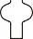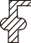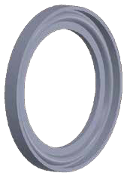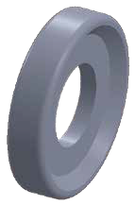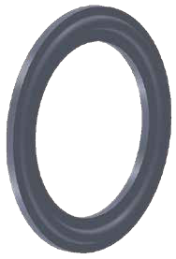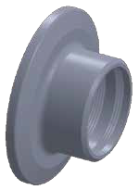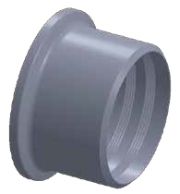

ØA
ØB
ØA
ØB

13PG

Ferrule Gasket
(EPDM、Silicone、Viton、PTFE、BUNA)
FLANGE TYPE 13FG
ØA
ØB
SIZE | øA  in. mm |  | øB  in. mm
1" | 0.898 | 22.8 | 2.075 | 52.7
1 1/2" | 1.409 | 35.8 | 2.075 | 52.7
2" | 1.921 | 48.8 | 2.606 | 66.2
2 1/2" | 2.382 | 60.5 | 3.138 | 79.7
3" | 2.878 | 73.1 | 3.669 | 93.2
4" | 3.850 | 97.8 | 4.772 | 121.2
6" | 5.827 | 148 | 6.657 | 169.1
10" | 9.803 | 249 | 10.657 | 270.7
12" | 11.811 | 300 | 12.657 | 321.5

13FG
11 12

2WCL
ØD
T
L
ØD

T
L
L1
L1
L1
SHORT WELD 90° ELBOW
SIZE | øD  in. mm |  | L  in. mm |  | T  in. mm
1/2" | 0.500 | 12.7 | 0.750 | 19.05 | 0.065 | 1.65
3/4" | 0.750 | 19.05 | 1.125 | 28.58 | 0.065 | 1.65
1" | 1.000 | 25.4 | 1.500 | 38.1 | 0.065 | 1.65
11/₂" | 1.500 | 38.1 | 2.252 | 57.2 | 0.065 | 1.65
2" | 2.000 | 50.8 | 3.000 | 76.2 | 0.065 | 1.65
21/₂" | 2.500 | 63.5 | 3.750 | 95.25 | 0.065 | 1.65
3" | 3.000 | 76.2 | 4.500 | 114.3 | 0.065 | 1.65
4" | 4.000 | 101.6 | 6.000 | 152.4 | 0.083 | 2.1
6" | 6.000 | 152.4 | 9.000 | 228.6 | 0.109 | 2.77
8" | 8.000 | 203.2 | 12.000 | 304.8 | 0.109 | 2.77

L2S
LONG WELD 90° ELBOW
SIZE | øD  in. mm |  | L  in. mm |  | T  in. mm
1/2" | 0.500 | 12.7 | 1.772 | 45 | 0.065 | 1.65
3/4" | 0.750 | 19.05 | 2.362 | 60 | 0.065 | 1.65
1" | 1.000 | 25.4 | 2.063 | 52.4 | 0.065 | 1.65
11/₂" | 1.500 | 38.1 | 2.937 | 74.6 | 0.065 | 1.65
2" | 2.000 | 50.8 | 4.063 | 103.2 | 0.065 | 1.65
21/₂" | 2.500 | 63.5 | 5.189 | 131.8 | 0.065 | 1.65
3" | 3.000 | 76.2 | 6.311 | 160.3 | 0.065 | 1.65
4" | 4.000 | 101.6 | 8.311 | 211.1 | 0.083 | 2.1
6" | 6.000 | 152.4 | 11.500 | 292.1 | 0.109 | 2.77

2WK

SHORT 45° ELBOW
SIZE | øD  in. mm |  | L  in. mm |  | T  in. mm
1/2" | 0.500 | 12.7 | 0.311 | 7.9 | 0.065 | 1.65
3/4" | 0.750 | 19.05 | 0.465 | 11.8 | 0.065 | 1.65
1" | 1.000 | 25.4 | 0.622 | 15.8 | 0.065 | 1.65
11/₂" | 1.500 | 38.1 | 0.937 | 23.8 | 0.065 | 1.65
2" | 2.000 | 50.8 | 1.250 | 31.75 | 0.065 | 1.65
21/₂" | 2.500 | 63.5 | 1.559 | 39.6 | 0.065 | 1.65
3" | 3.000 | 76.2 | 1.874 | 47.6 | 0.065 | 1.65
4" | 4.000 | 101.6 | 2.500 | 63.5 | 0.083 | 2.1
6" | 6.000 | 152.4 | 3.750 | 95.25 | 0.109 | 2.77

L2KS
LONG 45° ELBOW
SIZE | øD  in. mm |  | L  in. mm |  | T  in. mm
1/2" | 0.500 | 12.7 | 1.189 | 30.2 | 0.065 | 1.65
3/4" | 0.750 | 19.05 | 1.189 | 30.2 | 0.065 | 1.65
1" | 1.000 | 25.4 | 1.189 | 30.2 | 0.065 | 1.65
11/₂" | 1.500 | 38.1 | 1.626 | 41.3 | 0.065 | 1.65
2" | 2.000 | 50.8 | 2.311 | 58.7 | 0.065 | 1.65
21/₂" | 2.500 | 63.5 | 3.000 | 76.2 | 0.065 | 1.65
3" | 3.000 | 76.2 | 3.689 | 93.7 | 0.065 | 1.65
4" | 4.000 | 101.6 | 4.811 | 122.2 | 0.083 | 2.1
6" | 6.000 | 152.4 | 6.228 | 158.2 | 0.109 | 2.77

9WWWW
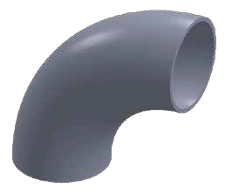
SHORT EQUAL WELD CROSS
T

ØD
L

SIZE | øD  in. mm |  | L  in. mm |  | L1  in. mm |  | T  in. mm
1" | 1.000 | 25.4 | 2.252 | 57.2 | 1.126 | 28.6 | 0.065 | 1.65
11/₂" | 1.500 | 38.1 | 3.315 | 84.2 | 1.657 | 42.1 | 0.065 | 1.65
2" | 2.000 | 50.8 | 4.126 | 104.8 | 2.063 | 52.4 | 0.065 | 1.65
21/₂" | 2.500 | 63.5 | 4.685 | 119 | 2.343 | 59.5 | 0.065 | 1.65
3" | 3.000 | 76.2 | 5.189 | 131.8 | 2.594 | 65.9 | 0.065 | 1.65
4" | 4.000 | 101.6 | 6.874 | 174.6 | 3.437 | 87.3 | 0.083 | 2.1

9W
LONG EQUAL WELD CROSS
T

ØD
L

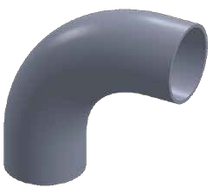
SIZE | øD  in. mm |  | L  in. mm |  | L1  in. mm |  | T  in. mm
1/2" | 0.500 | 12.7 | 1.500 | 38.1 | 0.750 | 19.05 | 0.065 | 1.65
3/4" | 0.750 | 19.05 | 3.750 | 95.25 | 1.874 | 47.6 | 0.065 | 1.65
1" | 1.000 | 25.4 | 3.748 | 95.2 | 1.874 | 47.6 | 0.065 | 1.65
11/₂" | 1.500 | 38.1 | 4.504 | 114.4 | 2.252 | 57.2 | 0.065 | 1.65
2" | 2.000 | 50.8 | 6.000 | 152.4 | 3.000 | 76.2 | 0.065 | 1.65
21/₂" | 2.500 | 63.5 | 6.000 | 152.4 | 3.000 | 76.2 | 0.065 | 1.65
3" | 3.000 | 76.2 | 6.504 | 165.2 | 3.252 | 82.6 | 0.065 | 1.65
4" | 4.000 | 101.6 | 7.748 | 196.8 | 3.874 | 98.4 | 0.083 | 2.1

7WWW
SHORT EQUAL WELD TEE
T

ØD

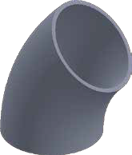
SIZE | øD  in. mm |  | L  in. mm |  | L1  in. mm |  | T  in. mm
1/2" | 0.500 | 12.7 | 1.500 | 38.1 | 0.750 | 19.05 | 0.065 | 1.65
3/4" | 0.750 | 19.05 | 2.252 | 57.2 | 1.126 | 28.6 | 0.065 | 1.65
1" | 1.000 | 25.4 | 2.252 | 57.2 | 1.126 | 28.6 | 0.065 | 1.65
11/₂" | 1.500 | 38.1 | 3.315 | 84.2 | 1.657 | 42.1 | 0.065 | 1.65
2" | 2.000 | 50.8 | 4.126 | 104.8 | 2.063 | 52.4 | 0.065 | 1.65
21/₂" | 2.500 | 63.5 | 4.685 | 119 | 2.343 | 59.5 | 0.065 | 1.65
3" | 3.000 | 76.2 | 5.189 | 131.8 | 2.594 | 65.9 | 0.065 | 1.65
4" | 4.000 | 101.6 | 6.874 | 174.6 | 3.437 | 87.3 | 0.083 | 2.1
6" | 6.000 | 152.4 | 10.000 | 254 | 5.000 | 127 | 0.109 | 2.77

7W
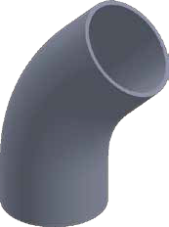
LONG EQUAL WELD TEE
T

ØD
SIZE | øD  in. mm |  | L  in. mm |  | L1  in. mm |  | T  in. mm
1/2" | 0.500 | 12.7 | 3.748 | 95.2 | 1.874 | 47.6 | 0.065 | 1.65
3/4" | 0.750 | 19.05 | 3.748 | 95.2 | 1.874 | 47.6 | 0.065 | 1.65
1" | 1.000 | 25.4 | 3.748 | 95.2 | 1.874 | 47.6 | 0.065 | 1.65
11/₂" | 1.500 | 38.1 | 4.504 | 114.4 | 2.252 | 57.2 | 0.065 | 1.65
2" | 2.000 | 50.8 | 6.000 | 152.4 | 3.000 | 76.2 | 0.065 | 1.65
21/₂" | 2.500 | 63.5 | 6.000 | 152.4 | 3.000 | 76.2 | 0.065 | 1.65
3" | 3.000 | 76.2 | 6.504 | 165.2 | 3.252 | 82.6 | 0.065 | 1.65
4" | 4.000 | 101.6 | 7.748 | 196.8 | 3.874 | 98.4 | 0.083 | 2.1
6" | 6.000 | 152.4 | 11.252 | 285.8 | 5.626 | 142.9 | 0.109 | 2.77

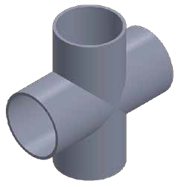

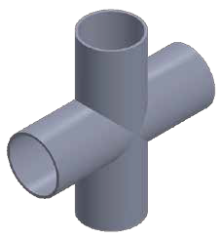

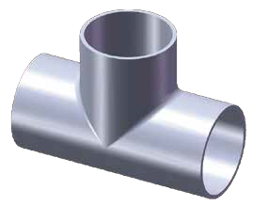

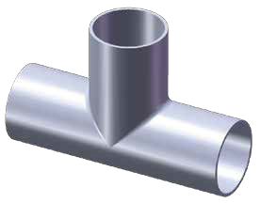
ØD

T
L
ØD
T
L
L
L
L1

CONCENTRIC-31W ECCENTRIC-32W
T
T

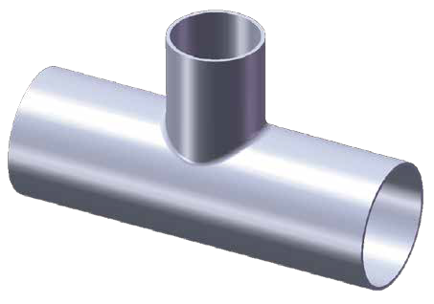
Ød

L

L
ØD
t
Ød
ØD
t
t
T
L1
Ød

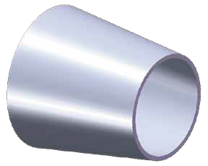
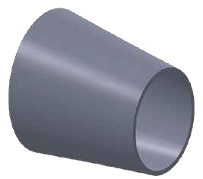
L
ØD

7RW
LONG REDUCING WELD TEE

WELD REDUCERS

SIZE | øD  in. mm |  | ød  in. mm |  | L  in. mm |  | L1  in. mm |  | T  in. mm |  | t  in. mm
1"*1/2" | 1.000 | 25.4 | 0.500 | 12.7 | 3.760 | 95.5 | 1.000 | 25.4 | 0.065 | 1.65 | 0.065 | 1.65
1"*3/4" | 1.000 | 25.4 | 0.750 | 19.05 | 3.760 | 95.5 | 1.120 | 28.45 | 0.065 | 1.65 | 0.065 | 1.65
1 1/2"*1/2" | 1.500 | 38.1 | 0.500 | 12.7 | 4.500 | 114.3 | 1.250 | 31.75 | 0.065 | 1.65 | 0.065 | 1.65
1 1/2"*3/4" | 1.500 | 38.1 | 0.750 | 19.05 | 4.500 | 114.3 | 1.380 | 35.05 | 0.065 | 1.65 | 0.065 | 1.65
1 1/2"*1" | 1.500 | 38.1 | 1.000 | 25.4 | 4.500 | 114.3 | 2.126 | 54 | 0.065 | 1.65 | 0.065 | 1.65
2"*1/2" | 2.000 | 50.8 | 0.500 | 12.7 | 6.000 | 152.4 | 1.500 | 38.1 | 0.065 | 1.65 | 0.065 | 1.65
2"*3/4" | 2.000 | 50.8 | 0.750 | 19.05 | 6.000 | 152.4 | 1.630 | 41.4 | 0.065 | 1.65 | 0.065 | 1.65
2"*1" | 2.000 | 50.8 | 1.000 | 25.4 | 6.000 | 152.4 | 2.374 | 60.3 | 0.065 | 1.65 | 0.065 | 1.65
2"*1 1/2" | 2.000 | 50.8 | 1.500 | 38.1 | 6.000 | 152.4 | 2.500 | 63.5 | 0.065 | 1.65 | 0.065 | 1.65
2 1/2"*1" | 2.500 | 63.5 | 1.000 | 25.4 | 6.000 | 152.4 | 2.750 | 69.85 | 0.065 | 1.65 | 0.065 | 1.65
2 1/2"*11/2" | 2.500 | 63.5 | 1.500 | 38.1 | 6.000 | 152.4 | 2.750 | 69.85 | 0.065 | 1.65 | 0.065 | 1.65
2 1/2"*2" | 2.500 | 63.5 | 2.000 | 50.8 | 6.000 | 152.4 | 3.250 | 82.55 | 0.065 | 1.65 | 0.065 | 1.65
3"*1" | 3.000 | 76.2 | 1.000 | 25.4 | 6.500 | 165.1 | 3.125 | 79.38 | 0.065 | 1.65 | 0.065 | 1.65
3"*1 1/2" | 3.000 | 76.2 | 1.500 | 38.1 | 6.500 | 165.1 | 3.000 | 76.2 | 0.065 | 1.65 | 0.065 | 1.65
3"*2" | 3.000 | 76.2 | 2.000 | 50.8 | 6.500 | 165.1 | 3.500 | 88.9 | 0.065 | 1.65 | 0.065 | 1.65
3"*2 1/2" | 3.000 | 76.2 | 2.500 | 63.5 | 6.500 | 165.1 | 3.250 | 82.55 | 0.065 | 1.65 | 0.065 | 1.65
4"*1" | 4.000 | 101.6 | 1.000 | 25.4 | 7.748 | 196.8 | 3.625 | 92.08 | 0.083 | 2.1 | 0.065 | 1.65
4"*11/2" | 4.000 | 101.6 | 1.500 | 38.1 | 7.748 | 196.8 | 3.625 | 92.08 | 0.083 | 2.1 | 0.065 | 1.65
4"*2" | 4.000 | 101.6 | 2.000 | 50.8 | 7.748 | 196.8 | 4.000 | 101.6 | 0.083 | 2.1 | 0.065 | 1.65
4"*21/2" | 4.000 | 101.6 | 2.500 | 63.5 | 7.748 | 196.8 | 3.750 | 95.25 | 0.083 | 2.1 | 0.065 | 1.65
4"*3" | 4.000 | 101.6 | 3.000 | 76.2 | 7.748 | 196.8 | 3.750 | 95.25 | 0.083 | 2.1 | 0.065 | 1.65
6"*2" | 6.000 | 152.4 | 2.000 | 50.8 | 11.252 | 285.8 | 4.750 | 120.65 | 0.109 | 2.77 | 0.065 | 1.65
6"X3" | 6.000 | 152.4 | 3.000 | 76.2 | 11.252 | 285.8 | 4.750 | 120.65 | 0.109 | 2.77 | 0.065 | 1.65
6"X4" | 6.000 | 152.4 | 4.000 | 101.6 | 11.252 | 285.8 | 4.874 | 123.8 | 0.109 | 2.77 | 0.083 | 2.1

SIZE | øD  in. mm |  | ød  in. mm |  | L  in. mm |  | T  in. mm |  | t  in. mm
3/4"*1/2" | 0.750 | 19.05 | 0.500 | 12.7 | 1.000 | 25.4 | 0.065 | 1.65 | 0.065 | 1.65
1"*1/2" | 1.000 | 25.4 | 0.500 | 12.7 | 2.000 | 50.8 | 0.065 | 1.65 | 0.065 | 1.65
1"*3/4" | 1.000 | 25.4 | 0.750 | 19.05 | 1.000 | 25.4 | 0.065 | 1.65 | 0.065 | 1.65
1 1/2"*1/2" | 1.500 | 38.1 | 0.500 | 12.7 | 4.000 | 101.6 | 0.065 | 1.65 | 0.065 | 1.65
1 1/2"*3/4" | 1.500 | 38.1 | 0.750 | 19.05 | 3.000 | 76.2 | 0.065 | 1.65 | 0.065 | 1.65
11/2"*1" | 1.500 | 38.1 | 1.000 | 25.4 | 2.000 | 50.8 | 0.065 | 1.65 | 0.065 | 1.65
2"*1/2" | 2.000 | 50.8 | 0.500 | 12.7 | 6.000 | 152.4 | 0.065 | 1.65 | 0.065 | 1.65
2"*3/4" | 2.000 | 50.8 | 0.750 | 19.05 | 5.000 | 127 | 0.065 | 1.65 | 0.065 | 1.65
2"*1" | 2.000 | 50.8 | 1.000 | 25.4 | 4.000 | 101.6 | 0.065 | 1.65 | 0.065 | 1.65
2"*11/ 2" | 2.000 | 50.8 | 1.500 | 38.1 | 2.000 | 50.8 | 0.065 | 1.65 | 0.065 | 1.65
2 1/2"*1" | 2.500 | 63.5 | 1.000 | 25.4 | 6.000 | 152.4 | 0.065 | 1.65 | 0.065 | 1.65
2 1/2"*11/2" | 2.500 | 63.5 | 1.500 | 38.1 | 4.000 | 101.6 | 0.065 | 1.65 | 0.065 | 1.65
2 1/2"*2" | 2.500 | 63.5 | 2.000 | 50.8 | 2.000 | 50.8 | 0.065 | 1.65 | 0.065 | 1.65
3"*1" | 3.000 | 76.2 | 1.000 | 25.4 | 8.000 | 203.2 | 0.065 | 1.65 | 0.065 | 1.65
3"*11/2" | 3.000 | 76.2 | 1.500 | 38.1 | 6.000 | 152.4 | 0.065 | 1.65 | 0.065 | 1.65
3"*2" | 3.000 | 76.2 | 2.000 | 50.8 | 4.000 | 101.6 | 0.065 | 1.65 | 0.065 | 1.65
3"*21/2" | 3.000 | 76.2 | 2.500 | 63.5 | 2.000 | 50.8 | 0.065 | 1.65 | 0.065 | 1.65
4"*1" | 4.000 | 101.6 | 1.000 | 25.4 | 12.000 | 304.8 | 0.083 | 2.1 | 0.065 | 1.65
4"*11/2" | 4.000 | 101.6 | 1.500 | 38.1 | 10.000 | 254 | 0.083 | 2.1 | 0.065 | 1.65
4"*2" | 4.000 | 101.6 | 2.000 | 50.8 | 8.000 | 203.2 | 0.083 | 2.1 | 0.065 | 1.65
4"*21/2" | 4.000 | 101.6 | 2.500 | 63.5 | 6.000 | 152.4 | 0.083 | 2.1 | 0.065 | 1.65
4"*3" | 4.000 | 101.6 | 3.000 | 76.2 | 4.000 | 101.6 | 0.083 | 2.1 | 0.065 | 1.65
6"*2" | 6.000 | 152.4 | 2.000 | 50.8 | 5.500 | 139.7 | 0.109 | 2.77 | 0.065 | 1.65
6"*3" | 6.000 | 152.4 | 3.000 | 76.2 | 5.500 | 139.7 | 0.109 | 2.77 | 0.065 | 1.65
6"*4" | 6.000 | 152.4 | 4.000 | 101.6 | 5.500 | 139.7 | 0.109 | 2.77 | 0.083 | 2.1

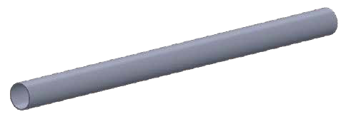 3A STANDARD SANITARY TUBE
SIZE | O.D  in. mm |  | T  in. mm
1/2" | 0.500 | 12.7 | 0.065 | 1.65
3/4" | 0.750 | 19.05 | 0.065 | 1.65
1" | 1.000 | 25.4 | 0.065 | 1.65
11/₂" | 1.500 | 38.1 | 0.065 | 1.65
2" | 2.000 | 50.8 | 0.065 | 1.65
21/₂" | 2.500 | 63.5 | 0.065 | 1.65
3" | 3.000 | 76.2 | 0.065 | 1.65
4" | 4.000 | 101.6 | 0.083 | 2.1
6" | 6.000 | 152.4 | 0.109 | 2.77

28WA

L1
L
OD
T
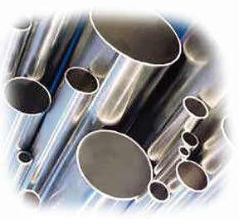
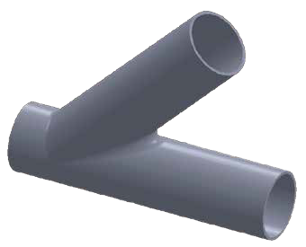
45° LATERAL BW
1"
1 1/ "
2"
2 1/ "
3"
4"
6"
ØD
T
SIZE | øD  in. mm |  | L  in. mm |  | L1  in. mm |  | L2  in. mm |  | T  in. mm
1/2" | 0.500 | 12.7 | 6.000 | 152.4 | 1.000 | 25.4 | 5.000 | 127 | 0.065 | 1.65
3/4" | 0.750 | 19.05 | 6.000 | 152.4 | 1.000 | 25.4 | 5.000 | 127 | 0.065 | 1.65
1" | 1.000 | 25.4 | 6.000 | 152.4 | 1.000 | 25.4 | 5.000 | 127 | 0.065 | 1.65
11/₂" | 1.500 | 38.1 | 7.375 | 187.33 | 1.930 | 49.02 | 6.930 | 176.02 | 0.065 | 1.65
2" | 2.000 | 50.8 | 8.750 | 222.25 | 1.625 | 41.28 | 7.125 | 180.98 | 0.065 | 1.65
21/₂" | 2.500 | 63.5 | 10.000 | 254 | 1.500 | 38.1 | 8.500 | 215.9 | 0.065 | 1.65
3" | 3.000 | 76.2 | 10.750 | 273.05 | 1.875 | 47.63 | 8.875 | 225.43 | 0.065 | 1.65
4" | 4.000 | 101.6 | 12.812 | 325.43 | 2.015 | 51.18 | 10.750 | 273.05 | 0.083 | 2.1
6" | 6.000 | 152.4 | 18.000 | 457.2 | 3.500 | 88.9 | 14.500 | 368.3 | 0.109 | 2.77

TH-4
SIZE | øA  in. mm |  | L1  in. mm
1/2" | 0.500 | 12.7 | 3.110 | 79
3/4" | 0.750 | 19.05 | 3.110 | 79
1" | 1.000 | 25.4 | 3.110 | 79
1 1/₂" | 1.500 | 38.1 | 3.740 | 95
2" | 2.000 | 50.8 | 4.642 | 117.9
2 1/₂" | 2.500 | 63.5 | 4.724 | 120
3" | 3.000 | 76.2 | 5.319 | 135.1
4" | 4.000/4.094 | 101.6/104 | 6.630 | 168.4
6" | 6.000 | 152.4 | 8.858 | 225
Type A 1/2"

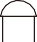3/4"~6.0" L1

ψA

ψA
Rubber Grommets
Type B 1/2"

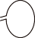3/4"~6.0" L1

ψA

ψA

PP Sleeve

28W
BPE STANDARD |  |  |  |  |  |  |  |  | 3A STANDARD DIN 11850
SIZE | in. | O.D |  | mm | in. | T |  | mm | in. | O.D |  | mm | in. | T |  | mm | SIZE | in. | O.D |  | mm | in. | T |  | mm
1/2" | 0.500 |  | 12.7 |  | 0.065 |  | 1.65 |  | 0.500 |  | 12.7 |  | 0.065 |  | 1.65
1" | 1.000 |  | 25.4 |  | 0.065 |  | 1.65 |  | 1.000 |  | 25.4 |  | 0.065 |  | 1.65 |  | 25 | 1.102 |  | 28 |  | 0.039 |  | 1
 |  |  |  |  |  |  |  |  |  |  |  |  |  |  |  |  |  |  |  |  |  | 0.059 |  | 1.5
 |  |  |  |  |  |  |  |  |  |  |  |  |  |  |  |  | 32 | 1.339 |  | 34 |  | 0.039 |  | 1
 |  |  |  |  |  |  |  |  |  |  |  |  |  |  |  |  |  |  |  |  |  | 0.059 |  | 1.5
1 1/2" | 1.500 |  | 38.1 |  | 0.065 |  | 1.65 |  | 1.500 |  | 38.1 |  | 0.065 |  | 1.65 |  | 40 | 1.575 |  | 40 |  | 0.039 |  | 1
 |  |  |  |  |  |  |  |  |  |  |  |  |  |  |  |  |  |  |  |  |  | 0.059 |  | 1.5
2" | 2.000 |  | 50.8 |  | 0.065 |  | 1.65 |  | 2.000 |  | 50.8 |  | 0.065 |  | 1.65 |  | 50 | 2.047 |  | 52 |  | 0.039 |  | 1
 |  |  |  |  |  |  |  |  |  |  |  |  |  |  |  |  |  |  |  |  |  | 0.059 |  | 1.5
2 1/2" | 2.500 |  | 63.5 |  | 0.065 |  | 1.65 |  | 2.500 |  | 63.5 |  | 0.065 |  | 1.65 |  | 65 | 2.756 |  | 70 |  | 0.079 |  | 2
3" | 3.000 |  | 76.2 |  | 0.065 |  | 1.65 |  | 3.000 |  | 76.2 |  | 0.065 |  | 1.65 |  | 80 | 3.346 |  | 85 |  | 0.079 |  | 2
4" | 4.000 |  | 101.6 |  | 0.083 |  | 2.1 |  | 4.000 |  | 101.6 |  | 0.065 |  | 1.65 |  | 100 | 4.094 |  | 104 |  | 0.079 |  | 2
 |  |  |  |  |  |  |  |  |  |  |  |  | 0.083 |  | 2.1

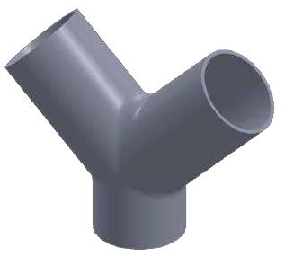
90° TRUF Y BW
1"

2"

3"
4"
T
ØD
L

SIZE | øD  in. mm |  | in. L mm |  | L1  in. mm |  | T  in. mm
1" | 1.000 | 25.4 | 0.866 | 22 | 1.732 | 44 | 0.065 | 1.65
11/2" | 1.500 | 38.1 | 1.220 | 31 | 2.520 | 64 | 0.065 | 1.65
2" | 2.000 | 50.8 | 1.732 | 44 | 3.504 | 89 | 0.065 | 1.65
21/2" | 2.500 | 63.5 | 2.283 | 58 | 4.488 | 114 | 0.065 | 1.65
3" | 3.000 | 76.2 | 2.638 | 67 | 5.276 | 134 | 0.065 | 1.65
4" | 4.000 | 101.6 | 3.346 | 85 | 6.850 | 174 | 0.083 | 2.1

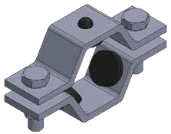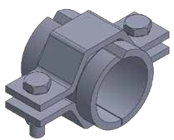

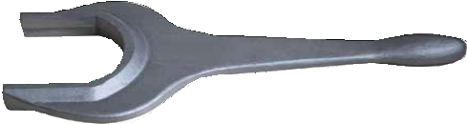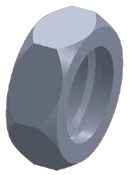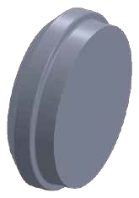

SPANNER

HEXAGONAL SPANNER
A
SIZE | øA  in. mm |  | L  in. mm
1" | 2.039 | 51.8 | 9.449 | 240
1 1/₂" | 2.598 | 66 | 11.339 | 288
2" | 3.165 | 80.4 | 11.811 | 300
2 1/₂" | 3.669 | 93.2 | 12.835 | 326
3" | 4.185 | 106.3 | 17.323 | 440
4" | 4.783 | 121.5 | 17.638 | 448

L

BEVEL SEAT UNION

13H
HEXAGONAL NUT
1"

2"

3"
4"
ØC
B
ØA
SIZE | øA  in. mm |  | B | C  in. mm |  | L  in. mm
1" | 1.193 | 25.4 | 38.02 ACME 8TPI | 1.811 | 46 | 0.906 | 23
11/2" | 1.709 | 38.1 | 51.54 ACME 8TPI | 2.406 | 61.1 | 0.969 | 24.6
2" | 2.224 | 50.8 | 65.05 ACME 8TPI | 3.000 | 76.2 | 1.063 | 27
21/2" | 2.740 | 63.5 | 78.56 ACME 8TPI | 3.594 | 91.3 | 1.165 | 29.6
3" | 3.256 | 76.2 | 92.08 ACME 8TPI | 4.189 | 106.4 | 1.280 | 32.5
4" | 4.287 | 101.6 | 120.14 ACME 6TPI | 5.417 | 137.6 | 1.500 | 38.1

L

16A CAP
ØA
ØB
SIZE | øA  in. mm |  | øB  in. mm |  | L  in. mm
1" | 1.161 | 29.5 | 1.311 | 33.3 | 0.469 | 11.9
1 1/₂" | 1.677 | 42.6 | 1.843 | 46.8 | 0.563 | 14.3
2" | 2.193 | 55.7 | 2.374 | 60.3 | 0.626 | 15.9
2 1/₂" | 2.709 | 68.8 | 2.906 | 73.8 | 0.657 | 16.7
3" | 3.224 | 81.9 | 3.437 | 87.3 | 0.720 | 18.3
4" | 4.256 | 108.1 | 4.500 | 114.3 | 0.811 | 20.6

L

19 20

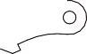BEVEL SEAT UNION DIN 11851 UNIONS

L

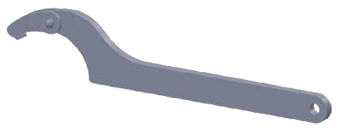
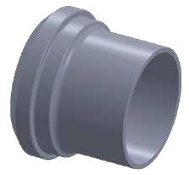14A PLAIN LONG WELD FERRULE
SIZE | øA  in. mm |  | øB  in. mm |  | øC  in. mm |  | øF  in. mm |  | L  in. mm
1" | 0.870 | 22.1 | 1.000 | 25.4 | 1.161 | 29.5 | 1.311 | 33.3 | 1.374 | 34.9
11/₂" | 1.370 | 34.8 | 1.500 | 38.1 | 1.677 | 42.6 | 1.842 | 46.8 | 1.500 | 38.1
2" | 1.870 | 47.5 | 2.000 | 50.8 | 2.193 | 55.7 | 2.374 | 60.3 | 1.500 | 38.1
21/₂" | 2.370 | 60.2 | 2.500 | 63.5 | 2.709 | 68.8 | 2.906 | 73.8 | 1.752 | 44.5
3" | 2.870 | 72.9 | 3.000 | 76.2 | 3.224 | 81.9 | 3.437 | 87.3 | 1.752 | 44.5
4" | 3.843 | 97.6 | 4.000 | 101.6 | 4.256 | 108.1 | 4.500 | 114.3 | 1.752 | 44.5

L
ØF
ØA
ØB
ØC
DIN SPANNER
SIZE | øA  in. mm |  | øB  in. mm
DN36~DN60 | 0.866 | 22 | 6.890 | 175
DN60~DN90 | 1.220 | 31 | 9.724 | 247
DN90~DN155 | 1.929 | 49 | 11.417 | 290
DN155~DN230 | 3.248 | 82.5 | 20.276 | 515

15A THREADED LONG WELD FERRULE
F
SIZE | øA  in. mm |  | øB  in. mm |  | F | L  in. mm
1" | 0.870 | 22.1 | 1.000 | 25.4 | 37.13 ACME 8TPI | 1.374 | 34.9
11/2" | 1.370 | 34.8 | 1.500 | 38.1 | 50.65 ACME 8TPI | 1.500 | 38.1
2" | 1.870 | 47.5 | 2.000 | 50.8 | 64.16 ACME 8TPI | 1.500 | 38.1
21/2" | 2.370 | 60.2 | 2.500 | 63.5 | 77.67 ACME 8TPI | 1.752 | 44.5
3" | 2.870 | 72.9 | 3.000 | 76.2 | 91.19 ACME 8TPI | 1.752 | 44.5
4" | 3.843 | 97.6 | 4.000 | 101.6 | 119.25 ACME 6TPI | 1.752 | 44.5

14PRF SHORT PLAIN WELD FERRULE
ØF
SIZE | øA  in. mm |  | øB  in. mm |  | øC  in. mm |  | øF  in. mm |  | L  in. mm
1" | 0.870 | 22.1 | 1.000 | 25.4 | 1.161 | 29.5 | 1.311 | 33.3 | 0.720 | 18.3
11/₂" | 1.370 | 34.8 | 1.500 | 38.1 | 1.677 | 42.6 | 1.842 | 46.8 | 0.720 | 18.3
2" | 1.870 | 47.5 | 2.000 | 50.8 | 2.193 | 55.7 | 2.374 | 60.3 | 0.752 | 19.1
21/₂" | 2.370 | 60.2 | 2.500 | 63.5 | 2.709 | 68.8 | 2.906 | 73.8 | 0.878 | 22.3
3" | 2.870 | 72.9 | 3.000 | 76.2 | 3.224 | 81.9 | 3.437 | 87.3 | 0.909 | 23.1
4" | 3.843 | 97.6 | 4.000 | 101.6 | 4.256 | 108.1 | 4.500 | 114.3 | 1.031 | 26.2

15TRF SHORT THREADED WELD FERRULE
L
F
ROUND NUT

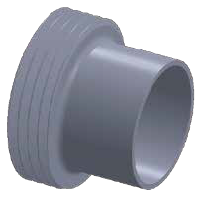
SIZE | øA  in. mm |  | B | øC  in. mm |  | D  in. mm |  | L  in. mm |  | SOLTS
10 | 0.748 | 19 | RD 28*1/8 | 0.059 | 1.496 | 0.591 | 15 | 0.709 | 18 | 4
15 | 0.984 | 25 | RD 34*1/8 | 0.068 | 1.732 | 0.591 | 15 | 0.709 | 18 | 4
20 | 1.220 | 31 | RD 44*1/6 | 0.084 | 2.126 | 0.669 | 17 | 0.787 | 20 | 4
25 | 1.417 | 36 | RD 52*1/6 | 0.098 | 2.480 | 0.709 | 18 | 0.827 | 21 | 4
32 | 1.654 | 42 | RD 58*1/6 | 0.109 | 2.756 | 0.709 | 18 | 0.827 | 21 | 4
40 | 1.929 | 49 | RD 65*1/6 | 0.121 | 3.071 | 0.709 | 18 | 0.827 | 21 | 4
50 | 2.441 | 62 | RD 78*1/6 | 0.143 | 3.622 | 0.748 | 19 | 0.866 | 22 | 4
65 | 3.150 | 80 | RD 95*1/6 | 0.174 | 4.409 | 0.827 | 21 | 0.984 | 25 | 6
80 | 3.701 | 94 | RD110*1/4 | 0.197 | 5.000 | 0.984 | 25 | 1.142 | 29 | 6
100 | 4.528 | 115 | RD130*1/4 | 0.229 | 5.827 | 1.024 | 26 | 1.220 | 31 | 6
125 | 5.433 | 138 | RD160*1/4 | 0.276 | 7.008 | 1.181 | 30 | 1.378 | 35 | 6
150 | 6.457 | 164 | RD190*1/4 | 0.326 | 8.268 | 1.339 | 34 | 1.575 | 40 | 6

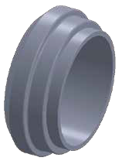
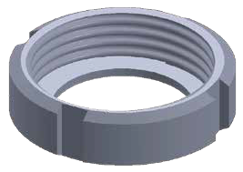
DIN-13R DIN-13RBN
L
L
ØC
B

Ø8
Ø16
ØA
ØB
ØA
ØB
ØC
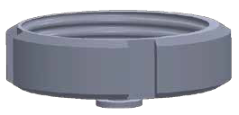
ØC
B
L
D
L

ØA
2
5

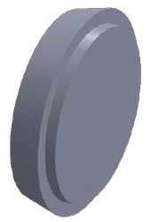
DIN-14 ROUND NUTWELDING LINER
L
SIZE | øA  in. mm |  | øC  in. mm |  | L  in. mm
10 | 0.709 | 18 | 0.886 | 22.5 | 0.354 | 9
15 | 0.945 | 24 | 1.122 | 28.5 | 0.354 | 9
20 | 1.181 | 30 | 1.437 | 36.5 | 0.433 | 11
25 | 1.378 | 35 | 1.732 | 44 | 0.512 | 13
32 | 1.614 | 41 | 1.969 | 50 | 0.512 | 13
40 | 1.890 | 48 | 2.205 | 56 | 0.512 | 13
50 | 2.402 | 61 | 2.697 | 68.5 | 0.551 | 14
65 | 3.110 | 79 | 3.386 | 86 | 0.630 | 16
80 | 3.661 | 93 | 3.937 | 100 | 0.630 | 16
100 | 4.488 | 114 | 4.764 | 121 | 0.787 | 20
125 | 5.394 | 137 | 5.906 | 150 | 0.866 | 22
150 | 6.417 | 163 | 6.929 | 176 | 0.945 | 24

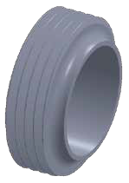
1"

2"

3"
4"
L
ØA
ØB
ØA
ØB
SIZE | øA  in. mm |  | øB  in. mm |  | F | L  in. mm
1" | 0.870 | 22.1 | 1.000 | 25.4 | 37.13 ACME 8TPI | 0.720 | 18.3
11/2" | 1.370 | 34.8 | 1.500 | 38.1 | 50.65 ACME 8TPI | 0.720 | 18.3
2" | 1.870 | 47.5 | 2.000 | 50.8 | 64.17 ACME 8TPI | 0.752 | 19.1
21/2" | 2.370 | 60.2 | 2.500 | 63.5 | 77.67 ACME 8TPI | 0.874 | 22.2
3" | 2.870 | 72.9 | 3.000 | 76.2 | 91.19 ACME 8TPI | 0.909 | 23.1
4" | 3.843 | 97.6 | 4.000 | 101.6 | 119.25 ACME 6TPI | 1.031 | 26.2

DIN 11851 UNIONS TUBE OD FITTIINGS

DIN-14

WELDING LINER
SIZE | øA  in. mm |  | øB  in. mm |  | øC  in. mm |  | L  in. mm
10 | 0.354/0.394 | 9/10 | 0.472/0.512 | 12/13 | 0.874 | 22.2 | 0.669 | 17
15 | 0.591/0.630 | 15/16 | 0.709/0.748 | 18/19 | 1.110 | 28.2 | 0.669 | 17
20 | 0.748/0.787 | 19/20 | 0.866/0.906 | 22/23 | 1.429 | 36.3 | 0.709 | 18
25 | 0.984/1.024 | 25/26 | 1.102/1.142 | 28/29 | 1.732 | 44 | 0.866 | 22
32 | 1.220/1.260 | 31/32 | 1.339/1.378 | 34/35 | 1.969 | 50 | 0.984 | 25
40 | 1.457/1.496 | 37/38 | 1.575/1.614 | 40/41 | 2.205 | 56 | 1.024 | 26
50 | 1.929/1.969 | 49/50 | 2.047/2.078 | 52/53 | 2.677 | 68 | 1.102 | 28
65 | 2.598 | 66 | 2.756 | 70 | 3.386 | 86 | 1.260 | 32
80 | 3.189 | 81 | 3.346 | 85 | 3.937 | 100 | 1.457 | 37
100 | 3.937 | 100 | 4.094 | 104 | 4.764 | 121 | 1.732 | 44

ØC

DIN-15

WELDING MALE
SIZE | øA  in. mm |  | øB  in. mm |  | C | L  in. mm
10 | 0.354/0.394 | 9/10 | 0.472/0.512 | 12/13 | RD 28X1/8 | 0.827 | 21
15 | 0.591/0.630 | 15/16 | 0.709/0.748 | 18/19 | RD 34X1/8 | 0.827 | 21
20 | 0.748/0.787 | 19/20 | 0.866/0.906 | 22/23 | RD 44X1/6 | 0.945 | 24
25 | 0.984/1.024 | 25/26 | 1.102/1.142 | 28/29 | RD 52X1/6 | 1.142 | 29
32 | 1.220/1.260 | 31/32 | 1.339/1.378 | 34/35 | RD 58X1/6 | 1.260 | 32
40 | 1.457/1.496 | 37/38 | 1.575/1.614 | 40/41 | RD 65X1/6 | 1.299 | 33
50 | 1.929/1.969 | 49/50 | 2.047/2.078 | 52/53 | RD 78X1/6 | 1.378 | 35
65 | 2.598 | 66 | 2.756 | 70 | RD 95X1/6 | 1.575 | 40
80 | 3.189 | 81 | 3.346 | 85 | RD 110X1/4 | 1.772 | 45
100 | 3.937 | 100 | 4.094 | 104 | RD 130X1/4 | 2.126 | 54

DIN-14l
WELDING LINER
ØC
ØA
ØB
14VB STUB END
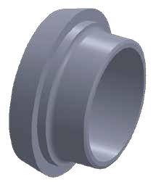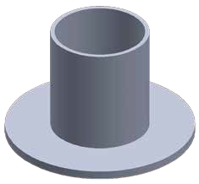
SIZE | øA  in. mm |  | øB  in. mm |  | T  in. mm |  | L  in. mm
1" | 1.000 | 25.4 | 2.000 | 50.8 | 0.065 | 1.65 | 1.626 | 41.3
11/₂" | 1.500 | 38.1 | 2.874 | 73 | 0.065 | 1.65 | 1.626 | 44.5
2" | 2.000 | 50.8 | 3.626 | 92.1 | 0.065 | 1.65 | 1.626 | 38.1
21/₂" | 2.500 | 63.5 | 4.126 | 104.8 | 0.065 | 1.65 | 2.000 | 50.8
3" | 3.000 | 76.2 | 5.000 | 127 | 0.065 | 1.65 | 2.252 | 57.2
4" | 4.000 | 101.6 | 6.189 | 157.2 | 0.083 | 2.1 | 2.626 | 66.7
6" | 6.000 | 152.4 | 8.500 | 215.9 | 0.109 | 2.77 | 3.000 | 76.2

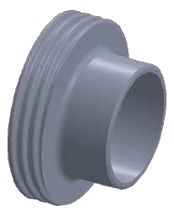
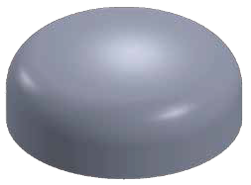
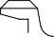 16W CAP
L
L
ØA
T
ØB

ØA
ØA
ØB
L
SIZE | øD  in. mm |  | T  in. mm |  | L  in. mm
1/2" | 0.500 | 12.7 | 0.065 | 1.65 | 0.252 | 6.4
3/4" | 0.750 | 19.05 | 0.065 | 1.65 | 0.311 | 7.9
1" | 1.000 | 25.4 | 0.065 | 1.65 | 0.752 | 19.1
11/₂" | 1.500 | 38.1 | 0.065 | 1.65 | 0.559 | 14.2
2" | 2.000 | 50.8 | 0.065 | 1.65 | 0.752 | 19.1
21/₂" | 2.500 | 63.5 | 0.065 | 1.65 | 1.000 | 25.4
3" | 3.000 | 76.2 | 0.065 | 1.65 | 1.252 | 31.8
4" | 4.000 | 101.6 | 0.083 | 2.1 | 1.500 | 38.1
6" | 6.000 | 152.4 | 0.109 | 2.77 | 2.252 | 57.2

T
ØB
ØA
L

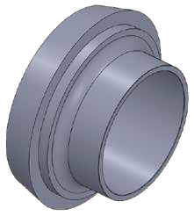
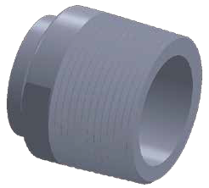
B19W
L
L
ØB
ØA
NPT
SIZE | øA  in. mm |  | øB  in. mm |  | L  in. mm |  | NPT
1/2" | 0.370 | 9.4 | 0.500 | 12.7 | 1.626 | 41.3 | 1/2"-14T
3/4" | 0.620 | 15.75 | 0.750 | 19.05 | 1.626 | 41.3 | 3/4"-14T
1" | 0.870 | 22.1 | 1.000 | 25.4 | 1.752 | 44.5 | 1"-11.5T
11/₂" | 1.370 | 34.8 | 1.500 | 38.1 | 1.752 | 44.5 | 1.5"-11.5T
2" | 1.870 | 47.5 | 2.000 | 50.8 | 1.811 | 46 | 2"-11.5T
21/₂" | 2.370 | 60.2 | 2.500 | 63.5 | 2.311 | 58.7 | 2.5"-8T
3" | 2.870 | 72.9 | 3.000 | 76.2 | 2.500 | 63.5 | 3"-8T
4" | 3.835 | 97.4 | 4.000 | 101.6 | 2.563 | 65.1 | 4"-8T
6" | 5.783 | 146.9 | 6.000 | 152.4 | 3.000 | 76.2 | 6"-8T

SIZE | øA  in. mm |  | øB  in. mm |  | øC  in. mm |  | L  in. mm
1/2" | 0.370 | 9.4 | 0.500 | 12.7 | 0.866 | 22 | 0.669 | 17
3/4" | 0.620 | 15.75 | 0.750 | 19.05 | 1.417 | 36 | 0.709 | 18
1" | 0.870 | 22.1 | 1.000 | 25.4 | 1.732 | 44 | 0.866 | 22
11/₂" | 1.370 | 34.8 | 1.500 | 38.1 | 2.205 | 56 | 1.024 | 26
2" | 1.870 | 47.5 | 2.000 | 50.8 | 2.677 | 68 | 1.102 | 28
21/₂" | 2.370 | 60.2 | 2.500 | 63.5 | 3.386 | 86 | 1.260 | 32
3" | 2.870 | 72.9 | 3.000 | 76.2 | 3.937 | 100 | 1.457 | 37
4" | 3.843 | 97.6 | 4.000 | 101.6 | 4.764 | 121 | 1.732 | 44

DIN-15l
C
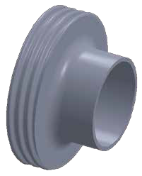
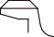 WELDING MALE
L
C
ØA
ØB
SIZE | øA  in. mm |  | øB  in. mm |  | C | L  in. mm
1/2" | 0.370 | 9.4 | 0.500 | 12.7 | RD28*1/8 | 0.827 | 21
3/4" | 0.620 | 15.75 | 0.750 | 19.05 | RD44*1/6 | 0.945 | 24
1" | 0.870 | 22.1 | 1.000 | 25.4 | RD52*1/6 | 1.142 | 29
11/₂" | 1.370 | 34.8 | 1.500 | 38.1 | RD65*1/6 | 1.299 | 33
2" | 1.870 | 47.5 | 2.000 | 50.8 | RD78*1/6 | 1.378 | 35
21/₂" | 2.370 | 60.2 | 2.500 | 63.5 | RD95*1/6 | 1.575 | 40
3" | 2.870 | 72.9 | 3.000 | 76.2 | RD110*1/4 | 1.772 | 45
4" | 3.843 | 97.6 | 4.000 | 101.6 | RD130*1/4 | 2.126 | 54

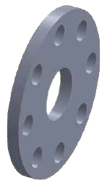
BACK-UP FLANGE
SIZE | øA  in. mm |  | øB  in. mm |  | øC  in. mm |  | øD  in. mm |  | L  in. mm
1" | 1.063 | 27 | 3.126 | 79.4 | 4.252 | 108 | 0.157 - 0.626 | 4-15.9 | 0.374 | 9.5
11/₂" | 1.563 | 39.7 | 3.874 | 98.4 | 5.000 | 127 | 0.157 - 0.626 | 4-15.9 | 0.374 | 9.5
2" | 2.063 | 52.4 | 4.752 | 120.7 | 6.000 | 152.4 | 0.157 - 0.750 | 4-19.05 | 0.437 | 11.1
21/₂" | 2.563 | 65.1 | 5.500 | 139.7 | 7.000 | 177.8 | 0.157 - 0.750 | 4-19.05 | 0.437 | 11.1
3" | 3.063 | 77.8 | 6.000 | 152.4 | 7.500 | 190.5 | 0.157 - 0.750 | 4-19.05 | 0.500 | 12.7
4" | 4.063 | 103.2 | 7.500 | 190.5 | 9.000 | 228.6 | 0.315 - 0.750 | 8-19.05 | 0.500 | 12.7
6" | 6.063 | 154 | 9.500 | 241.3 | 11.000 | 279.4 | 0.315 - 0.874 | 8-22.2 | 0.563 | 14.3

ØC
ØB
L

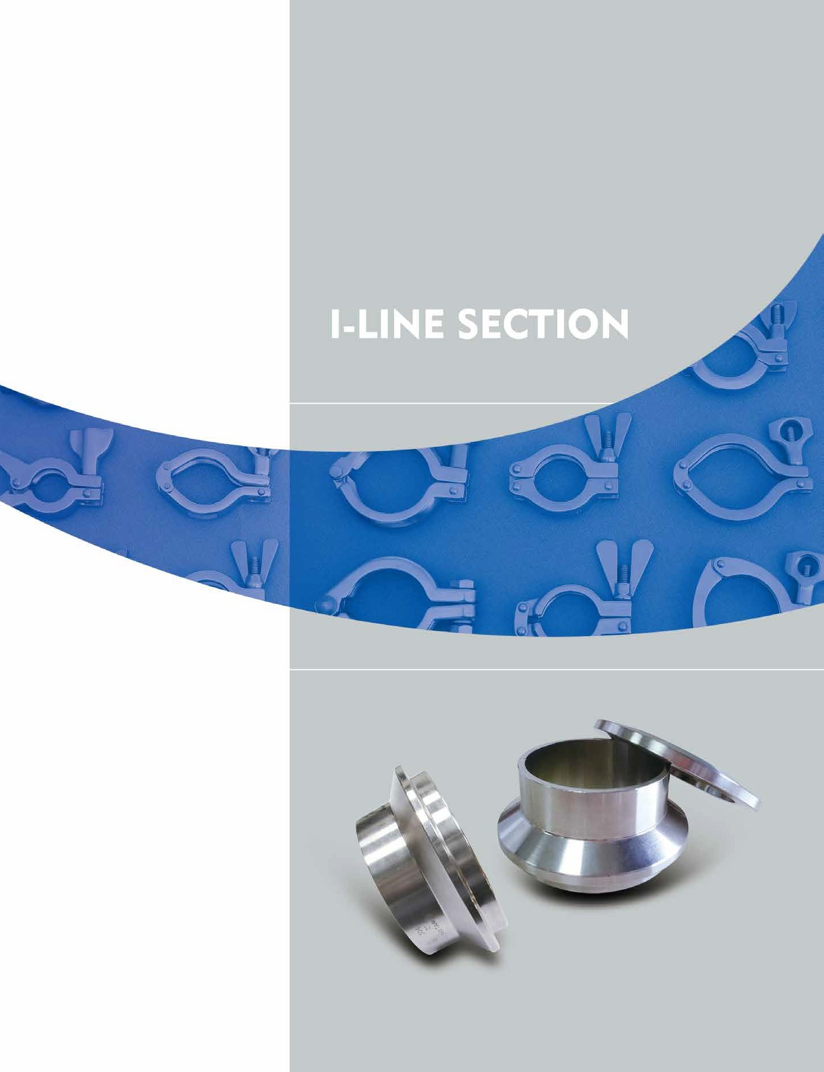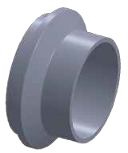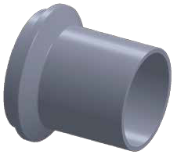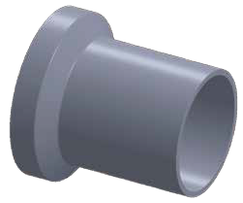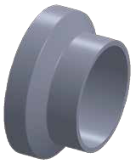

I-LINE SECTION

14WI
SHORT FERRULE MALE
L
ØD
ØC
ØA
ØB
SIZE | øA  in. mm |  | øB  in. mm |  | øC  in. mm |  | øD  in. mm |  | L  in. mm
1" | 0.870 | 22.1 | 1.010 | 25.65 | 1.240 | 31.5 | 1.995 | 50.67 | 0.781 | 19.84
11/₂" | 1.370 | 34.8 | 1.510 | 38.35 | 1.740 | 44.2 | 1.995 | 50.67 | 0.937 | 23.8
2" | 1.870 | 47.5 | 2.010 | 51.05 | 2.240 | 56.9 | 2.640 | 67.05 | 1.031 | 26.19
21/₂" | 2.370 | 60.2 | 2.510 | 63.75 | 2.740 | 69.6 | 3.307 | 84 | 1.156 | 29.36
3" | 2.870 | 72.89 | 3.010 | 76.45 | 3.300 | 83.82 | 3.870 | 98.3 | 1.218 | 30.94
4" | 3.834 | 97.38 | 4.010 | 101.85 | 4.297 | 109.14 | 4.870 | 123.7 | 1.343 | 34.11

15WI
SHORT FERRULE FEMALE
L
ØD
ØC
ØA
ØB
SIZE | øA  in. mm |  | øB  in. mm |  | øC  in. mm |  | øD  in. mm |  | L  in. mm
1" | 0.870 | 22.1 | 1.010 | 25.65 | 1.255 | 31.88 | 1.995 | 50.67 | 0.781 | 19.84
11/₂" | 1.370 | 34.8 | 1.510 | 38.35 | 1.755 | 44.58 | 1.995 | 50.67 | 0.937 | 23.8
2" | 1.870 | 47.5 | 2.010 | 51.05 | 2.255 | 57.28 | 2.640 | 67.05 | 1.031 | 26.19
21/₂" | 2.370 | 60.2 | 2.510 | 63.75 | 2.755 | 69.98 | 3.307 | 84 | 1.156 | 29.36
3" | 2.870 | 72.89 | 3.010 | 76.45 | 3.315 | 84.2 | 3.870 | 98.3 | 1.218 | 30.94
4" | 3.834 | 97.38 | 4.010 | 101.85 | 4.315 | 109.6 | 4.870 | 123.7 | 1.343 | 34.11

14WLI
LONG FERRULE MALE
L
ØD
ØC
ØA
ØB
SIZE | øA  in. mm |  | øB  in. mm |  | øC  in. mm |  | øD  in. mm |  | L  in. mm
1" | 0.870 | 22.1 | 1.010 | 25.65 | 1.240 | 31.5 | 1.995 | 50.67 | 1.563 | 39.7
11/₂" | 1.370 | 34.8 | 1.510 | 38.35 | 1.740 | 44.2 | 1.995 | 50.67 | 1.843 | 46.8
2" | 1.870 | 47.5 | 2.010 | 51.05 | 2.240 | 56.9 | 2.640 | 67.05 | 2.063 | 52.4
21/₂" | 2.370 | 60.2 | 2.510 | 63.75 | 2.740 | 69.6 | 3.307 | 84 | 2.189 | 55.6
3" | 2.870 | 72.89 | 3.010 | 76.45 | 3.300 | 83.82 | 3.870 | 98.3 | 2.374 | 60.3
4" | 3.834 | 97.38 | 4.010 | 101.85 | 4.297 | 109.14 | 4.870 | 123.7 | 2.689 | 68.3

15WLI
LONG FERRULE FEMALE
L
ØD
ØC
ØA
ØB
SIZE | øA  in. mm |  | øB  in. mm |  | øC  in. mm |  | øD  in. mm |  | L  in. mm
1" | 0.870 | 22.1 | 1.010 | 25.65 | 1.255 | 31.88 | 1.995 | 50.67 | 1.752 | 44.5
11/₂" | 1.370 | 34.8 | 1.510 | 38.35 | 1.755 | 44.58 | 1.995 | 50.67 | 2.031 | 51.6
2" | 1.870 | 47.5 | 2.010 | 51.05 | 2.255 | 57.28 | 2.640 | 67.05 | 2.311 | 58.7
21/₂" | 2.370 | 60.2 | 2.510 | 63.75 | 2.755 | 69.98 | 3.307 | 84 | 2.500 | 63.5
3" | 2.870 | 72.89 | 3.010 | 76.45 | 3.315 | 84.2 | 3.870 | 98.3 | 2.689 | 68.3
4" | 3.834 | 97.38 | 4.010 | 101.85 | 4.315 | 109.6 | 4.870 | 123.7 | 3.000 | 76.2

25
26

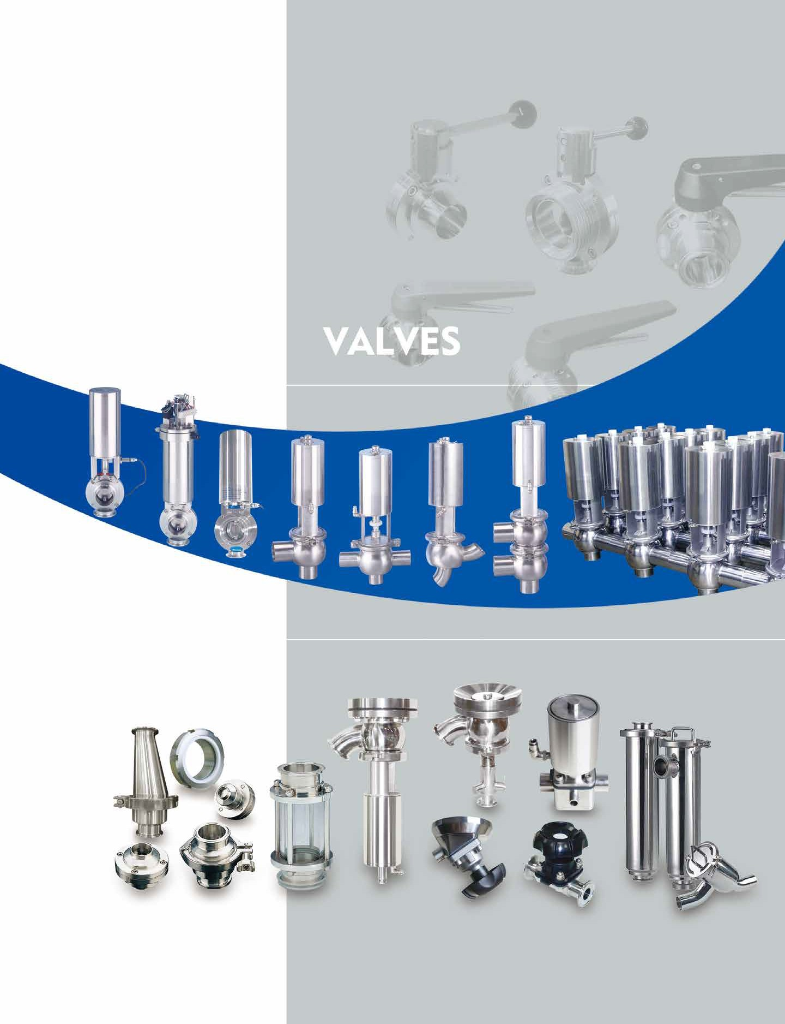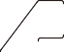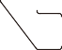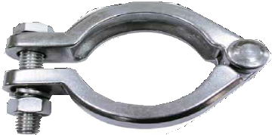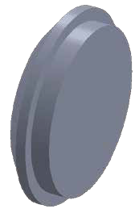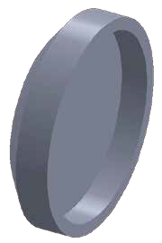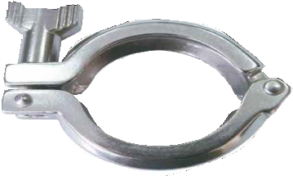

I-LINE SECTION

16AI-15I FEMALE I-LINE END CAP
ØA
ØB
SIZE | øA  in. mm |  | øB  in. mm |  | L  in. mm
1" | 1.255 | 31.88 | 1.995 | 50.67 | 0.502 | 12.75
11/₂" | 1.755 | 44.58 | 1.995 | 50.67 | 0.502 | 12.75
2" | 2.255 | 57.28 | 2.640 | 67.05 | 0.695 | 17.66
21/₂" | 2.755 | 69.98 | 3.307 | 84 | 0.739 | 18.77
3" | 3.315 | 84.2 | 3.870 | 98.3 | 0.763 | 19.37
4" | 4.315 | 109.6 | 4.870 | 123.7 | 0.763 | 19.37

L

16AI-14I MALE I-LINE END CAP
ØA
ØB
SIZE | øA  in. mm |  | øB  in. mm |  | L  in. mm
1" | 1.240 | 31.5 | 1.995 | 50.67 | 0.487 | 12.37
11/₂" | 1.740 | 44.2 | 1.995 | 50.67 | 0.487 | 12.37
2" | 2.240 | 56.9 | 2.640 | 67.05 | 0.556 | 14.11
21/₂" | 2.740 | 69.6 | 3.307 | 84 | 0.737 | 18.72
3" | 3.300 | 83.82 | 3.870 | 98.3 | 0.761 | 19.32
4" | 4.297 | 109.14 | 4.870 | 123.7 | 0.761 | 19.32

L

13IU
BOLTED I-LINE CLAMP
ØB
SIZE | øA  in. mm |  | øB  in. mm
1"~1/2" | 1.772 | 45 | 2.165 | 55
2" | 2.480 | 63 | 2.874 | 73
2 1/₂" | 2.913 | 74 | 3.504 | 89
3" | 3.465 | 88 | 4.016 | 102
4" | 4.370 | 111 | 5.039 | 128

13IS
I-LINE CLAMP
ØB
SIZE | øA  in. mm |  | øB  in. mm
1"~1/2" | 2.102 | 53.4 | 3.299 | 83.8
2" | 2.843 | 72.2 | 4.370 | 111
2 1/₂" | 3.469 | 88.1 | 4.780 | 121.4
3" | 4.031 | 102.4 | 5.358 | 136.1
4" | 5.031 | 127.8 | 6.378 | 162
6" | 7.689 | 195.3 | 9.531 | 242.1

27 28

CHECK VALVE 3A SIGHT GLASS

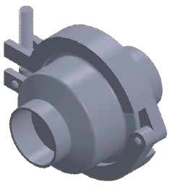
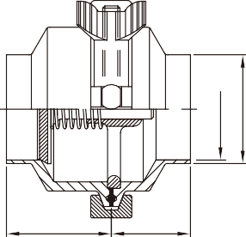 CHECK VALVE MIDDLE CLAMP/WELD END
SIZE | øA  in. mm |  | øB  in. mm |  | C  in. mm |  | D  in. mm
1/2" | 0.370 | 9.4 | 0.500 | 12.7 | 0.945 | 24 | 1.339 | 34
3/4" | 0.620 | 15.75 | 0.750 | 19.05 | 0.945 | 24 | 1.339 | 34
1" | 0.870 | 22.1 | 1.000 | 25.4 | 1.339 | 34 | 1.890 | 48
11/2" | 1.370 | 34.8 | 1.500 | 38.1 | 1.417 | 36 | 1.890 | 48
2" | 1.870 | 47.5 | 2.000 | 50.8 | 1.417 | 36 | 1.890 | 48
21/2" | 2.370 | 60.2 | 2.500 | 63.5 | 1.417 | 36 | 1.890 | 48
3" | 2.870 | 72.9 | 3.000 | 76.2 | 1.417 | 36 | 1.890 | 48
4" | 3.835 | 97.4 | 4.000 | 101.6 | 1.850 | 47 | 2.126 | 54

D
C
ØA
ØB

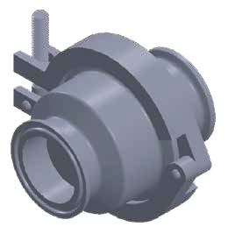
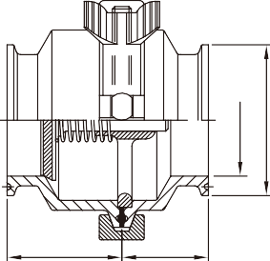 CHECK VALVE MIDDLE CLAMP/CLAMP END
D
C
ØA
ØB
SIZE | øA  in. mm |  | øB  in. mm |  | C  in. mm |  | D  in. mm
1/2" | 0.370 | 9.4 | 0.992 | 25.2 | 1.122 | 28.5 | 1.555 | 39.5
3/4" | 0.620 | 15.75 | 0.992 | 25.2 | 1.122 | 28.5 | 1.555 | 39.5
1" | 0.870 | 22.1 | 1.988 | 50.5 | 1.339 | 34 | 1.890 | 48
11/2" | 1.370 | 34.8 | 1.988 | 50.5 | 1.417 | 36 | 1.890 | 48
2" | 1.870 | 47.5 | 2.520 | 64 | 1.417 | 36 | 1.890 | 48
21/2" | 2.370 | 60.2 | 3.051 | 77.5 | 1.417 | 36 | 1.890 | 48
3" | 2.870 | 72.9 | 3.583 | 91 | 1.417 | 36 | 1.890 | 48
4" | 3.835 | 97.4 | 4.685 | 119 | 1.850 | 47 | 2.126 | 54

Parts list
Item | Parts name | Q'TY | Material
1 | Long Body | 1 | St.St 304、316、316L
2 | Short Body | 1 | St.St 304、316、316L
3 | Disc | 1 | St.St 316
4 | Body Seal | 2 | EPDM/Silicone/Viton
5 | Seal-Ring | 1 | EPDM/Silicone/Viton
6 | Flow Suport Plate | 1 | St.St 316
7 | St.St Spring | 1 | St.St 316
8 | St.St Screw | 4 | St.St 304

WELD END

SIZE | øA  in. mm |  | øB  in. mm |  | øC  in. mm |  | øD  in. mm |  | øE  in. mm |  | L  in. mm
1/2" | 0.370 | 9.4 | 0.500 | 12.7 | 1.850 | 47 | 0.402 | 10.2 | 0.591 | 15 | 4.173 | 106
3/4" | 0.620 | 15.75 | 0.750 | 19.05 | 1.850 | 47 | 0.669 | 17 | 0.866 | 22 | 4.173 | 106
1" | 0.870 | 22.1 | 1.000 | 25.4 | 3.110 | 79 | 1.024 | 26 | 1.260 | 32 | 5.827 | 148
11/2" | 1.370 | 34.8 | 1.500 | 38.1 | 3.346 | 85 | 1.339 | 34 | 1.575 | 40 | 6.142 | 156
2" | 1.870 | 47.5 | 2.000 | 50.8 | 4.134 | 105 | 1.969 | 50 | 2.362 | 60 | 6.299 | 160
21/2" | 2.370 | 60.2 | 2.500 | 63.5 | 4.409 | 112 | 2.559 | 65 | 2.953 | 75 | 6.299 | 160
3" | 2.870 | 72.9 | 3.000 | 76.2 | 4.921 | 125 | 2.969 | 75.4 | 3.346 | 85 | 6.378 | 162
4" | 3.835 | 97.4 | 4.000 | 101.6 | 6.181 | 157 | 3.937 | 100 | 4.331 | 110 | 6.575 | 167

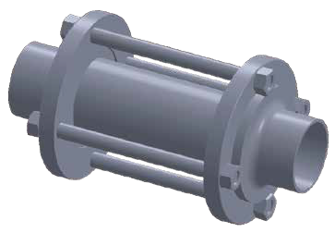
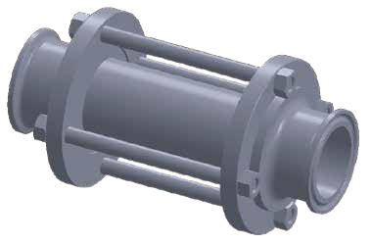
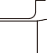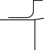 CLAMP END
90
80
L
90
80
L
ØC
ØC
ØE
ØE
ØD
ØD
ØA
ØB
ØA
ØB

SIZE | øA  in. mm |  | øB  in. mm |  | øC  in. mm |  | øD  in. mm |  | øE  in. mm |  | L  in. mm
1" | 0.870 | 22.1 | 1.988 | 50.5 | 3.110 | 79 | 1.024 | 26 | 1.260 | 32 | 5.630 | 143
11/2" | 1.370 | 34.8 | 1.988 | 50.5 | 3.346 | 85 | 1.339 | 34 | 1.575 | 40 | 5.748 | 146
2" | 1.870 | 47.5 | 2.520 | 64 | 4.134 | 105 | 1.969 | 50 | 2.362 | 60 | 5.906 | 150
21/2" | 2.370 | 60.2 | 3.051 | 77.5 | 4.409 | 112 | 2.559 | 65 | 2.953 | 75 | 5.906 | 150
3" | 2.870 | 72.9 | 3.583 | 91 | 4.921 | 125 | 2.969 | 75.4 | 3.346 | 85 | 6.142 | 156
4" | 3.835 | 97.4 | 4.685 | 119 | 6.181 | 157 | 3.937 | 100 | 4.331 | 110 | 6.142 | 156

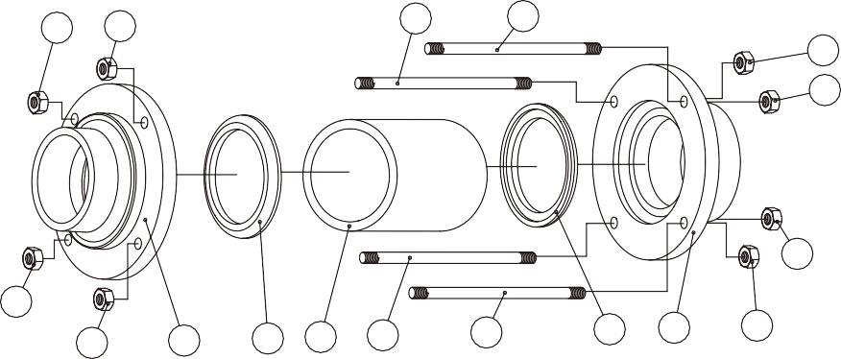 Parts list
5
5
4
4
5
5
5
5
5
1
2
3
4
4
2
1
5

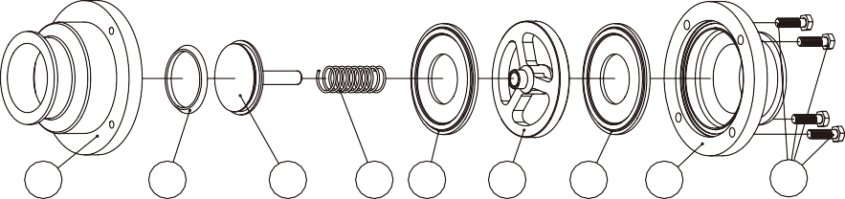
1
5
3
7
4
6
4
2
8
Item | Parts name | Q'TY | Material
1 | Body-weld | 2 | St.St 304/316(L)
2 | Seal | 2 | TEFLON/EPDM
3 | High press clean glass | 1 | Borosilicate glass
4 | Screw blot | 4 | St.St304
5 | Nylon lock nut | 8 | St.St304

PNEUMATIC ACTUATOR BUTTERFLY VALVE W/12 POSITION GRIP HANDLE
PULL HANDLE 4 POSITION-P4 GRIPPER HANDLE 12 POSITION-G12

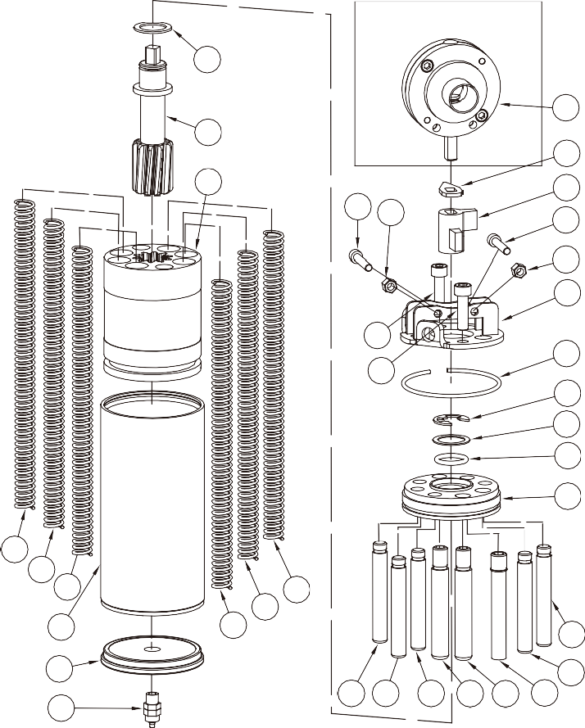
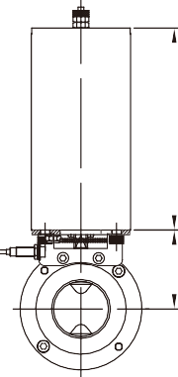
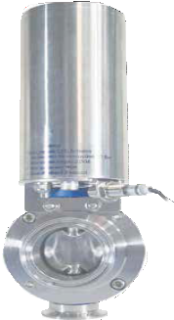
C3 Assembly valve way
11
174
17
12
22
3 16
20 19 20
31
19
15
18

143

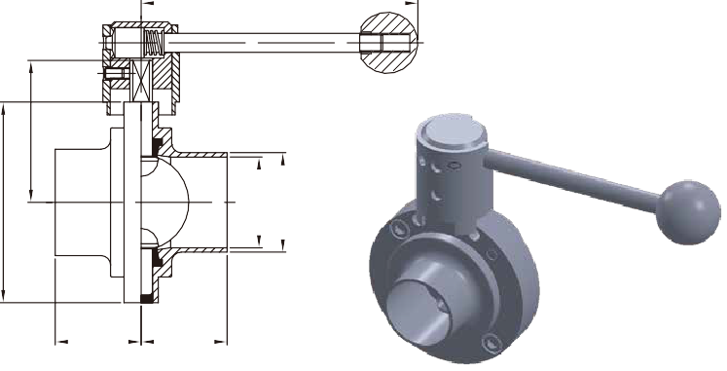
D D
ØE
L
ØA
ØB

167

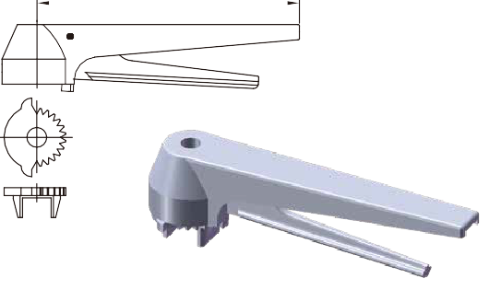
※PULL HANDLE AVAILABLE UPON REQUEST

18 4
WELD BUTTERFLY VALVE

C101

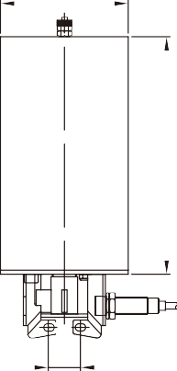
Ø120

Ø120
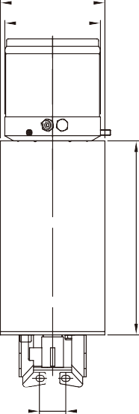
Ø104

8
8 8
1
189
2
21
189
14
13
10
5

8 8
8 9
9
9 9 9 6 6 7
SIZE
1/2"
3/4"
1"
11/2"
2"
21/2"
3"
4"
6"
in.
0.370
0.620
0.870
1.370
1.870
2.370
2.870
3.835
5.782
øA
mm
9.4
15.75
22.1
34.8
47.5
60.2
72.9
97.4
146.86
in.
0.500
0.750
1.000
1.500
2.000
2.500
3.000
4.000
6.000
øB mm
12.7
19.05
25.4
38.1
50.8
63.5
76.2
101.6
152.4
in. D mm
1.339 34
1.339 34
1.339 34
1.496 38
1.575 40
1.575 40
1.614 41
1.732 44
2.244 57
in. øE
3.110
3.110
3.110
3.346
4.134
4.409
4.921
6.181
8.425
mm
79
79
79
85
105
112
125
157
214
in.
2.402
2.402
2.402
2.531
2.925
3.055
3.339
4.004
5.469
L
mm
61
61
61
64.3
74.3
77.6
84.8
101.7
138.9

31
L

31
Parts list

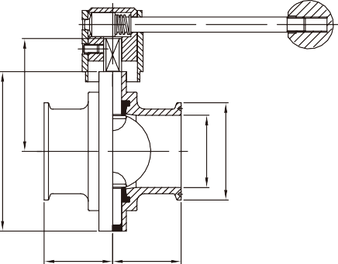
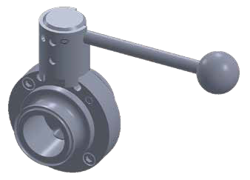
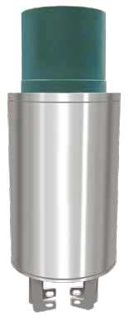
D D
ØE
ØA ØB
Item | Parts name | Q'TY | Material | Item | Parts name | Q'TY | Material
1 | St.St cylinder | 1 | St.St 304 | 12 | Coupling axle piece | 1 | St.St 304
2 | St.St cylinder cap | 1 | St.St 304 | 13 | Contact seal | 1 | St.St 304
3 | Piston stem | 1 | Tenac  4010/SH410 | 14 | Circlip | 1 | St.St 304
 |  |  |  | 15 | Mounting bracket | 1 | St.St 304
4 | Lock wire clip | 1 | St.St 304 | 16 | Connection piece | 1 | St.St 304
5 | Lower cylinder end | 1 | St.St 304 | 17 | Assembly valve way | 1 | St.St  304/316(L)
6 | Piston guide part | 2 | St.St 304
7 | Piston guide part | 1 | St.St 304 | 18 | M8x12 ST.ST screw | 2 | St.St 304
8 | Compress spring | 6 | St.St 304 | 19 | M6 Nut | 2 | St.St 304
9 | Piston guide part | 5 | St.St 304 | 20 | M6x35 ST.ST screw | 2 | St.St 304
10 | Piston axle O-ring | 1 | Teﬂon | 21 | Air connection | 1 | Copper
11 | Teﬂon gasket | 1 | Teﬂon | 22 | Positioning index | 1 | St.St 304

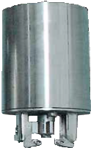
CLAMP BUTTERFLY VALVE
SIZE | øA  in. mm |  | in. øB mm |  | in. D mm |  | in. øE mm |  | L  in. mm
1/2" | 0.370 | 9.4 | 0.992 | 25.2 | 1.339 | 34 | 3.110 | 79 | 2.402 | 61
3/4" | 0.620 | 15.75 | 0.992 | 25.2 | 1.339 | 34 | 3.110 | 79 | 2.402 | 61
1" | 0.870 | 22.1 | 1.988 | 50.5 | 1.299 | 33 | 3.110 | 79 | 2.402 | 61
11/₂" | 1.370 | 34.8 | 1.988 | 50.5 | 1.299 | 33 | 3.346 | 85 | 2.531 | 64.3
2" | 1.870 | 47.5 | 2.520 | 64.0 | 1.378 | 35 | 4.134 | 105 | 2.925 | 74.3
21/₂" | 2.370 | 60.2 | 3.051 | 77.5 | 1.378 | 35 | 4.409 | 112 | 3.055 | 77.6
3" | 2.870 | 72.9 | 3.583 | 91.0 | 1.496 | 38 | 4.921 | 125 | 3.339 | 84.8
4" | 3.835 | 97.4 | 4.685 | 119.0 | 1.496 | 38 | 6.181 | 157 | 4.004 | 101.7
6" | 5.782 | 146.86 | 6.567 | 166.8 | 2.244 | 57 | 8.386 | 213 | 5.469 | 138.9

BUTTERFLY VALVE W/12 POSITION GRIP HANDLE CONTROL BOX

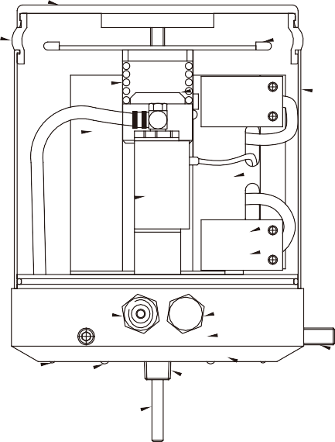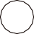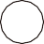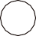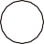C3 type
19
10

11

20

5
7

8
2
9
1
3
4.1
4.2
6
17

14

15
12
18
13
Ø104
16
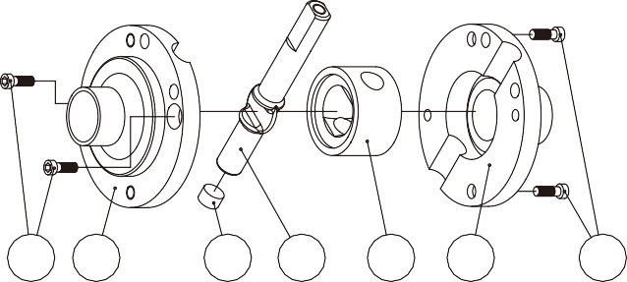
Parts list
Item | Parts name | Q'TY | Material
1 | BODY | 2 | St.St 304、316、316L
2 | DISC | 1 | St.St 304、316、316L
3 | EPDM RUBBER SEAT | 1 | EPDM
4 | COVER | 1 | EPDM
5 | SCREW BOLT | 4 | St.St 304

5
1
4
2
3
1
5

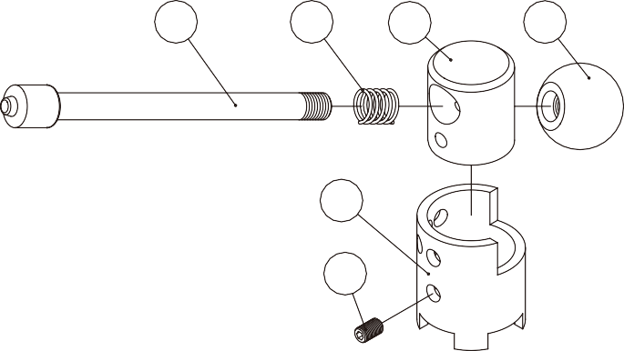 Parts list
5
3
2
6
4
1
127
Item | Parts name | Q'TY | Material
1 | Hex socket screw | 1 | St.St 304
2 | Hub | 1 | St.St 304
3 | Spring | 1 | St.St 304
4 | Locking bushing | 1 | St.St 304
5 | Locking rod | 1 | St.St 304
6 | Button | 1 | Button

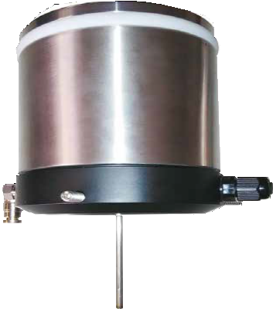
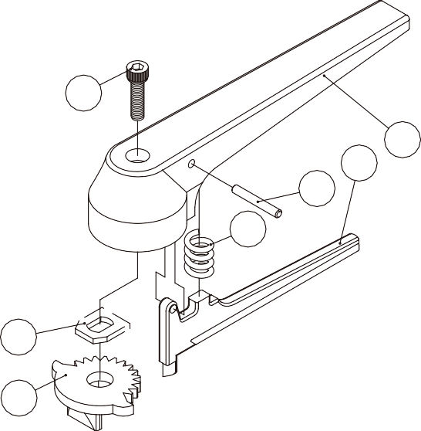 Parts list
4
1
5
7
6
3
2

CONTROL BOX CONSTRUCTION ASSEMBLY DRAWING & ITEMS LIST
Parts list

Item | Parts name | Q'TY | Material
1 | Cover | 1 | St.St 304
2 | LED Light | 1
3 | Switch bracket | 1 | St.St 304
4.1 | Proximity sensor | 2 | 3A 125VAC.  30VDC
4.2 | Micro switch | 2 | 3A 125VAC.  30VDC
5 | Electrovalve | 1 | DC24 3.0W AC110V  AC220V
6 | E/N connect piece | 1 | St.St 304
7 | Air connection | 1 | Cu
8 | Air manifold | 1 | P.O.M St.St 304
9 | House | 1 | P.C
10 | Light screen | 1 | PC
11 | Spring | 1 | St.St 304
12 | Sensor pin | 1 | St.St 304
13 | Plate | 1 | St.St 304
14 | O-Ring | 1 | NBR
15 | O-Ring | 1 | NBR
16 | Adapter (3/8" NPT) | 1 | St.St 304
17 | O-Ring | 1 | NBR
18 | Set screw | 3 | St.St 304
19 | Top cover | 1 | St.St 304
20 | PCB board | 6

Item | Parts name | Q'TY | Material
1 | Body | 1 | St.St 304
2 | Sprocket | 1 | St.St 304
3 | Metall-inlay | 1 | St.St 304
4 | Screw | 1 | St.St 304
5 | PIN | 1 | St.St 304
6 | Spring | 1 | St.St 304
7 | Trigger | 1 | St.St 304

PNEUMATIC DIVERT VALVE

F type construction assembly drawing & items list
PNEUMATIC DIVERT VALVE

Parts list
Item | Parts name | Q'TY | Material | Item | Parts name | Q'TY | Material | Item | Parts name | Q'TY | Material
1 | Piston | 1 | St.St 304 | 10 | Valve body-lower | 1 | St.St 316 | 19 | X-ring | 1 | NBR
2 | Cylinder | 1 | St.St 304 | 11 | Valve body-upper | 1 | St.St 316 | 20 | Clamp | 4 | St.St 304
3 | Spring assembly | 1 | St.St 304 | 12 | Middle piece | 1 | St.St 316 | 21 | M6 screws | 4 | St.St 304
4 | Air connect | 1 | Coupler | 13 | Lip seal-EPDM | 1 | 304/EPDM | 22 | Valve body se-al ring | 1 | EPDM
5 | Air connect | 1 | Coupler | 14 | Clip complete | 1 | St.St 304
6 | Screws | 1 | St.St. 316 | 15 | Seal ring lower | 2 | EPDM | 23 | O-ring | 1 | NBR
7 | O-ring | 1 | Rubber,NBR | 16 | Lock wire clip | 1 | St.St 304 | 24 | O-ring | 1 | NBR
8 | Stem | 1 | St.St 316 | 17 | Bracket | 1 | St.St 304 | 25 | O-ring | 1 | NBR
9 | Washer | 1 | St.St 316 | 18 | Stop ring | 1 | Tecﬂo

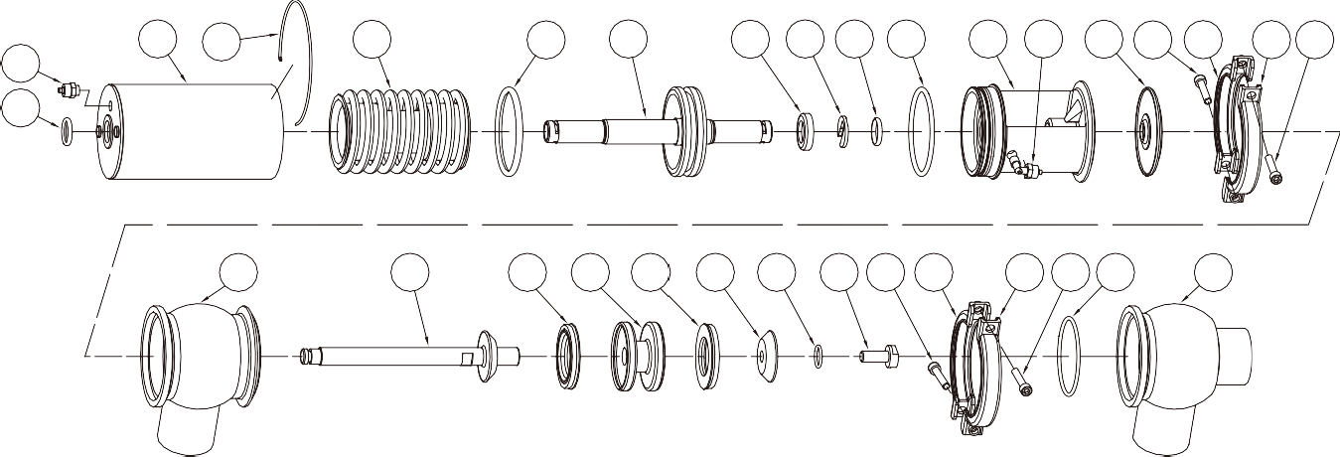
2 16 3
4
23
19 1
18 14
25 24
17 5
13 21 20
20 21

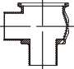
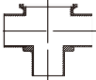
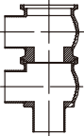
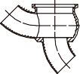
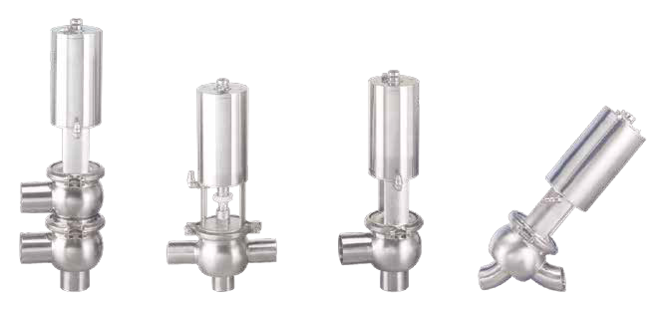
Type : L , T , Y and L/L , T/L , L/T , T/T
SIZE | in. 1" mm |  | 11/₂"  in. mm |  | in. 2" mm |  | 21/₂"  in. mm |  | in. 3" mm |  | in. 4" mm
ØA | 0.870 | 22.1 | 1.370 | 34.8 | 1.870 | 47.5 | 2.370 | 60.2 | 2.870 | 72.9 | 3.835 | 97.4
ØB | 1.000 | 25.4 | 1.500 | 38.1 | 2.000 | 50.8 | 2.500 | 63.5 | 3.000 | 76.2 | 4.000 | 101.6
C | 2.232 | 56.7 | 3.150 | 80 | 3.638 | 92.4 | 4.724 | 120 | 5.039 | 128 | 5.937 | 150.8
C1 | 2.303 | 58.5 | 3.197 | 81.2 | 3.374 | 85.7 | 4.059 | 103.1 | 4.583 | 116.4 | 4.500 | 114.3
C2 | 1.992 | 50.6 | 2.402 | 61 | 2.575 | 65.4 | 2.839 | 72.1 | 3.138 | 79.7 | 4.500 | 114.3
C3 | 3.205 | 81.4
W | 2.000 | 59.9 | 2.697 | 68.5 | 2.874 | 73 | 3.559 | 90.4 | 4.083 | 103.7 | 3.878 | 98.5
W1 | 2.000 | 52 | 2.260 | 57.4 | 2.630 | 66.8 | 3.130 | 79.5 | 3.783 | 96.1 | 3.878 | 98.5
ØD | 2.362 | 60 | 3.346 | 85 | 3.346 | 85 | 5.236 | 133 | 5.236 | 133 | 5.236 | 133
L | 6.047 | 153.6 | 11.417 | 290 | 11.665 | 296.3 | 14.402 | 365.8 | 14.524 | 368.9 | 25.421 | 645.7
L1 | 0.669 | 17 | 0.984 | 25 | 0.984 | 25 | 1.260 | 32 | 1.417 | 36 | 1.496 | 38
Y | 3.783 | 96.1 | 5.602 | 142.3 | 6.638 | 168.6 | 8.331 | 211.6 | 9.634 | 244.7 | 11.933 | 303.1
Y1 | 4.783 | 121.5 | 6.602 | 167.7 | 7.638 | 194 | 9.331 | 237 | 10.634 | 270.1 | 13.177 | 334.7

L | T | Y | F
L/L | T/L | L/T | T/T

11 8
15 12 15 9 7 6
21 20
20 21
22 10

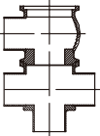
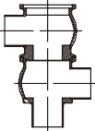
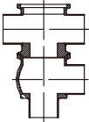
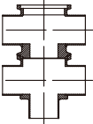
Max. ﬂow tube pressure without leakage valve seat.
If over table Max. pressure suggestion add proof Max. valve

Actuator type / function:
10. SA. Pneumatic downward movement, spring return (NO-lower seat) ØD
20. AS. Pneumatic upward movement, spring return (NC-lower seat)
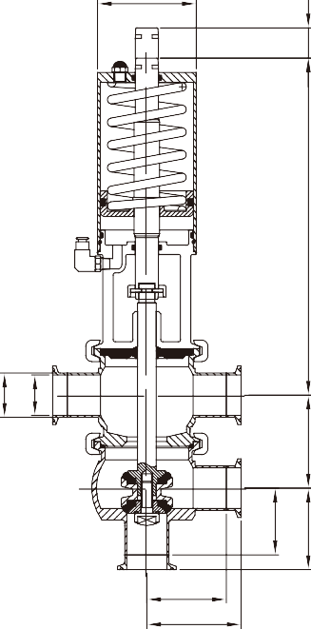
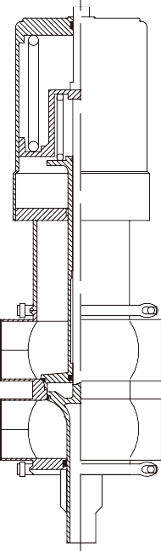
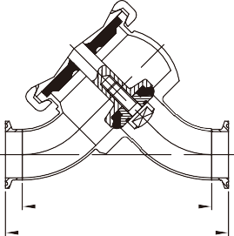
30. AA. Pneumatic upward and downward movement (A/A)
L1

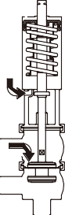
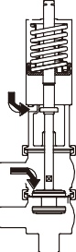
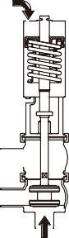
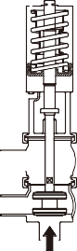
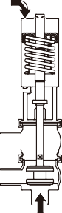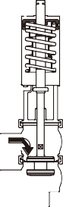 Y
L
Actuator/Valve Body combination and direction of pressure  NO : Normal open NC : Normal close  A/A : Air/Air double action  Stop and change-over  valves- Max. pressure without leakage at the valve seat  = Max. air input pressure  as 8 bar  = Tube-Line ﬂow Pressure |  | Spring closes | Air  Air closes |  | Air  Air closes | Spring closes | Air  Air closes |  | Air  Air closes
Air pressure (bar)  Actuator Type/Function |  | 10 (NO) | 5  10 | 8 (NO) | 5  20 (NC) | 20 (NC) | 5  30 | 8  30 | 5  30 | 6  30
Valve size (Max. Pressure) | 1" | 9.5 | 10 | 10 | 9.5 | 10 | 10 | 10 | 10 | 10
 | 11/ 2" | 4.5 | 7.0 | 10 | 4.5 | 7.0 | 9.0 | 10 | 10 | 10
 | 2" | 4.5 | 4.0 | 5.0 | 4.5 | 4.0 | 9.0 | 10 | 9.0 | 10
 | 2 1/ 2" | 3.0 | 3.0 | 4.0 | 3.0 | 2.5 | 8.0 | 9.0 | 6.0 | 7.0
 | 3" | 5.0 | 4.0 | 6.0 | 4.5 | 5.0 | 10 | 10 | 10 | 10

Y1

Y Type
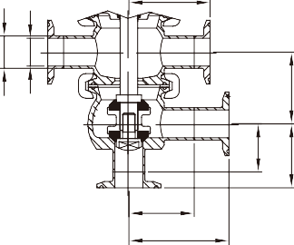
C1
ØB ØA
C
ØB ØA
C

W W
W1
C2
W1
C2
C3 C1

SIZE:1.0" SIZE:1.5"~4.0"

BALL VALVE
BALL VALVE
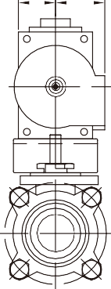
2WAY SPECIFICATIONS FOR CLAMP & WELD END
SIZE |  | 1/2"  DN15 | 3/4"  DN20 | 1"  DN25 | 11/₂"  DN40 | 2"  DN50 | 21/ ₂"  DN65 | 3"  DN80 | 4"  DN100
ISO-5211 |  | F03 | F03 | F04 | F05 | F05 | F07 | F07 | F10
C | in.  mm | 2.165 | 2.362 | 2.717 | 3.307 | 3.622 | 4.922 | 5.354 | 6.252
 |  | 55 | 60 | 69 | 84 | 92 | 126.8 | 136 | 158.8
L | in.  mm | 3.504 | 3.976 | 4.488 | 5.512 | 6.142 | 7.756 | 9.016 | 9.555
 |  | 89 | 101 | 114 | 140 | 156 | 197 | 229 | 242.7
W | in.  mm | 5.197 | 5.177 | 6.496 | 7.650 | 7.650 | 9.921 | 9.921 | 13.071
 |  | 132 | 131.5 | 165 | 194.3 | 194.3 | 252 | 252 | 332
ød | in.  mm | 0.370 | 0.620 | 0.870 | 1.370 | 1.870 | 2.370 | 2.870 | 3.835
 |  | 9.4 | 15.75 | 22.1 | 34.8 | 47.5 | 60.2 | 72.9 | 97.4
øD | in.  mm | 0.984 | 0.984 | 1.984 | 1.984 | 2.516 | 3.047 | 3.579 | 4.681
 |  | 25 | 25 | 50.4 | 50.4 | 63.9 | 77.4 | 90.9 | 118.9
øD1 | in.  mm | 0.500 | 0.750 | 1.000 | 1.500 | 2.000 | 2.500 | 3.000 | 4.000
 |  | 12.7 | 19.05 | 25.4 | 38.1 | 50.8 | 63.5 | 76.2 | 101.6
R | in.  mm | 0.197 | 0.197 | 0.256 | 0.335 | 0.335 | 0.472 | 0.472 | 0.630
 |  | 5 | 5 | 6.5 | 8.5 | 8.5 | 12 | 12 | 16
L1 | in.  mm | 1.289 | 1.437 | 1.575 | 1.713 | 1.801 | 2.205 | 2.539 | 2.386
 |  | 32.75 | 36.5 | 40 | 43.5 | 45.75 | 56 | 64.5 | 60.6

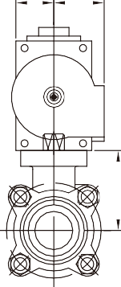
F H
D
D
R
K F H K

C B
ØA ØB
ØA ØC
L L

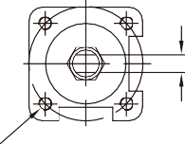
Bracket
E
G
C
DIN 3337
ISO 5211
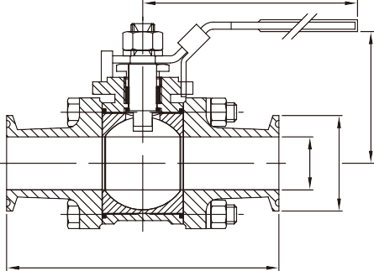
W

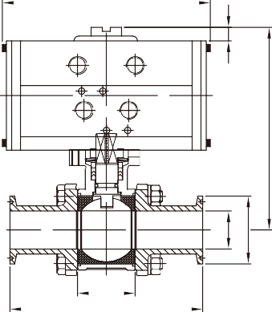
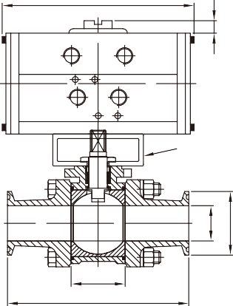
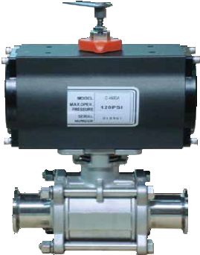
HIGH MOUNT PLATE DESIGN LOW MOUNT PLATE DESIGN
Ød ØD,D1

3WAY SPECIFICATIONS FOR CLAMP & WELD END
ØD
Ød

L

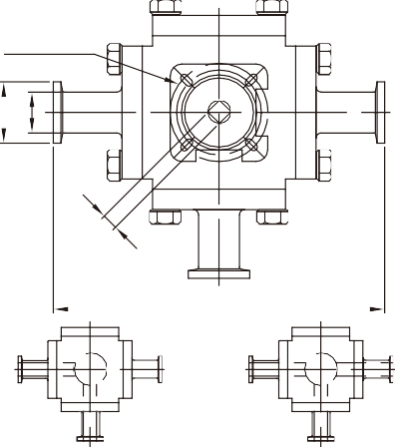
DIN 3337
ISO 5211

L
SIZE |  | 1/2"  C-125 | 3/4"  C-125 | 1"  C-250 | 11/₂"  C-450 | 2"  C-1000 | 11/₂"  C-1000 | 3"  C-2250 | 4"  C-2250
ISO-5211 |  | F03/F04 | F03/F04 | F04/F05 | F05/F07 | F05/F07 | F07/F10 | F07/F10 | F10/F12
INCH/LBS  TORQUE | in.  mm | 3.543 | 3.937 | 5.512 | 9.449 | 18.898 | 25.591 | 45.276 | 55.118
 |  | 90 | 100 | 140 | 240 | 480 | 650 | 1150 | 1400
øA | in.  mm | 0.370 | 0.620 | 0.870 | 1.370 | 1.909 | 2.370 | 2.870 | 3.835
 |  | 9.4 | 15.75 | 22.1 | 34.8 | 48.5 | 60.2 | 72.9 | 97.4
øB | in.  mm | 0.984 | 0.984 | 1.984 | 1.984 | 2.516 | 3.047 | 3.579 | 4.681
 |  | 25 | 25 | 50.4 | 50.4 | 63.9 | 77.4 | 90.9 | 118.9
C | in.  mm | 1.457 | 1.457 | 1.654 | 1.969 | 1.969 | 2.835 | 2.835 | 3.740
 |  | 37 | 37 | 42 | 50 | 50 | 72 | 72 | 95
D | in.  mm | 0.787 | 0.787 | 0.787 | 0.787 | 0.787 | 0.787 | 0.787 | 1.181
 |  | 20 | 20 | 20 | 20 | 20 | 20 | 20 | 30
E | in.  mm | 1.457 | 1.850 | 2.252 | 3.079 | 3.394 | 4.299 | 4.634 | 5.559
 |  | 37 | 47 | 57.2 | 78.2 | 86.2 | 109.2 | 117.7 | 141.2
F | in.  mm | 1.122 | 1.122 | 1.323 | 1.713 | 2.146 | 2.146 | 2.559 | 2.559
 |  | 28.5 | 28.5 | 33.6 | 43.5 | 54.5 | 54.5 | 65 | 65
G | in.  mm | 4.764 | 5.157 | 6.150 | 7.724 | 8.945 | 9.850 | 10.972 | 11.898
 |  | 121 | 131 | 156.2 | 196.2 | 227.2 | 250.2 | 278.7 | 302.2
H | in.  mm | 1.327 | 1.327 | 1.882 | 2.028 | 2.539 | 2.539 | 2.972 | 2.972
 |  | 33.7 | 33.7 | 47.8 | 51.5 | 64.5 | 64.5 | 75.5 | 75.5
K | in.  mm | 4.724 | 4.724 | 5.681 | 5.874 | 7.205 | 7.205 | 10.220 | 10.220
 |  | 120 | 120 | 144.3 | 149.2 | 183 | 183 | 259.6 | 259.6
L | in.  mm | 3.504 | 3.976 | 4.488 | 5.512 | 6.142 | 7.756 | 9.016 | 9.488
 |  | 89 | 101 | 114 | 140 | 156 | 197 | 229 | 241

SIZE |  | 1/2"  DN15 | 3/4"  DN20 | 1"  DN25 | 11/₂"  DN40 | 2"  DN50 | 21/ ₂"  DN65 | 3"  DN80 | 4"  DN100
ISO-5211 |  | F03 | F03 | F04 | F05 | F05 | F07 | F10 | F10
ød | in.  mm | 0.374 | 0.622 | 0.874 | 1.378 | 1.874 | 2.370 | 2.874 | 3.835
 |  | 9.5 | 15.8 | 22.2 | 35 | 47.6 | 60.2 | 73 | 97.4
øD | in.  mm | 1.000 | 1.000 | 1.984 | 1.984 | 2.516 | 3.051 | 3.579 | 4.681
 |  | 25.4 | 25.4 | 50.4 | 50.4 | 63.9 | 77.5 | 90.9 | 118.9
R | in.  mm | 0.354 | 0.354 | 0.433 | 0.551 | 0.551 | 0.669 | 0.866 | 0.866
 |  | 9 | 9 | 11 | 14 | 14 | 17 | 22 | 22
L | in.  mm | 4.646 | 5.000 | 6.008 | 6.890 | 7.480 | 8.976 | 10.260 | 11.417
 |  | 118 | 127 | 152.6 | 175 | 190 | 228 | 260.6 | 290

L PORT
T PORT

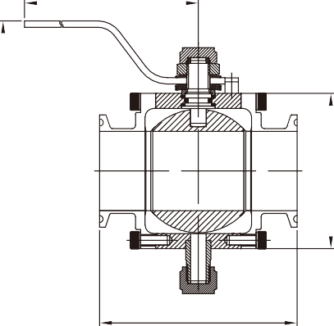 D
HIGH PURITY BALL VALVE
C
SIZE |  | 1" | 11/₂" | 2" | 21/₂" | 3"
A | in.  mm | 3.752 | 4.252 | 4.685 | 5.315 | 6.500
 |  | 95.3 | 108 | 119 | 135 | 165.1
B | in.  mm | 2.311 | 3.063 | 3.689 | 4.189 | 4.937
 |  | 58.7 | 77.8 | 93.7 | 106.4 | 125.4
C | in.  mm | 2.374 | 2.811 | 3.126 | 3.374 | 3.752
 |  | 60.3 | 71.4 | 79.4 | 85.7 | 95.3
D | in.  mm | 6.437 | 6.437 | 6.437 | 6.437 | 6.437
 |  | 163.5 | 163.5 | 163.5 | 163.5 | 163.5

B

A

BALL VALVE ACTUATOR DIAPHRAGM VALVE PARTS LIST

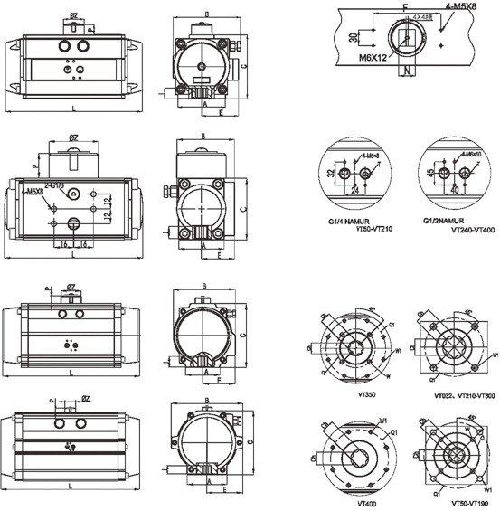
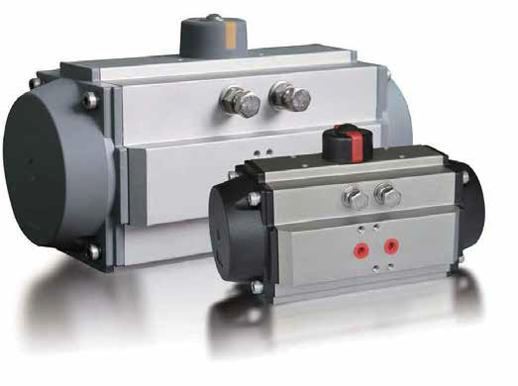
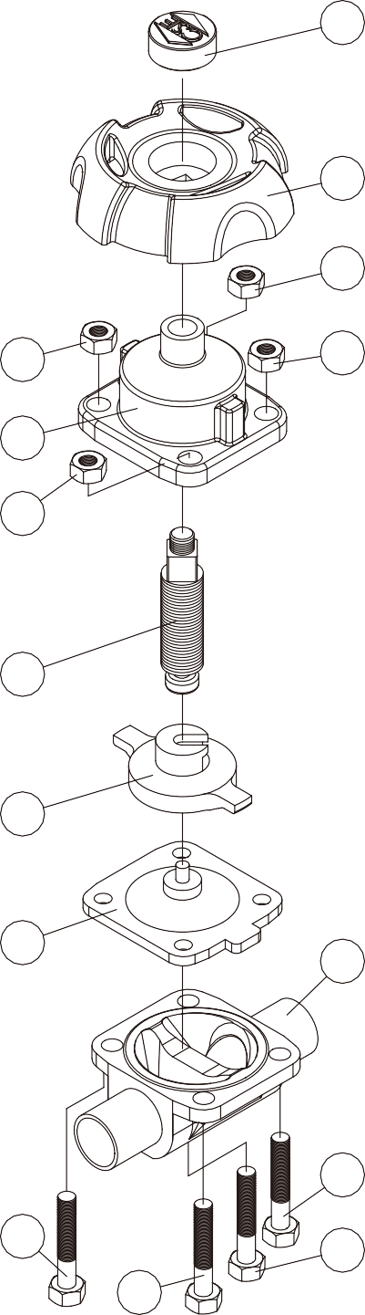 Construction Assembly & Parts List
Item | Parts name | Q'TY | Material
1 | BODY | 1 | ST.ST 316L
2 | SEAL | 1 | EPDM+PTFE
3 | Seat | 1 | ST.ST 304
4 | Screw | 1 | ST.ST 304
5 | Bonnet | 1 | POBOM/CASTING
6 | Handwheel | 1 | NYLON 66+30% GF
7 | Cover | 1 | NYLON 66+30% GF
8 | M6 SCREW BOLT | 1 | ST.ST304

7
6
9
9
9
5
9
4
3
2
1
8
8
8
8

SIZING CHART (INCH)
Speciﬁcations

Material | Body：Forged/316L
 | Diaphragm：EPDM+PTFE/ NC or NO：EPDM+PTFE
Connection | Clamp End/Weld End
Body Type | Direct Connection (Two Way)/Equal T/  Reducing T/U-Point‧‧‧
Operation | Normal Open/Normal Close
Work Temp. | Diaphragm：EPDM+PTFE(-10°C~150°C)
Work Pressure | Max：10 Bar
Surface | SF1：ID Polished to Ra≦0.5µm/ SF4：EP Finished to Ra≦0.38µm
ID/OD Mirror Polished &
ID Ra≦0.5µm/OD Sand Blasted‧‧‧

SIZE | A | B | C | L | E | F | P | øZ | N | I | FLANGE | Q | Q1 | W | W1 | Ch | T
VT032 | 1.457 | 1.850 | 1.969 | 4.331 | 1.063 | 1.969 | 0.787 | 1.575 | 0.394 | 0.394 | F03 |  | 1.417 |  | M5*9 | 9*9 | G1/8"
VT050 | 1.772 | 2.776 | 2.756 | 6.063 | 1.634 | 3.150 | 0.787 | 1.575 | 0.394 | 0.472 | F03/05 | 1.417 | 1.969 | M5*7.5 | M6*9 | 11*11 | G1/4"
VT065 | 2.441 | 3.524 | 3.504 | 7.441 | 2.028 | 3.150 | 0.787 | 1.575 | 0.394 | 0.630 | F05/07 | 1.969 | 2.756 | M6*9 | M8*12 | 14*14 | G1/4"
VT075 | 2.677 | 4.035 | 3.937 | 8.268 | 2.323 | 3.150 | 0.787 | 1.575 | 0.551 | 0.630 | F05/07 | 1.969 | 2.756 | M6*9 | M8*12 | 14*14 | G1/4"
VT085 | 2.677 | 4.429 | 4.449 | 9.016 | 2.500 | 3.150 | 0.787 | 1.575 | 0.551 | 0.748 | F05/07 | 1.969 | 2.756 | M6*9 | M8*12 | 17*17 | G1/4"
VT095 | 3.622 | 4.961 | 4.843 | 10.394 | 2.795 | 3.150 | 0.787 | 1.575 | 0.551 | 0.748 | F05/07 | 1.969 | 2.756 | M6*9 | M8*12 | 17*17 | G1/4"
VT110 | 3.661 | 5.453 | 5.354 | 10.472 | 3.012 | 3.150 | 0.787 | 1.575 | 0.551 | 0.748 | F07/10 | 2.756 | 4.016 | M8*12 | M10*15 | 17*17 | G1/4"
VT125 | 3.780 | 6.181 | 6.339 | 13.268 | 3.346 | 3.150 | 1.181 | 2.205 | 0.866 | 0.984 | F07/10 | 2.756 | 4.016 | M8*12 | M10*15 | 22*22 | G1/4"
VT140 | 4.331 | 7.008 | 7.008 | 14.843 | 3.819 | 3.150/5.118 | 1.181 | 2.205 | 0.866 | 1.220 | F10/12 | 4.016 | 4.921 | M10*15 | M12*18 | 27*27 | G1/4"
VT160 | 4.409 | 7.717 | 7.874 | 16.220 | 4.173 | 3.150/5.118 | 1.181 | 2.205 | 0.866 | 1.220 | F10/12 | 4.016 | 4.921 | M10*15 | M12*18 | 27*27 | G1/4"
VT190 | 5.354 | 8.524 | 9.134 | 19.213 | 4.409 | 5.118 | 1.181 | 3.150 | 1.260 | 1.614 | F10/14 | 4.016 | 5.512 | M10*15 | M16*24 | 36*36 | G1/4"
VT210 | 5.512 | 9.272 | 10.039 | 21.654 | 4.724 | 5.118 | 1.181 | 3.150 | 1.260 | 1.575 | F14 |  | 5.512 |  | M16*24 | 36*36 | G1/4"
VT240 | 6.260 | 10.315 | 11.496 | 23.701 | 5.157 | 5.118 | 1.181 | 3.150 | 1.260 | 1.969 | F16 |  | 6.496 |  | M20*28 | 46*46 | G1/2"
VT270 | 6.260 | 11.614 | 13.031 | 26.457 | 5.807 | 5.118 | 1.181 | 3.150 | 1.260 | 1.969 | F16 |  | 6.496 |  | M20*28 | 46*46 | G1/2"
VT300 | 7.087 | 13.189 | 13.937 | 30.866 | 6.811 | 5.118 | 1.181 | 3.150 | 1.260 | 1.969 | F16 |  | 6.496 |  | M20*28 | 46*46 | G1/2"
VT350 | 10.630 | 15.157 | 16.142 | 33.268 | 7.677 | 5.118 | 1.181 | 3.150 | 1.260 | 1.969 | F16/25 | 6.496 | 10.000 | M20*28 | M16*30 | 46*46 | G1/2"
VT400 | 11.417 | 20.472 | 18.346 | 37.638 | 10.236 | 5.118 | 1.181 | 3.150 | 1.260 | 2.362 | F25 |  | 10.000 |  | M16*30 | 55*55 | G1/2"

PNEUMATIC/MANUAL DIAPHRAGM VALVE PNEUMATIC/MANUAL DIAPHRAGM VALVE

2WAY VALVE
3WAY/U-BEND VALVE
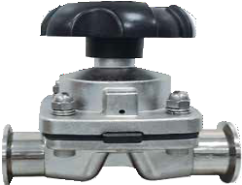
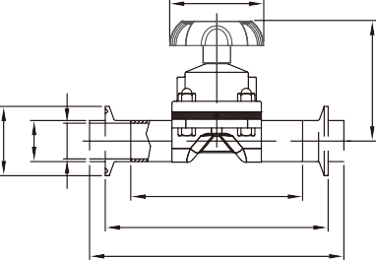ØD
L
L1 L2
G1;G2
ØE

F1
ØC ØB ØA

ØC ØB ØA

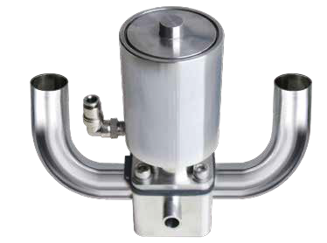
H
K
M1
M

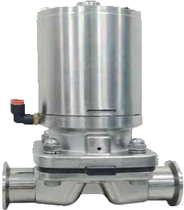
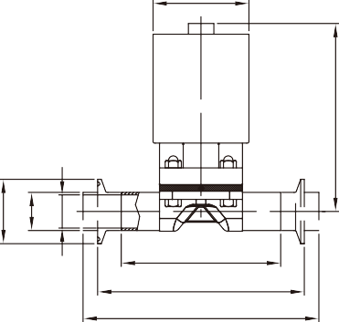N
ØE
L
L1 L2
L L1
SIZE |  | 1/2" | 3/4" | 1" | 11/₂" | 2"
øA | in.  mm | 0.370 | 0.620 | 0.870 | 1.370 | 1.870
 |  | 9.4 | 15.75 | 22.1 | 34.8 | 47.5
øB | in.  mm | 0.500 | 0.750 | 1.000 | 1.500 | 2.000
 |  | 12.7 | 19.05 | 25.4 | 38.1 | 50.8
øC | in.  mm | 0.992 | 0.992 | 1.988 | 1.988 | 2.520
 |  | 25.2 | 25.2 | 50.5 | 50.5 | 64
øD | in.  mm | 2.362 | 2.362 | 3.740 | 3.740 | 4.646
 |  | 60 | 60 | 95 | 95 | 118
øE | in.  mm | 2.362 | 2.362 | 3.346 | 3.346 | 5.236
 |  | 60 | 60 | 85 | 85 | 133
F1 | in.  mm | 4.803 | 4.803 | 8.346 | 8.543 | 12.402
 |  | 122 | 122 | 212 | 217 | 315
F2 | in.  mm | 5.157 | 5.157 | 8.858 | 9.134 | 13.110
 |  | 131 | 131 | 225 | 232 | 333
G1 | in.  mm | 2.913 | 2.913 | 3.937 | 4.685 | 5.315
 |  | 74 | 74 | 100 | 119 | 135
G2 | in.  mm | 3.268 | 3.268 | 4.449 | 5.276 | 6.024
 |  | 83 | 83 | 113 | 134 | 153
L1 | in.  mm | 3.717 | 3.717 | 4.921 | 6.260 | 7.559
 |  | 94.4 | 94.4 | 125 | 159 | 192

ØC1
ØC ØB ØA
F1,F2

ØA1 ØB1
ØD
K
M1 M
F2
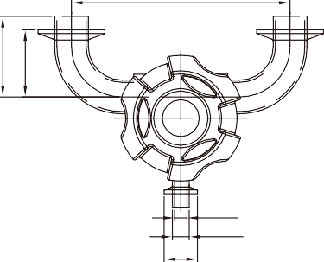
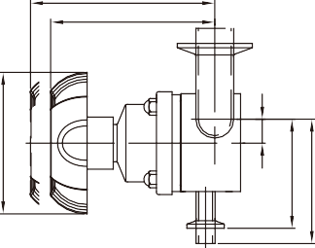
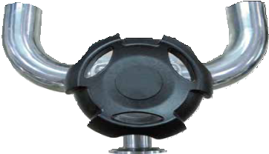
G2 G1

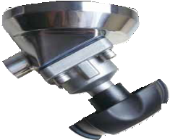

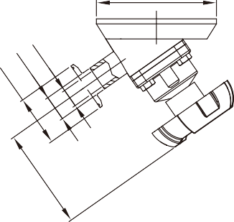
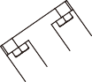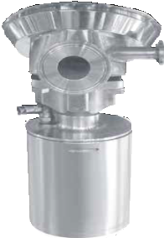 ØD ØD
SIZE |  | 1/2"*1/2" | 1/2"*3/4" | 1/2"*1" | 1/2"*11/2" | 1/2"*2" | 3/4"*3/4" | 3/4"*1" | 3/4"*11/2" | 3/4"*2" | 1"*1" | 1"*11/2" | 1"*2" | 11/2"*11/2" | 11/2"*2" | 2"*2"
øA | in.  mm | 0.370 | 0.620 | 0.870 | 1.370 | 1.870 | 0.620 | 0.870 | 1.370 | 1.870 | 0.870 | 1.370 | 1.870 | 1.370 | 1.870 | 1.870
 |  | 9.4 | 15.75 | 22.1 | 34.8 | 47.5 | 15.75 | 22.1 | 34.8 | 47.5 | 22.1 | 34.8 | 47.5 | 34.8 | 47.5 | 47.5
øB | in.  mm | 0.500 | 0.750 | 1.000 | 1.500 | 2.000 | 0.750 | 1.000 | 1.500 | 2.000 | 1.000 | 1.500 | 2.000 | 1.500 | 2.000 | 2.000
 |  | 12.7 | 19.05 | 25.4 | 38.1 | 50.8 | 19.05 | 25.4 | 38.1 | 50.8 | 25.4 | 38.1 | 50.8 | 38.1 | 50.8 | 50.8
øC | in.  mm | 0.992 | 0.992 | 1.988 | 1.988 | 2.520 | 0.992 | 1.988 | 1.988 | 2.520 | 1.988 | 1.988 | 2.520 | 1.988 | 2.520 | 2.520
 |  | 25.2 | 25.2 | 50.5 | 50.5 | 64 | 25.2 | 50.5 | 50.5 | 64 | 50.5 | 50.5 | 64 | 50.5 | 64 | 64
øA1 | in.  mm | 0.370 | 0.370 | 0.370 | 0.370 | 0.370 | 0.620 | 0.620 | 0.620 | 0.620 | 0.870 | 0.870 | 0.870 | 1.370 | 1.370 | 1.870
 |  | 9.4 | 9.4 | 9.4 | 9.4 | 9.4 | 15.75 | 15.75 | 15.75 | 15.75 | 22.1 | 22.1 | 22.1 | 34.8 | 34.8 | 47.5
øB1 | in.  mm | 0.500 | 0.750 | 1.000 | 1.500 | 2.000 | 0.750 | 1.000 | 1.500 | 2.000 | 1.000 | 1.500 | 2.000 | 1.500 | 2.000 | 2.000
 |  | 12.7 | 12.7 | 12.7 | 12.7 | 12.7 | 19.05 | 19.05 | 19.05 | 19.05 | 25.4 | 25.4 | 25.4 | 38.1 | 38.1 | 50.8
øC1 | in.  mm | 0.992 | 0.992 | 1.988 | 1.988 | 2.520 | 0.992 | 1.988 | 1.988 | 2.520 | 1.988 | 1.988 | 2.520 | 1.988 | 2.520 | 2.520
 |  | 25.2 | 25.2 | 25.2 | 25.2 | 25.2 | 25.2 | 25.2 | 25.2 | 25.2 | 50.5 | 50.5 | 50.5 | 50.5 | 64 | 64
øD | in.  mm | 2.362 | 2.362 | 2.362 | 2.362 | 2.362 | 2.362 | 2.362 | 2.362 | 2.362 | 3.740 | 3.740 | 3.740 | 3.740 | 3.740 | 4.646
 |  | 60 | 60 | 60 | 60 | 60 | 60 | 60 | 60 | 60 | 95 | 95 | 95 | 95 | 95 | 118
øE | in.  mm | 2.362 | 2.362 | 2.362 | 2.362 | 2.362 | 2.362 | 2.362 | 2.362 | 2.362 | 3.346 | 3.346 | 3.346 | 3.346 | 3.346 | 5.236
 |  | 60 | 60 | 60 | 60 | 60 | 60 | 60 | 60 | 60 | 85 | 85 | 85 | 85 | 85 | 133
F1 | in.  mm | 4.803 | 4.803 | 4.803 | 4.803 | 4.803 | 4.803 | 4.803 | 4.803 | 4.803 | 8.346 | 8.346 | 8.346 | 8.543 | 8.543 | 12.402
 |  | 122 | 122 | 122 | 122 | 122 | 122 | 122 | 122 | 122 | 212 | 212 | 212 | 217 | 217 | 315
F2 | in.  mm | 5.157 | 5.157 | 5.157 | 5.157 | 5.157 | 5.157 | 5.157 | 5.157 | 5.157 | 8.858 | 8.858 | 8.858 | 9.134 | 9.134 | 13.110
 |  | 131 | 131 | 131 | 131 | 131 | 131 | 131 | 131 | 131 | 225 | 225 | 225 | 232 | 232 | 333
G1 | in.  mm | 2.913 | 2.913 | 2.913 | 2.913 | 2.913 | 2.913 | 2.913 | 2.913 | 2.913 | 3.937 | 3.937 | 3.937 | 4.685 | 4.685 | 5.315
 |  | 74 | 74 | 74 | 74 | 74 | 74 | 74 | 74 | 74 | 100 | 100 | 100 | 119 | 119 | 135
G2 | in.  mm | 3.268 | 3.268 | 3.268 | 3.268 | 3.268 | 3.268 | 3.268 | 3.268 | 3.268 | 4.449 | 4.449 | 4.449 | 5.276 | 5.276 | 6.024
 |  | 83 | 83 | 83 | 83 | 83 | 83 | 83 | 83 | 83 | 113 | 113 | 113 | 134 | 134 | 153
H | in.  mm |  | 0.243 | 0.520 | 0.768 | 0.768 | 0.177 | 0.421 | 0.689 | 0.689 | 0.244 | 0.571 | 0.724 | 0.244 | 0.539
 |  |  | 6.18 | 13.44 | 19.5 | 19.5 | 4.5 | 10.7 | 17.5 | 17.5 | 6.2 | 14.5 | 18.4 | 6.2 | 13.7
K | in.  mm | 0.268 | 0.393 | 0.518 | 0.768 | 1.018 | 0.393 | 0.518 | 0.768 | 1.018 | 0.632 | 0.882 | 1.132 | 0.882 | 1.132 | 1.132
 |  | 6.8 | 9.98 | 13.15 | 19.5 | 25.85 | 9.98 | 13.15 | 19.5 | 25.85 | 16.05 | 22.4 | 28.75 | 22.4 | 28.75 | 28.75
L | in.  mm | 2.250 | 2.625 | 3.000 | 3.752 | 4.752 | 2.625 | 3.000 | 3.752 | 4.752 | 3.000 | 3.752 | 4.752 | 3.752 | 4.752 | 4.752
 |  | 57.15 | 66.68 | 76.2 | 95.3 | 120.7 | 66.68 | 76.2 | 95.3 | 120.7 | 76.2 | 95.3 | 120.7 | 95.3 | 120.7 | 120.7
L1 | in.  mm | 1.250 | 1.624 | 2.000 | 2.752 | 3.500 | 1.625 | 2.000 | 2.752 | 3.500 | 2.000 | 2.752 | 3.500 | 2.752 | 3.500 | 3.500
 |  | 31.75 | 41.25 | 50.8 | 69.9 | 88.9 | 41.28 | 50.8 | 69.9 | 88.9 | 50.8 | 69.9 | 88.9 | 69.9 | 88.9 | 88.9
M | in.  mm | 2.732 | 2.868 | 2.982 | 3.232 | 3.482 | 2.857 | 2.982 | 3.232 | 3.482 | 3.411 | 3.661 | 3.911 | 4.134 | 4.384 | 4.872
 |  | 69.4 | 72.85 | 75.75 | 82.1 | 88.45 | 72.58 | 72.75 | 82.1 | 88.45 | 70.6 | 93 | 99.35 | 105 | 111.35 | 123.75
M1 | in.  mm | 2.008 | 2.133 | 2.258 | 2.508 | 2.758 | 2.133 | 2.258 | 2.508 | 2.758 | 2.780 | 2.937 | 3.187 | 3.409 | 3.659 | 3.896
 |  | 51 | 54.18 | 57.35 | 63.7 | 70.05 | 54.18 | 57.35 | 63.7 | 70.05 | 68.25 | 74.6 | 80.95 | 86.6 | 92.95 | 98.95

SIZE |  | 1/2" | 3/4" | 1" | 11/₂" | 2"
øA | in.  mm | 0.370 | 0.620 | 0.870 | 1.370 | 1.870
 |  | 9.4 | 15.75 | 22.1 | 34.8 | 47.5
øB | in.  mm | 0.500 | 0.750 | 1.000 | 1.500 | 2.000
 |  | 12.7 | 19.05 | 25.4 | 38.1 | 50.8
øC | in.  mm | 0.992 | 0.992 | 1.988 | 1.988 | 2.520
 |  | 25.2 | 25.2 | 50.5 | 50.5 | 64
øD | in.  mm | 4.724 | 4.724 | 4.724 | 6.299 | 6.299
 |  | 120 | 120 | 120 | 160 | 160
L | in.  mm | 8.346 | 8.346 | 8.346 | 8.543 | 12.402
 |  | 212 | 212 | 212 | 217 | 315
L1 | in.  mm | 8.858 | 8.858 | 8.858 | 9.134 | 13.110
 |  | 225 | 225 | 225 | 232 | 333
L2 | in.  mm | 3.937 | 3.937 | 3.937 | 4.685 | 5.315
 |  | 100 | 100 | 100 | 119 | 135
L3 | in.  mm | 4.449 | 4.449 | 4.449 | 5.276 | 6.024
 |  | 113 | 113 | 113 | 134 | 153

PNEUMATIC/MANUAL DIAPHRAGM VALVE SAMPLE COCK VALVE

3WAY VALVE

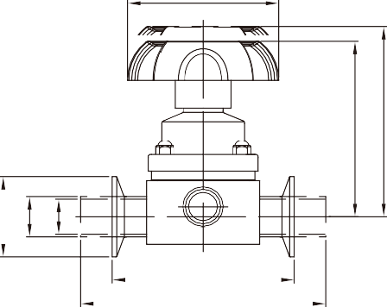
ØD
G1
G2

L1
ØC ØB ØA
L
ØE
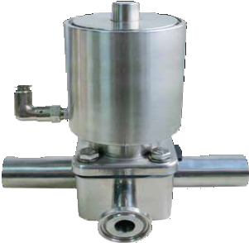

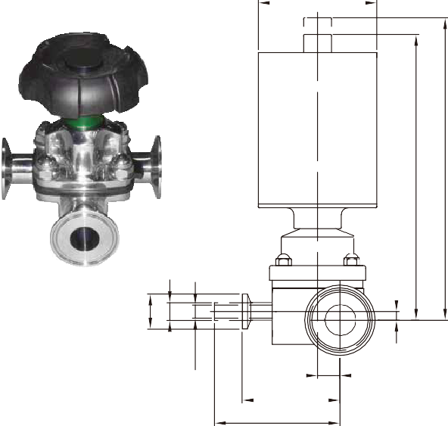
K
ØC1
ØB1
ØA1
H
F1
F2
M1 M

A Type

B Type

C Type
Ø4
55
75 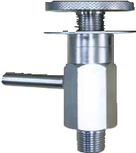
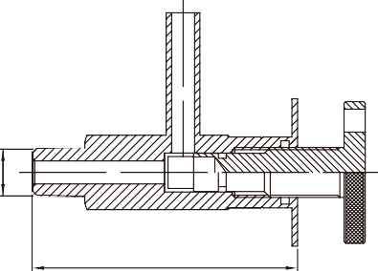
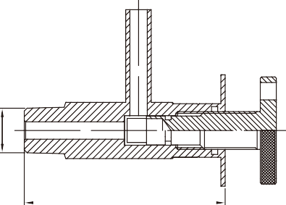
75 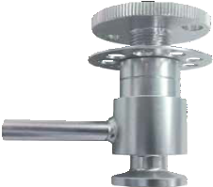
NPT 1/2 NPT 3/8-18 NPT 1/4-8
NPT 1/2 NPT 3/8-18 NPT 1/4-8

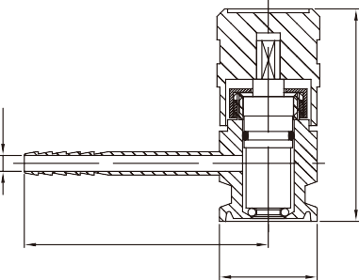
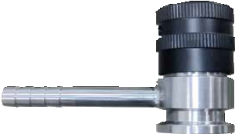
62
SIZE |  | 1/2"*1/2" | 1/2"*3/4" | 1/2"*1" | 1/2"*11/₂" | 1/2"*2" | 3/4"*3/4" | 3/4"*1" | 3/4"*11/₂" | 3/4"*2" | 1"*1" | 1"*11/₂" | 1"*2" | 11/₂"*11/₂" | 11/₂"*2" | 2"*2"
øA | in.  mm | 0.370 | 0.620 | 0.870 | 1.370 | 1.870 | 0.620 | 0.870 | 1.370 | 1.870 | 0.870 | 1.370 | 1.870 | 1.370 | 1.870 | 1.870
 |  | 9.4 | 15.75 | 22.1 | 34.8 | 47.5 | 15.75 | 22.1 | 34.8 | 47.5 | 22.1 | 34.8 | 47.5 | 34.8 | 47.5 | 47.5
øB | in.  mm | 0.500 | 0.750 | 1.000 | 1.500 | 2.000 | 0.750 | 1.000 | 1.500 | 2.000 | 1.000 | 1.500 | 2.000 | 1.500 | 2.000 | 2.000
 |  | 12.7 | 19.05 | 25.4 | 38.1 | 50.8 | 19.05 | 25.4 | 38.1 | 50.8 | 25.4 | 38.1 | 50.8 | 38.1 | 50.8 | 50.8
øC | in.  mm | 0.992 | 0.992 | 1.988 | 1.988 | 2.520 | 0.992 | 1.988 | 1.988 | 2.520 | 1.988 | 1.988 | 2.520 | 1.988 | 2.520 | 2.520
 |  | 25.2 | 25.2 | 50.5 | 50.5 | 64 | 25.2 | 50.5 | 50.5 | 64 | 50.5 | 50.5 | 64 | 50.5 | 64 | 64
øA1 | in.  mm | 0.370 | 0.370 | 0.370 | 0.370 | 0.370 | 0.620 | 0.620 | 0.620 | 0.620 | 0.870 | 0.870 | 0.870 | 1.370 | 1.370 | 1.870
 |  | 9.4 | 9.4 | 9.4 | 9.4 | 9.4 | 15.75 | 15.75 | 15.75 | 15.75 | 22.1 | 22.1 | 22.1 | 34.8 | 34.8 | 47.5
øB1 | in.  mm | 0.500 | 0.750 | 1.000 | 1.500 | 2.000 | 0.750 | 1.000 | 1.500 | 2.000 | 1.000 | 1.500 | 2.000 | 1.500 | 2.000 | 2.000
 |  | 12.7 | 19.05 | 25.4 | 38.1 | 50.8 | 19.05 | 25.4 | 38.1 | 50.8 | 25.4 | 38.1 | 50.8 | 38.1 | 50.8 | 50.8
øC1 | in.  mm | 0.992 | 0.992 | 1.988 | 1.988 | 2.520 | 0.992 | 1.988 | 1.988 | 2.520 | 1.988 | 1.988 | 2.520 | 1.988 | 2.520 | 2.520
 |  | 25.2 | 25.2 | 50.5 | 50.5 | 64 | 25.2 | 50.5 | 50.5 | 64 | 50.5 | 50.5 | 64 | 50.5 | 64 | 64
øD | in.  mm | 2.362 | 2.362 | 2.362 | 2.362 | 2.362 | 2.362 | 2.362 | 2.362 | 2.362 | 3.740 | 3.740 | 3.740 | 3.740 | 3.740 | 4.646
 |  | 60 | 60 | 60 | 60 | 60 | 60 | 60 | 60 | 60 | 95 | 95 | 95 | 95 | 95 | 118
øE | in.  mm | 2.362 | 2.362 | 2.362 | 2.362 | 2.362 | 2.362 | 2.362 | 2.362 | 2.362 | 3.346 | 3.346 | 3.346 | 3.346 | 3.346 | 5.236
 |  | 60 | 60 | 60 | 60 | 60 | 60 | 60 | 60 | 60 | 85 | 85 | 85 | 85 | 85 | 133
F1 | in.  mm | 4.803 | 4.803 | 4.803 | 4.803 | 4.803 | 4.803 | 4.803 | 4.803 | 4.803 | 8.346 | 8.346 | 8.346 | 8.543 | 8.543 | 12.402
 |  | 122 | 122 | 122 | 122 | 122 | 122 | 122 | 122 | 122 | 212 | 212 | 212 | 217 | 217 | 315
F2 | in.  mm | 5.157 | 5.157 | 5.157 | 5.157 | 5.157 | 5.157 | 5.157 | 5.157 | 5.157 | 8.858 | 8.858 | 8.858 | 9.134 | 9.134 | 13.110
 |  | 131 | 131 | 131 | 131 | 131 | 131 | 131 | 131 | 131 | 225 | 225 | 225 | 232 | 232 | 333
G1 | in.  mm | 2.913 | 2.913 | 2.913 | 2.913 | 2.913 | 2.913 | 2.913 | 2.913 | 2.913 | 3.937 | 3.937 | 3.937 | 4.685 | 4.685 | 5.315
 |  | 74 | 74 | 74 | 74 | 74 | 74 | 74 | 74 | 74 | 100 | 100 | 100 | 119 | 119 | 135
G2 | in.  mm | 3.268 | 3.268 | 3.268 | 3.268 | 3.268 | 3.268 | 3.268 | 3.268 | 3.268 | 4.449 | 4.449 | 4.449 | 5.276 | 5.276 | 6.024
 |  | 83 | 83 | 83 | 83 | 83 | 83 | 83 | 83 | 83 | 113 | 113 | 113 | 134 | 134 | 153
H | in.  mm |  | 0.243 | 0.520 | 0.768 | 0.768 | 0.177 | 0.421 | 0.689 | 0.689 | 0.244 | 0.571 | 0.724 | 0.244 | 0.539
 |  |  | 6.18 | 13.2 | 19.5 | 19.5 | 4.5 | 10.7 | 17.5 | 17.5 | 6.2 | 14.5 | 18.4 | 6.2 | 13.7
K | in.  mm | 0.268 | 0.393 | 0.518 | 0.768 | 1.018 | 0.393 | 0.518 | 0.768 | 1.018 | 0.632 | 0.882 | 1.132 | 0.882 | 1.132 | 1.132
 |  | 6.8 | 9.98 | 13.15 | 19.5 | 25.85 | 9.98 | 13.15 | 19.5 | 25.85 | 16.05 | 22.4 | 28.75 | 22.4 | 28.75 | 28.75
L | in.  mm | 5.500 | 5.500 | 6.063 | 6.047 | 6.047 | 5.500 | 6.047 | 6.047 | 6.047 | 6.795 | 6.795 | 6.795 | 7.780 | 7.780 | 8.331
 |  | 139.7 | 139.7 | 154 | 153.6 | 153.6 | 139.7 | 153.6 | 153.6 | 153.6 | 172.6 | 172.6 | 172.6 | 197.6 | 197.6 | 211.6
L1 | in.  mm | 3.500 | 3.500 | 4.500 | 4.500 | 4.500 | 3.500 | 4.500 | 4.500 | 4.500 | 4.500 | 4.500 | 4.500 | 5.500 | 5.500 | 6.252
 |  | 88.9 | 88.9 | 114.3 | 114.3 | 114.3 | 88.9 | 114.3 | 114.3 | 114.3 | 114.3 | 114.3 | 114.3 | 139.7 | 139.7 | 158.8
M | in.  mm | 2.732 | 2.857 | 2.982 | 3.232 | 3.482 | 2.857 | 2.982 | 3.232 | 3.482 | 3.411 | 3.661 | 3.911 | 4.134 | 4.384 | 4.872
 |  | 69.4 | 72.58 | 75.75 | 82.1 | 88.45 | 72.58 | 75.75 | 82.1 | 88.45 | 86.65 | 93 | 99.35 | 105 | 111.35 | 123.75
M1 | in.  mm | 2.008 | 2.133 | 2.258 | 2.508 | 2.758 | 2.133 | 2.258 | 2.508 | 2.758 | 2.780 | 2.937 | 3.187 | 3.409 | 3.659 | 3.896
 |  | 51 | 54.18 | 57.35 | 63.7 | 70.05 | 54.18 | 57.35 | 63.7 | 70.05 | 70.6 | 74.6 | 80.95 | 86.6 | 92.95 | 98.95

Ø25.2
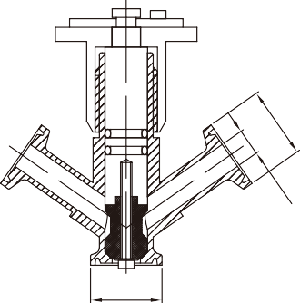

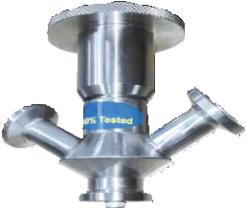
D Type

F Type

Ø25.2

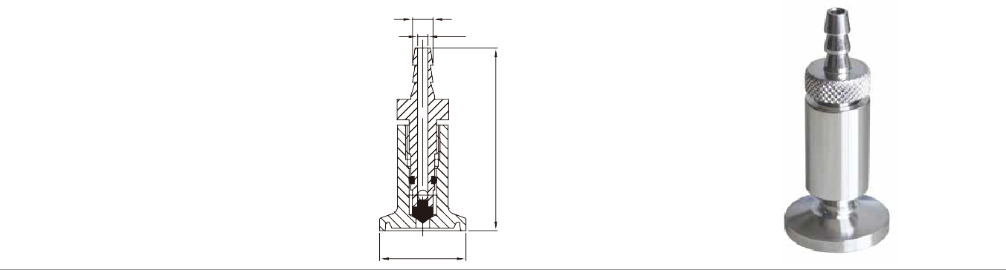
Ø6
Ø4
55

Ø25.2

PLUG VALVE

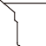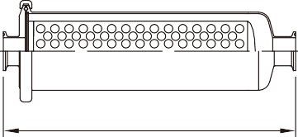E TYPE

A C
L
ØA ØB
C
ØA
ØB
STRAINERS

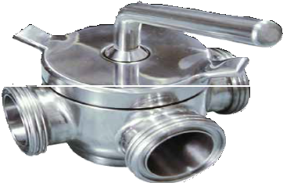
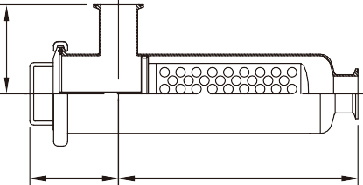INLINE STRAINER SIDE OUTLET STRAINER
L
L1

2WAY & 3WAY-PLUG VALVE FOR WELD / MALE / FEMALE / CLAMP
B
STRAINER INLINE TYPE (I)
SIZE |  | 1" | 11/₂" | 2" | 21/₂" | 3"
øA | in.  mm | 0.870 | 1.370 | 1.870 | 2.370 | 2.870
 |  | 22.1 | 34.8 | 47.5 | 60.2 | 72.9
øB | in.  mm | 1.988 | 1.988 | 2.520 | 3.051 | 3.583
 |  | 50.5 | 50.5 | 64 | 77.5 | 91
øC | in.  mm | 4.000 | 4.000 | 4.000 | 4.000 | 4.000
 |  | 101.6 | 101.6 | 101.6 | 101.6 | 101.6
øD | in.  mm | 4.685 | 4.685 | 4.685 | 4.685 | 4.685
 |  | 119 | 119 | 119 | 119 | 119
L | in.  mm | 14.961 | 14.961 | 14.961 | 17.717 | 21.654
 |  | 380 | 380 | 380 | 450 | 550

STRAINER SIDE OUTLET TYPE (L)
SIZE |  | 1" | 11/₂" | 2" | 21/₂" | 3"
øA | in.  mm | 0.870 | 1.370 | 1.870 | 2.370 | 2.870
 |  | 22.1 | 34.8 | 47.5 | 60.2 | 72.9
øB | in.  mm | 1.988 | 1.988 | 2.520 | 3.051 | 3.583
 |  | 50.5 | 50.5 | 64 | 77.5 | 91
øC | in.  mm | 4.126 | 4.126 | 4.500 | 4.252 | 4.252
 |  | 104.8 | 104.8 | 114.3 | 108 | 108
øD | in.  mm | 4.331 | 4.331 | 4.331 | 4.331 | 4.331
 |  | 110 | 110 | 110 | 110 | 110
L | in.  mm | 12.205 | 12.205 | 12.205 | 16.142 | 19.291
 |  | 310 | 310 | 310 | 410 | 490

SIZE  (TUBE O.D) | WELD A  in. mm |  | MALE  in. A mm |  | CLAMP  in. A mm |  | in. B mm |  | C  in. mm
DN25/1" | 2.610 | 66.3 | 3.752 | 95.3 | 3.736 | 94.9 | 1.024 | 26 | 5.480 | 139.19
DN4011 /2" | 3.350 | 85.1 | 4.650 | 118.1 | 4.476 | 113.7 | 1.378 | 35 | 5.480 | 139.19
DN50/2" | 4.496 | 114.2 | 5.874 | 149.2 | 5.622 | 142.8 | 1.772 | 45 | 5.630 | 143.01
DN65 1/2 | 5.197 | 132 | 6.772 | 172 | 6.323 | 160.6 | 2.165 | 55 | 5.657 | 143.69
DN80/3" | 6.638 | 168.6 | 8.409 | 213.6 | 7.764 | 197.2 | 2.756 | 70 | 5.662 | 143.81
DN100/4" | 8.122 | 206.3 | 10.248 | 260.3 | 9.248 | 234.9 | 2.953 | 75 | 6.859 | 174.21

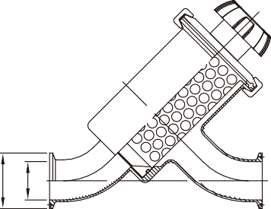A TYPE B
A
L
H
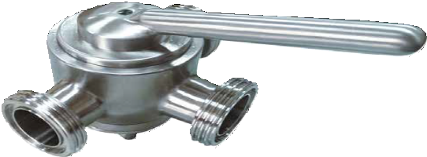

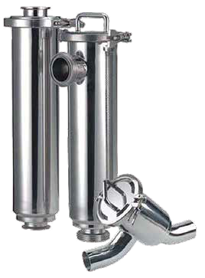
2WAY & 3WAY-PLUG VALVE FOR WELD / MALE / FEMALE / CLAMP
C
ØB ØA
STRAINER Y TYPE
SIZE |  | 1" | 11/₂" | 2" | 21/ ₂" | 3"
øA | in.  mm | 0.870 | 1.370 | 1.870 | 2.370 | 2.870
 |  | 22.1 | 34.8 | 47.5 | 60.2 | 72.9
øB | in.  mm | 1.988 | 1.988 | 2.520 | 3.051 | 3.583
 |  | 50.5 | 50.5 | 64 | 77.5 | 91
L | in.  mm | 6.102 | 7.559 | 8.189 | 9.921 | 11.811
 |  | 155 | 192 | 208 | 252 | 300

SIZE  (TUBE O.D) | WELD A  in. mm |  | CLAMP  in. A mm |  | in. B mm |  | in. C mm |  | H  in. mm
1" | 7.252 | 184.2 | 4.563 | 115.9 | 4.606 | 117 | 2.295 | 58.3 | 5.055 | 128.4
11/₂" | 7.811 | 198.4 | 5.811 | 147.6 | 5.618 | 142.7 | 2.402 | 61 | 6.472 | 164.4
2" | 8.811 | 223.8 | 6.811 | 173 | 5.677 | 144.2 | 2.850 | 72.4 | 7.008 | 178
21/₂" | 10.252 | 260.4 | 8.252 | 209.6 | 5.929 | 150.6 | 3.394 | 86.2 | 8.795 | 223.4
3" | 11.437 | 290.5 | 9.437 | 239.7 | 7.114 | 180.7 | 3.567 | 90.6 | 9.504 | 241.4

TECHNICAL INFORMATION

Optimum Flow Rate and Pipe Size Selection
Ø Sanitary Pipe Size Selection and Optimum Flow Rate
The optimum size pipe for a process pipeline depends on the relationship between the following factors:
Pump capacity Pipe pressure loss
In sanitary piping,the cleanability of the pipeline serves as another important factor.
The following are typical
requirements for implementing suﬃcient cleanability:
The ﬂow velocity must be 0.6m/sec or higher
(to prevent retention of air in the upper portion of the pipe interior). The ﬂow rate must be such that turbulent ﬂow is formed.
Table 1 shows recommended ﬂow rate ranges and other data useful for size selection.

2000
Nominal Pipe size | Sanitary Pipe Volume per meter  ﹝L/m﹞ | Recommended ﬂow rate  range for proess pipeline  ﹝L/h﹞ | Flow rate at pressure  ﹝L/h﹞ |  |  | Flow rate at pressure loss  ﹝0.008kgf/cm2﹞/m per meter﹝L/h﹞
 |  |  | Velocity 0.6m/sec | Velocity 1.0m/sec | Velocity 1.5m/sec
1.0s | 0.415 | 800~2200 | 896 | 1490 | 2241 | 1500
1.5s | 1.00 | 3600~6000 | 2160 | 3600 | 5400 | 6000
2s | 1.80 | 6000~13000 | 3877 | 6460 | 9693 | 12900
11/₂s | 2.78 | 13000~24000 | 6007 | 1000 | 15017 | 24000
3s | 4.11 | 24000~38000 | 8869 | 14800 | 22172 | 38700
31/₂s | 5.69 | 38000~60000 | 12286 | 20500 | 30715 | 60000
4s | 7.48 | 60000~88000 | 16161 | 26900 | 40403 | 88200
41/₂s | 9.21 | 88000~120000 | 19920 | 33200 | 49800 | 120000

1500

1000

500
400
300

200
150

100

50
40
30

TECHNICAL INFORMATION

SI Unit Conversion Table
Pressure | Pa | kPa | MPa | bar | kgf/cm2 | atm | mmH2O | mmHg
 |  |  |  |  |  |  |  | Torr
 | 1 | 1*10 -3 | 1*10-6 | 1*10-5 | 1.01972*10 -5 | 9.86923*10 -6 | 1.01972*10-1 | 7.50062*10 -3
 | 1*103 | 1 | 1*10-3 | 1*10-2 | 1.01972*10 -2 | 9.86923*10 -3 | 1.01972*102 | 7.50062
 | 1*106 | 1*106 | 1 | 1*10 | 1.01972*10 | 9.86923 | 1.01972*105 | 7.50062*10 3
 | 1*105 | 1*102 | 1*10-1 | 1 | 1.01972 | 9.86923*10 -1 | 1.01972*104 | 7.50062*10 2
 | 9.80665*104 | 9.80665*10 | 9.80665*10 -2 | 9.80665*10 -1 | 1 | 9.67841*10 -1 | 1*104 | 7.35559*10 2
 | 1.01325*105 | 1.01325*102 | 1.01325*10 -1 | 1.01325 | 1.03323 | 1 | 1.03323*104 | 7.60000*10 2
 | 9.80665 | 9.80665*10 -3 | 9.80665*10 -6 | 9.80665*10 -5 | 1*10 -4 | 9.67841*10 -5 | 1 | 7.35559*10 -2
 | 1.33322*102 | 1.33322*10 -1 | 1.33322*10 -4 | 1.33322*10 -3 | 1.35951*10 -3 | 1.31579*10 -3 | 1.35951*10 | 1

PS.)1Pa=1N/m2

Force | N | dyn | kgf
 | 1 | 1*10-5 | 1.01972*10 -1
 | 1*10-5 | 1 | 1.01972*10 -6
 | 9.80665 | 9.80665*105 | 1

Viscosity | Pa.s | cP | P
 | 1 | 1*10 3 | 1*10
 | 1*10 -3 | 1 | 1*10 -2
 | 1*10 -1 | 1*10 2 | 1
PS.)1P=1dyn.s/cm2=1g/cm.s , 1Pa.s=1N.S/m2,1cP=1mPa.s

20
0.01

0.02

0.05

0.1

0.2

0.5

1.0
Head(m)

1mmH2 O=9.80665Pa
1627 ﬂexible rubber symbol
PFA Perﬂuoroalkoxy polymer P
Ratings:  A=High suitability B=Normal suitability C=Limited suitability D=Unsuitable  -=Not recommended  Product or Process: | ISO Designation of Abbreviation | NBR Nitrile rubber N | EPDM Ethylene E | Q Silicon rubber Q | VITON Fluorinated rubber F | PTFE/ Polytetraﬂour ethylene P
Abrassive products |  | D | D | D | D | A
Dairy products (milk,cream) |  | B | A | A | - | A
Dairy products (sour milk products) |  | B | A | A | - | A
Brewery products (bear, hops etc.) |  | B | A | C | C | A
Wine and yeast |  | B | A | A | C | A
Aminal and vegetable fats | 100°C | B | D | B | A | A
Water and water solutions | <70°C | B | A | B | B | A
Hot water and steam | <130°C | D | A | C | - | A
Concentrated fruit juices and etheral oils | <100°C | D | D | D | B | A
Non-oxidation acids | <80°C | D | B | D | C | A
Oxidation acids | <80°C | - | B | D | C | A
Weak concentrate of lye | <100°C | C | A | C | C | A
Strong concentrate of lye | <100°C | D | B | D | D | A
Mineral oils | <100°C | B | - | - | A | A
Aliphatic carburetted hydrogen (hexane) |  | B | D | D | A | A
Aromatic carbuetted hydrogen (benzole) |  | D | D | D | B | A
Alcohols |  | C | B | A | A | A
Ester and ketones |  | D | D | D | A | A
Ether |  | D | D | B | A | A
Methylene chloride |  | D | D | B | A | A
Ozyne and almospheric condittions |  | C | A | A | A | A

Friction Head Loss-meter fo pipe

Pipe Run-Length of Fittings(m)
 | 90EL | TEE | TEE | TEE
1" | 0.5 | 1.1 | 1.3 | 0.4
1 1/2" | 0.5 | 2.3 | 2.0 | 0.4
2" | 1.0 | 2.6 | 2.6 | 0.6
2 1/2" | 1.5 | 3.8 | 3.8 | 0.8
3" | 2.0 | 4.0 | 4.5 | 1.2
4" | 1.5 | 6.0 | 6.0 | 1.2

1kPa=103 Pa 1MPa=106Pa

PS.)1Pa=1N/m2,1MPa=1N/mm2
Kineniatic  Viscosity | Pa or N/m2 | MPa or N/mm2 | kgf/mm2 | kgf/cm2
 | 1 | 1*10-6 | 1.01972*10 -7 | 1.01972*10 -5
 | 1*10 6 | 1 | 1.01972*10 -1 | 1.01972*10
 | 9.80665*106 | 9.80665 | 1 | 1*10 2
 | 9.80665*104 | 9.80665*10 -2 | 1*10 -2 | 1

PS.)1St=1cm2/s , 1cSt=1mm2/s
Propylene rubber
Viscosity
Kineniatic | m2/s | cSt | St
 | 1 | 1*10 6 | 1*10 4
 | 1*10-6 | 1 | 1*10 -2
 | 1*10-4 | 1*10 2 | 1

thermal  conductivity | W/(m‧K) | kcal(h‧m‧°C)
 | 1  1.16279 | 8.6000*10 -1  1

Micro-inch Finish
TYPE | mu | um
36 | 142 | 3.61
60 | 87 | 2.21
80 | 71 | 1.80
120 | 52 | 1.32
180 | 30 | 0.76
240 | 15 | 0.38
320 | 12 | 0.31

PS.)1cal=4.186 05J

coeﬃcient on  heat transfer | W/(m2‧K) | kcal(h‧m2‧°C)
 | 1  1.16279 | 8.6000*10 -1  1
PS.)1cal=4.186 05J
capacity

speciﬁc heat | J/(kg‧K) | kcal(h‧m2‧°C)
 | 1  4.18605*10 3 | 2.38889*10 -4  1
PS.)1cal=4.186 05J

PS.)1W=1J/S
power | W/(m‧K) | kcal(h‧m‧°C) | PS | kcal/h
 | 1 | 1.01972*10 -1 | 1.35962*10 -3 | 8.6000*10 -1
 | 9.80665 | 1 | 1.33333*10 -2 | 8.43371
 | 7.355*10 2 | 7.5*10 | 1 | 6.32529*102
 | 1.16279 | 1.18572*10 -1 | 1.58095*10 -3 | 1

1PS=0.735kW
1cal=4.186 05J

work,energy | J | kW‧h | kgf‧m | kcal/h
 | 1 | 2.77778*10 -7 | 1.01972*10 -1 | 2.38889*10 -4
 | 3.600*10 6 | 1 | 3.67098*10 5 | 8.6000*102
 | 9.80665 | 2.72407*10 -6 | 1 | 2.34270*10 -3
 | 4.18605*10 3 | 1.16279*10 -3 | 4.26858*10 2 | 1
PS.)1J=1W‧1J=1N‧m 1cal=4.186 05J

TECHNICAL INFORMATION

SERVICE PRESSURE RATINGS (PSI)
SIZE  Product | 1/2" | A37 DN10 | 1"~11/2" DN25 | 2" DN50 | 21/2" DN65 | 3" DN80 | 4" DN100 | DN115 | DN125 | 6" DN150 | 8" DN200 | 10" DN250 | 12" DN300
13MHH-Heavy Duty Single Pin Clamp
70F/21°C | 1500 |  | 500 | 150 | 400 | 350 | 200 |  |  | 200 | 180
250F/121°C | 1200 |  | 250 | 250 | 200 | 150 | 125 |  |  | 125 | 100
13MHHM-Heavy Duty Double Pin Clamp
70F/21°C | 1500 | 1200 | 500 | 150 | 400 | 350 | 200 |  |  | 150 | 100
250F/121°C | 1200 | 900 | 250 | 250 | 200 | 150 | 125 |  |  | 75 | 50
13MHP-High Pressure Clamp With Screw Bolt Brass Nut

PNEUMATIC DIVERT VALVE
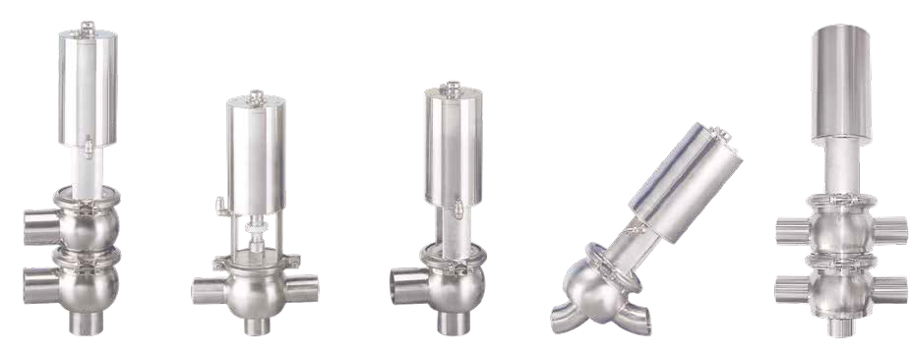

70F/21°C | 2000 |  | 1500 | 1000 | 1000 | 1000 | 1000 |  |  | 300 |  | 200 | 200
250F/121°C | 1500 |  | 1200 | 800 | 800 | 800 | 800 |  |  | 200 |  | 100 | 100

F T L Y T/T

13MHHS-3 Segments Clamp
70F/21°C |  |  | 600 | 550 | 450 | 350 | 350
250F/121°C |  |  | 300 | 275 | 225 | 175 | 150

13CS-Double Pin With Link Clamp
70F/21°C | 1500 | 1200 | 500 | 450 | 400 | 350 | 300 | 250 | 250 | 200 | 200 | 100 | 100
250F/121°C | 1200 | 900 | 300 | 250 | 200 | 150 | 120 | 100 | 100 | 75 | 50 | 30 | 20

13IS & 13IU SERVICE PRESSURE RATING
SIZE | SERVICE PRESSURE RATING AT 70°F*
1"~ 11/2" | 700PSI | 250PSI
2" | 450PSI | 250PSI
21/2" | 450PSI | 200PSI
3" | 350PSI | 150PSI
4" | 200PSI | 125PSI
6" | 150PSI | 100PSI
*Wing nuts tightened to 25 inch 1bs of torque.

1 psi=0.07kg/cm 2
1 psi=6.895kPa
1 bar=14.503psi
Operating Instructions
- The CSE pneumatic valve can be assembled with diﬀerent types of ﬂow designs , (as drawing A) to get various ﬂow control.
- You can choose SMS, DIN, IDF, RJT, 3A, Ferrule....., Welding; Clamp; Unions......connect end.
- Material:
3-1. All products being used with ﬂuid are made of stainless steel AISI 316/316L(1.4401/1.4571).
3-2. The other parts in AISI 304 (1.4301).
3-3. The valve stem is sealed by a FDA EPDM/Silicone/Viton seat and according international standard for use on food or pharmaceutical.
- Operating air pressure: 5bar-8bar compressed air.
- Control ways:
  - Designed to control diﬀerent types of various ﬂow, as type L; T; F...etc.
  - Choose appropriate dimensions of end, as 2".......clamp or welding.
  - Choose appropriate control ways (manual or pneumatic):
c-1. Manual control valve are equipped with a rapid pitch screw for protection against unscrewing.
c-2. Choose air/spring(simple eﬀect); or air/air (double eﬀect) for pneumatic control.
c-3. You can use CSE automatic control box to get signal transfer and complete individual valve control. c-3-1. Signal transfer:
    - with 10-30VDC proximity switch contact:1 or 2pcs (PNP OR NPN)
    - Or 3A 125VAC,30VDC micro switch contact: 2pcs c-3-2. Complete individual valve control:
Choose (a) or (b) +DC24 3.0W electric valve:1pc & air maniﬂod (for complete control box).

Range of Check valve:
- Make sure the valve is in correct ﬂow position.
- Be sure the valve surface is clean.
- Open to clean inner valve; do not loose all of gasket and spring.
- Please tighten up the valve clamp when the valve is used on pipe line.
- Be sure to check the stem gasket or change gasket on schedule to avoid leaking.

NOTICE:
  - PRECAUTION BEFORE USING:
    - Please always stock check valve in a dry and safe area.
    - Handle with care to avoid the surface of the screw of the check valve from damage.
  - ASSEMBLY ON THE PIPE LINE:
- Weld end:
  - Please disassemble all of weld ﬂange for weld jobs to avoid damage the gasket.
  - When you try re-assembly please clean all of inner surface.
  - Please tigthen all screw bolts and clamp.
- Clamp end & Male end
  - Please re-check the correct size clamp(ferrule) or thread on valve.
  - Please re-check correct clamp(ferrule)/thread on connect piece.
  - Need to tighten valve with connect piece or clamp-ring.
  - OPEN PRESSURE:

Valve Size | 1/2" | 3/4" | 1" | 1 1/₂" | 2" | 2 1/₂" | 3" | 4"
Pressure(PSI) | 0.5 | 0.5 | 3.0 | 1.6 | 0.6 | 1.3 | 0.8 | 0.9

Special note of Check valve:
Body & Stem & Disk: 304,316,316L.Full Precision Machined. Angle Design For Precision Open and Closed.
And Can be Use On level/vertical, and Sticky Liquid. Spring: Stainless Steel Material Sanitary Both End Design. O-ring & Seal Ring: EPDM,SILICON and Vition Material.
PTFE Can be Required (Need Min Q,ty)
Complete Valve: Open By 0.45bar.Max Work 10bar.
Design Can be Use On Food, Pharmaceutical and I.C Industry.
Valve connector end: 3A,BS,SMS,DIN Weld end, Male end, Clamp End.
Middle ﬂange: Can be choice clamp design or 4 screw bolt ﬂange design.

Sanitary Butterﬂy Valve:

Instructions:
- The butterﬂy valves are designed using for diﬀerent standards and low torque. And the valve can use for diﬀerent handle or actuator.(as actuator manual)
- Make sure the valve is set in correct position on or oﬀ
- The screws on the body must be locked.
- Need to check the valve on-oﬀ in the correct position need to check the on-oﬀ position of the valve.
- The handle which connecting with the valve is not tight.
- Need to keep the valve surface clean and to prevent it being damaged by strong acid
- Disassemble the valve for cleaning inner parts and surface from all screws and gasket.
- Screws loose or bolt shorted on valves will not allow valve to work properly.
- Make sure to check gasket (depends on type of operation) or to replace with a new gasket on schedule to avoid leaking.

Notice:
  - PRECAUTION BEFORE USING:
    - Please keep butterﬂy valve dry and always in a safe area.
    - Stocking in right location avoids handle and the butterﬂy valve damage.
  - CLEAN MODLE:
The butterﬂy valve can only be cleaned in mannal position.
  - ASSEMBLY ON THE PIPE LINE:
    - Weld end:
      - Please disassemble the weld ﬂanges for welding to avoid the gasket damaged.
      - Please clean all inner surface while assembling after welding.
      - Please make sure to tighten all screws and bolts.
      - Please turn on-oﬀ position a few times to make sure it works smoothly.
    - Clamp end & Screw end:
      - Please re-check the correct size clamp (ferrule) or thread on valve.
      - Please re-check correct clamp (ferrule) / thread on the piece that are going to be connected.
      - Need to tighten up valve with connecting piece or clamp-ring.
  - ASSEMBLY OF A DIFFERENT HANDLE:
- Please check the dimension of disk to assemble the correct handle
- Please check handle on-oﬀ in correct position after assembling the valve
  - WORK TEMPERATURE & PRESSURE:
- Work pressure for valve: -0.9bar~10bar on water temperature 20°C
- Work temperature(water):-50°C~210°C depend on Rubber seat:
Silicon: -50°C~210°C, EPDM: -40°C~110°C, Viton: -10°C~210°C

Torque for full open/close(SIZE) | 1" | 11/₂" | 2" | 21/₂" | 3" | 4"
H/M | <13 | <13 | <16 | <18 | <23 | <34

Special note of CSE Butterﬂy valve:
Body: SS304, 316, 316L Material made from precision CNC milling machined
Body connection can be changed and lower torque is available (Standards: BS,
SMS, DIN, 3A, Weld and Male end, Clamp end……ect.
Disk: Out from full machined & high level polished, the surface is less than Ra 0.6μm Disk assembling with the handle or actuator is square 9.5mm or 8 × 12mm or 12 × 12mm, Connection part is meeting USA and Europe requirement
(Electric polished and PTFE coating can be required)
Handle: Diﬀerent Nylon re-force and stainless steel handle in gripper, pull, press type.
From 2 Position up to 12 position, design for your width range and maximum options

Range of Diaphragm-Type Valve:

Diaphragm valve Aspect design:
- Control mode: Manual Type & Pneumatic Type
- Connection Type: Clamp & Weld
- Body Material: 316L, Forged, Or Casting
- Connection: INCH :1/2”~2”, DIN/ISO: DN10-DN50 other sizes available upon request.
- Work temp: Assembling Diaphragm: EPDM (-40°~150°C), PTFE/EPDM(-10°~150°C)
- Work pressure: MAX 10 Bar
- Surface: Standard: OD/ID mirror polished. ID Ra<0.5μm OD-Sand Blasted or E/P
ID-Polish to Ra<0.5μm(SF1) or E/P Finished Ra,0.38μm(SF4) can be requested.
- Clean model: CIP & Manual.

NOTICE:
- Make sure the valve is in the correct position on or oﬀ.
- Opening for cleaning in manual & CIP, Note: DO NOT loose seal /bolts.
- All bolts must be tightened for good operation.
- Be sure when checking the seal to change the seal when product leakage is detected.

Compression Valve Ranges:
- Pneumatic valve can be equipped with diﬀerent types of ﬂow design,(as drawing A)
- Can choose SMS, DIN, IDF, RJT, 3A, Ferrule......, Welding; Clamp; Unions.........connect end.
- Material:
3-1. All products being used with ﬂuid are made of stainless steel
AISI 316/316L(1.4401/1.4571).
3-2. The other parts in AISI 304 (1.4301).
3-3. The valve stem is sealed by a special PTFE/EPDM/Silicon/Viton seat and
according to international standard to use in food or pharmaceutical applications.
- Operating air pressure: 5bar-9bar compressed air.
- Control ways:
  - Designed diﬀerent type to control various ﬂow, as type F; T; L...etc.
  - Choose appropriate dimensions of end, as 2".......clamp or welding.
  - Choose appropriate control ways (manual or pneumatic):
c-1. Manual control valve are equipped with a rapid pitch screw to prevent unscrewing. c-2. Or choose air/spring(simple eﬀect); or air/air (double eﬀect) for pneumatic control.
c-3. Can use CSE automatic control box to get signal transfer and complete individual valve control. c-3-1. Signal transfer:
    - with 10-30VDC proximity switch contact:1 or 2pcs (PNP OR NPN).
    - Or 3A 125VAC,30VDC micro switch contact: 2pcs. c-3-2. Complete individual valve control:
Choose (a) or (b) +DC24 3.0W electric valve:1pc & air manifold
(for complete control box).

BPE FITTINGS

(DT7) DT-4.1.1-1
90° WELDING LONG ELBOW
SIZE | øD  in. mm |  | L  in. mm |  | T  in. mm
1/2" | 0.500 | 12.7 | 3.000 | 76.2 | 0.065 | 1.65
3/4" | 0.750 | 19.05 | 3.000 | 76.2 | 0.065 | 1.65
1" | 1.000 | 25.4 | 3.000 | 76.2 | 0.065 | 1.65
11/2" | 1.500 | 38.1 | 3.750 | 95.3 | 0.065 | 1.65
2" | 2.000 | 50.8 | 4.750 | 120.7 | 0.065 | 1.65
21/2" | 2.500 | 63.5 | 5.500 | 139.7 | 0.065 | 1.65
3" | 3.000 | 76.2 | 6.250 | 158.8 | 0.065 | 1.65
4" | 4.000 | 101.6 | 8.000 | 203.2 | 0.083 | 2.1
6" | 6.000 | 152.4 | 11.500 | 203.2 | 0.109 | 2.77

(DT8) DT-4.1.1-4
45° WELDING LONG ELBOW
SIZE | øD  in. mm |  | L  in. mm |  | T  in. mm
1/2" | 0.500 | 12.7 | 2.252 | 57.2 | 0.065 | 1.65
3/4" | 0.750 | 19.05 | 2.252 | 57.2 | 0.065 | 1.65
1" | 1.000 | 25.4 | 2.252 | 57.2 | 0.065 | 1.65
11/2" | 1.500 | 38.1 | 2.500 | 63.5 | 0.065 | 1.65
2" | 2.000 | 50.8 | 3.000 | 76.2 | 0.065 | 1.65
21/2" | 2.500 | 63.5 | 3.374 | 85.7 | 0.065 | 1.65
3" | 3.000 | 76.2 | 3.626 | 92.1 | 0.065 | 1.65
4" | 4.000 | 101.6 | 4.500 | 114.3 | 0.083 | 2.1
6" | 6.000 | 152.4 | 6.250 | 158.8 | 0.109 | 2.77

(DT13) DT-4.1.1-5
45° CLAMP/WELD ELBOW
SIZE | øD  in. mm |  | L  in. mm |  | L1  in. mm |  | T  in. mm
1/2" | 0.500 | 12.7 | 2.252 | 57.2 | 1.000 | 25.4 | 0.065 | 1.65
3/4" | 0.750 | 19.05 | 2.252 | 57.2 | 1.000 | 25.4 | 0.065 | 1.65
1" | 1.000 | 25.4 | 2.252 | 57.2 | 1.125 | 28.6 | 0.065 | 1.65
11/2" | 1.500 | 38.1 | 2.500 | 63.5 | 1.438 | 36.5 | 0.065 | 1.65
2" | 2.000 | 50.8 | 3.000 | 76.2 | 1.750 | 44.5 | 0.065 | 1.65
21/2" | 2.500 | 63.5 | 3.374 | 85.7 | 2.063 | 52.4 | 0.065 | 1.65
3" | 3.000 | 76.2 | 3.626 | 92.1 | 2.375 | 60.3 | 0.065 | 1.65
4" | 4.000 | 101.6 | 4.500 | 114.3 | 3.125 | 79.4 | 0.083 | 2.1
6" | 6.000 | 152.4 | 6.250 | 158.8 | 5.250 | 133.4 | 0.109 | 2.77

(DT17) DT-4.1.1-6
45° CLAMP ELBOW
SIZE | øD  in. mm |  | øD1  in. mm |  | L  in. mm |  | T  in. mm
1/2" | 0.500 | 12.7 | 0.984 | 25 | 1.000 | 25.4 | 0.065 | 1.65
3/4" | 0.750 | 19.05 | 0.984 | 25 | 1.000 | 25.4 | 0.065 | 1.65
1" | 1.000 | 25.4 | 1.339/1.984 | 34/50.4 | 1.125 | 28.6 | 0.065 | 1.65
11/2" | 1.500 | 38.1 | 1.984 | 50.4 | 1.438 | 36.5 | 0.065 | 1.65
2" | 2.000 | 50.8 | 2.516 | 63.9 | 1.750 | 44.5 | 0.065 | 1.65
21/2" | 2.500 | 63.5 | 3.047 | 77.4 | 2.063 | 52.4 | 0.065 | 1.65
3" | 3.000 | 76.2 | 3.579 | 90.9 | 2.375 | 60.3 | 0.065 | 1.65
4" | 4.000 | 101.6 | 4.681 | 118.9 | 3.125 | 79.4 | 0.083 | 2.1
6" | 6.000 | 152.4 | 6.571 | 146.86 | 5.250 | 133.4 | 0.109 | 2.77

T
L
ØD

T
L
ØD

T
L
ØD

T
L
ØD
ØD1

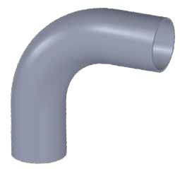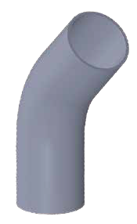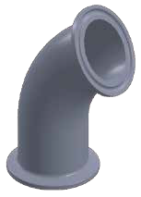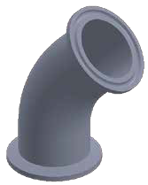

55 56

(DT12) DT-4.1.1-2
90° CLAMP/WELD ELBOW
L
L1
T
ØD
ØD1
SIZE | øD  in. mm |  | øD1  in. mm |  | L  in. mm |  | L1  in. mm |  | T  in. mm
1/2" | 0.500 | 12.7 | 0.984 | 25 | 1.626 | 41.3 | 3.000 | 76.2 | 0.065 | 1.65
3/4" | 0.750 | 19.05 | 0.984 | 25 | 1.626 | 41.3 | 3.000 | 76.2 | 0.065 | 1.65
1" | 1.000 | 25.4 | 1.339/1.984 | 34/50.4 | 2.000 | 50.8 | 3.000 | 76.2 | 0.065 | 1.65
11/2" | 1.500 | 38.1 | 1.984 | 50.4 | 2.752 | 69.9 | 3.752 | 95.3 | 0.065 | 1.65
2" | 2.000 | 50.8 | 2.516 | 63.9 | 3.500 | 88.9 | 4.752 | 120.7 | 0.065 | 1.65
21/2" | 2.500 | 63.5 | 3.047 | 77.4 | 4.252 | 108 | 5.500 | 139.7 | 0.065 | 1.65
3" | 3.000 | 76.2 | 3.579 | 90.9 | 5.000 | 127 | 6.252 | 158.8 | 0.065 | 1.65
4" | 4.000 | 101.6 | 4.681 | 118.9 | 6.626 | 168.3 | 8.000 | 203.2 | 0.083 | 2.1
6" | 6.000 | 152.4 | 6.571 | 166.9 | 10.500 | 266.7 | 11.500 | 292.1 | 0.109 | 2.77

(DT9) DT-4.1.2-1T
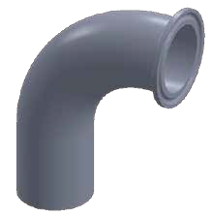
WELDING TEE
SIZE | øD  in. mm |  | L  in. mm |  | L1  in. mm |  | T  in. mm
1/2" | 0.500 | 12.7 | 3.750 | 95.2 | 1.875 | 47.6 | 0.065 | 1.65
3/4" | 0.750 | 19.05 | 4.000 | 101.6 | 2.000 | 50.8 | 0.065 | 1.65
1" | 1.000 | 25.4 | 4.250 | 108 | 2.125 | 54 | 0.065 | 1.65
11/2" | 1.500 | 38.1 | 4.750 | 120.6 | 2.375 | 60.3 | 0.065 | 1.65
2" | 2.000 | 50.8 | 5.748 | 146 | 2.875 | 73 | 0.065 | 1.65
21/2" | 2.500 | 63.5 | 6.250 | 158.8 | 3.125 | 97.4 | 0.065 | 1.65
3" | 3.000 | 76.2 | 6.750 | 171.4 | 3.375 | 85.7 | 0.065 | 1.65
4" | 4.000 | 101.6 | 8.250 | 209.6 | 4.125 | 104.8 | 0.083 | 2.1
6" | 6.000 | 152.4 | 11.250 | 285.8 | 5.625 | 142.9 | 0.109 | 2.77

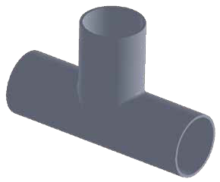 ØD
T
L1

L

(DT16) DT-4.1.4-3
90° CLAMP ELBOW

(DT15) DT-4.1.2-2
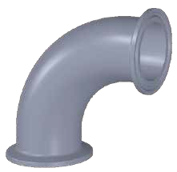
EQUAL OUTLET WELD/CLAMP TEE

ØD1
ØD
T

T

ØD
ØD1
L
L1
SIZE | øD  in. mm |  | øD1  in. mm |  | L  in. mm |  | T  in. mm
1/2" | 0.500 | 12.7 | 0.984 | 25 | 1.626 | 41.3 | 0.065 | 1.65
3/4" | 0.750 | 19.05 | 0.984 | 25 | 1.626 | 41.3 | 0.065 | 1.65
1" | 1.000 | 25.4 | 1.339/1.984 | 34/50.4 | 2.000 | 50.8 | 0.065 | 1.65
11/2" | 1.500 | 38.1 | 1.984 | 50.4 | 2.752 | 69.9 | 0.065 | 1.65
2" | 2.000 | 50.8 | 2.516 | 63.9 | 3.500 | 88.9 | 0.065 | 1.65
21/2" | 2.500 | 63.5 | 3.047 | 77.4 | 4.252 | 108 | 0.065 | 1.65
3" | 3.000 | 76.2 | 3.579 | 90.9 | 5.000 | 127 | 0.065 | 1.65
4" | 4.000 | 101.6 | 4.681 | 118.9 | 6.626 | 168.3 | 0.083 | 2.1
6" | 6.000 | 152.4 | 6.571 | 166.9 | 10.500 | 266.7 | 0.109 | 2.77

(DT23) DT-4.1.1-7
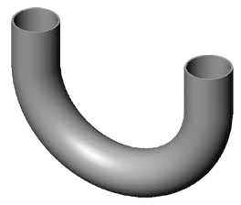
180° WELD ELBOW
SIZE | øD  in. mm |  | L  in. mm |  | L1  in. mm |  | T  in. mm
1/2" | 0.500 | 12.7 | 3.000 | 76.2 | 4.500 | 114.3 | 0.065 | 1.65
3/4" | 0.750 | 19.05 | 3.000 | 76.2 | 4.500 | 144.3 | 0.065 | 1.65
1" | 1.000 | 25.4 | 3.000 | 76.2 | 3.000 | 76.2 | 0.065 | 1.65
11/2" | 1.500 | 38.1 | 4.500 | 114.3 | 3.000 | 76.2 | 0.065 | 1.65
2" | 2.000 | 50.8 | 5.000 | 127 | 6.000 | 152.4 | 0.065 | 1.65
21/2" | 2.500 | 63.5 | 5.752 | 146.1 | 7.500 | 190.5 | 0.065 | 1.65
3" | 3.000 | 76.2 | 6.500 | 165.1 | 9.000 | 228.6 | 0.065 | 1.65
4" | 4.000 | 101.6 | 8.500 | 215.9 | 12.000 | 304.8 | 0.083 | 2.1
6" | 6.000 | 152.4 | 11.500 | 292.1 | 18.000 | 457.2 | 0.109 | 2.77

ØD
T
L1
L

(DT24) DT-4.1.1-8
ØD1
ØD T
L1
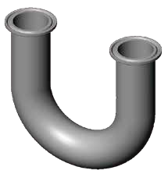
180° CLAMP ELBOW

L L1
L
L
T
ØD
ØD1

L

(DT18) DT-4.1.2-4T
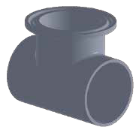
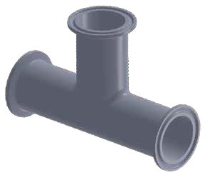 CLAMP TEE
ØD1
ØD

T
L
L1
SIZE | øD  in. mm |  | øD1  in. mm |  | L  in. mm |  | L1  in. mm |  | T  in. mm
1/2" | 0.500 | 12.7 | 0.984 | 25 | 3.750 | 95.2 | 1.000 | 25.4 | 0.065 | 1.65
3/4" | 0.750 | 19.05 | 0.984 | 25 | 4.000 | 101.6 | 1.125 | 28.6 | 0.065 | 1.65
1" | 1.000 | 25.4 | 1.339/1.984 | 34/50.4 | 4.250 | 108 | 1.125 | 28.6 | 0.065 | 1.65
11/2" | 1.500 | 38.1 | 1.984 | 50.4 | 4.750 | 120.6 | 1.375 | 34.9 | 0.065 | 1.65
2" | 2.000 | 50.8 | 2.516 | 63.9 | 5.270 | 146 | 1.625 | 41.3 | 0.065 | 1.65
21/2" | 2.500 | 63.5 | 3.047 | 77.4 | 6.250 | 158.8 | 1.875 | 47.6 | 0.065 | 1.65
3" | 3.000 | 76.2 | 3.579 | 90.9 | 6.750 | 171.4 | 2.125 | 54 | 0.065 | 1.65
4" | 4.000 | 101.6 | 4.681 | 118.9 | 8.250 | 209.6 | 2.750 | 69.9 | 0.083 | 2.1

SIZE | øD  in. mm |  | øD1  in. mm |  | L  in. mm |  | L1  in. mm |  | T  in. mm
1/2" | 0.500 | 12.7 | 0.984 | 25 | 4.500 | 114.4 | 4.500 | 57.2 | 0.065 | 1.65
3/4" | 0.750 | 19.05 | 0.984 | 25 | 4.750 | 120.6 | 4.750 | 60.3 | 0.065 | 1.65
1" | 1.000 | 25.4 | 1.339/1.984 | 34/50.4 | 5.250 | 133.4 | 5.250 | 66.7 | 0.065 | 1.65
11/2" | 1.500 | 38.1 | 1.984 | 50.4 | 5.750 | 146 | 5.750 | 73 | 0.065 | 1.65
2" | 2.000 | 50.8 | 2.516 | 63.9 | 6.750 | 171.4 | 6.750 | 85.7 | 0.065 | 1.65
21/2" | 2.500 | 63.5 | 3.047 | 77.4 | 7.250 | 182.2 | 7.250 | 92.1 | 0.065 | 1.65
3" | 3.000 | 76.2 | 3.579 | 90.9 | 7.750 | 196.8 | 7.750 | 98.4 | 0.065 | 1.65
4" | 4.000 | 101.6 | 4.681 | 118.9 | 9.500 | 241.4 | 9.500 | 120.7 | 0.083 | 2.1

(DT25) DT-4.1.2-3
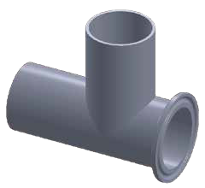
SHORT OUTLET RUN WELD/CLAMP TEE
SIZE | øD  in. mm |  | øD1  in. mm |  | L  in. mm |  | L1  in. mm |  | T  in. mm
1/2" | 0.500 | 12.7 | 0.984 | 25 | 1.875 | 47.6 | 0.87 | 22.2 | 0.065 | 1.65
3/4" | 0.750 | 19.05 | 0.984 | 25 | 2.000 | 50.8 | 1.000 | 25.4 | 0.065 | 1.65
1" | 1.000 | 25.4 | 1.339/1.984 | 34/50.4 | 2.125 | 54 | 1.125 | 28.6 | 0.065 | 1.65
11/2" | 1.500 | 38.1 | 1.984 | 50.4 | 2.375 | 60.3 | 1.375 | 34.9 | 0.065 | 1.65
2" | 2.000 | 50.8 | 2.516 | 63.9 | 2.875 | 73 | 1.625 | 41.3 | 0.065 | 1.65
21/2" | 2.500 | 63.5 | 3.047 | 77.4 | 3.125 | 79.4 | 1.875 | 47.6 | 0.065 | 1.65
3" | 3.000 | 76.2 | 3.579 | 90.9 | 3.375 | 85.7 | 2.125 | 54 | 0.065 | 1.65
4" | 4.000 | 101.6 | 4.681 | 118.9 | 4.125 | 104.8 | 2.750 | 69.9 | 0.083 | 2.1
6" | 6.000 | 152.4 | 6.571 | 166.9 | 5.625 | 142.9 | 4.625 | 117.5 | 0.109 | 2.77

SIZE | øD  in. mm |  | øD1  in. mm |  | L  in. mm |  | L1  in. mm |  | T  in. mm
1/2" | 0.500 | 12.7 | 0.984 | 25 | 3.500 | 88.9 | 4.500 | 114.3 | 0.065 | 1.65
3/4" | 0.750 | 19.05 | 0.984 | 25 | 3.500 | 88.9 | 4.500 | 144.3 | 0.065 | 1.65
1" | 1.000 | 25.4 | 1.339/1.984 | 34/50.4 | 3.500 | 88.9 | 3.000 | 76.2 | 0.065 | 1.65
11/2" | 1.500 | 38.1 | 1.984 | 50.4 | 5.000 | 127 | 3.000 | 76.2 | 0.065 | 1.65
2" | 2.000 | 50.8 | 2.516 | 63.9 | 5.000 | 139.7 | 6.000 | 152.4 | 0.065 | 1.65
21/2" | 2.500 | 63.5 | 3.047 | 77.4 | 6.252 | 158.8 | 7.500 | 190.5 | 0.065 | 1.65
3" | 3.000 | 76.2 | 3.579 | 90.9 | 7.000 | 177.8 | 9.000 | 228.6 | 0.065 | 1.65
4" | 4.000 | 101.6 | 4.681 | 118.9 | 9.126 | 231.8 | 12.000 | 304.8 | 0.083 | 2.1
6" | 6.000 | 152.4 | 6.571 | 166.9 | 13.000 | 330.2 | 18.000 | 457.2 | 0.109 | 2.77

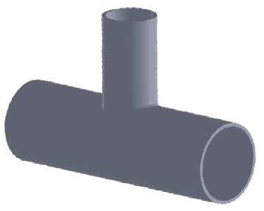
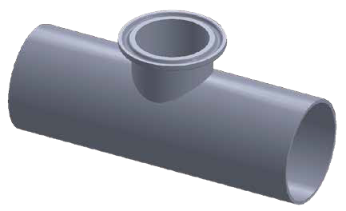
Ød
Ød1 Ød

t
L
t
ØD
T
L1
T
L1

L
ØD

(DT10) DT-4.1.2-6
REDUCING TEE

(DT14) DT-4.1.2-7
SHORT OUTLET W/C REDUCING TEE

SIZE | øD  in. mm |  | ød  in. mm |  | L  in. mm |  | L1  in. mm |  | T  in. mm |  | t  in. mm
3/4"*1/2" | 0.750 | 19.05 | 0.500 | 12.7 | 4.000 | 101.6 | 2.000 | 50.8 | 0.065 | 1.65 | 0.065 | 1.65
1"*1/2" | 1.000 | 25.4 | 0.500 | 12.7 | 4.250 | 108 | 2.126 | 54 | 0.065 | 1.65 | 0.065 | 1.65
1"*3/4" | 1.000 | 25.4 | 0.750 | 19.05 | 4.250 | 108 | 2.126 | 54 | 0.065 | 1.65 | 0.065 | 1.65
1 1/2"*1/2" | 1.500 | 38.1 | 0.500 | 12.7 | 4.748 | 120.6 | 2.374 | 60.3 | 0.065 | 1.65 | 0.065 | 1.65
1 1/2"*3/4" | 1.500 | 38.1 | 0.750 | 19.05 | 4.748 | 120.6 | 2.374 | 60.3 | 0.065 | 1.65 | 0.065 | 1.65
1 1/2"*1" | 1.500 | 38.1 | 1.000 | 25.4 | 4.748 | 120.6 | 2.374 | 60.3 | 0.065 | 1.65 | 0.065 | 1.65
2"*1/2" | 2.000 | 50.8 | 0.500 | 12.7 | 5.740 | 145.8 | 2.626 | 66.7 | 0.065 | 1.65 | 0.065 | 1.65
2"*3/4" | 2.000 | 50.8 | 0.750 | 19.05 | 5.740 | 145.8 | 2.626 | 66.7 | 0.065 | 1.65 | 0.065 | 1.65
2"*1" | 2.000 | 50.8 | 1.000 | 25.4 | 5.740 | 145.8 | 2.626 | 66.7 | 0.065 | 1.65 | 0.065 | 1.65
2"*11/2" | 2.000 | 50.8 | 1.500 | 38.1 | 6.252 | 158.8 | 2.784 | 73 | 0.065 | 1.65 | 0.065 | 1.65
2 1/2"*1/2" | 2.500 | 63.5 | 0.500 | 12.7 | 6.252 | 158.8 | 2.874 | 73 | 0.065 | 1.65 | 0.065 | 1.65
2 1/2"*3/4" | 2.500 | 63.5 | 0.750 | 19.05 | 6.252 | 158.8 | 2.874 | 73 | 0.065 | 1.65 | 0.065 | 1.65
2 1/2"*1" | 2.500 | 63.5 | 1.000 | 25.4 | 6.252 | 158.8 | 2.874 | 73 | 0.065 | 1.65 | 0.065 | 1.65
2 1/₂"*11 /₂" | 2.500 | 63.5 | 1.500 | 38.1 | 6.252 | 158.8 | 2.874 | 73 | 0.065 | 1.65 | 0.065 | 1.65
2 1/2"*2" | 2.500 | 63.5 | 2.000 | 50.8 | 6.252 | 158.8 | 2.874 | 73 | 0.065 | 1.65 | 0.065 | 1.65
3"*1/2" | 3.000 | 76.2 | 0.500 | 12.7 | 6.740 | 171.2 | 3.126 | 79.4 | 0.065 | 1.65 | 0.065 | 1.65
3"*3/4" | 3.000 | 76.2 | 0.750 | 19.05 | 6.740 | 171.2 | 3.126 | 79.4 | 0.065 | 1.65 | 0.065 | 1.65
3"*1" | 3.000 | 76.2 | 1.000 | 25.4 | 6.740 | 171.2 | 3.126 | 79.4 | 0.065 | 1.65 | 0.065 | 1.65
3"*11/₂" | 3.000 | 76.2 | 1.500 | 38.1 | 6.740 | 171.2 | 3.126 | 79.4 | 0.065 | 1.65 | 0.065 | 1.65
3"*2" | 3.000 | 76.2 | 2.000 | 50.8 | 6.740 | 171.2 | 3.126 | 79.4 | 0.065 | 1.65 | 0.065 | 1.65
3"*21/₂" | 3.000 | 76.2 | 2.500 | 63.5 | 6.740 | 171.2 | 3.126 | 79.4 | 0.065 | 1.65 | 0.065 | 1.65
4"*1" | 4.000 | 101.6 | 1.000 | 25.4 | 8.240 | 209.3 | 3.626 | 92.1 | 0.083 | 2.1 | 0.065 | 1.65
4"*11/₂" | 4.000 | 101.6 | 1.500 | 38.1 | 8.240 | 209.3 | 3.626 | 92.1 | 0.083 | 2.1 | 0.065 | 1.65
4"*2" | 4.000 | 101.6 | 2.000 | 50.8 | 8.240 | 209.3 | 3.874 | 98.4 | 0.083 | 2.1 | 0.065 | 1.65
4"*21/₂" | 4.000 | 101.6 | 2.500 | 63.5 | 8.240 | 209.3 | 3.874 | 98.4 | 0.083 | 2.1 | 0.065 | 1.65
4"*3" | 4.000 | 101.6 | 3.000 | 76.2 | 8.240 | 209.3 | 3.874 | 98.4 | 0.083 | 2.1 | 0.065 | 1.65

SIZE | øD  in. mm |  | ød  in. mm |  | ød1  in. mm |  | L  in. mm |  | L1  in. mm |  | T  in. mm |  | t  in. mm
3/4"*1/2" | 0.750 | 19.05 | 0.500 | 12.7 | 0.984 | 25 | 4.00 | 101.6 | 1.000 | 25.4 | 0.065 | 1.65 | 0.065 | 1.65
1"*1/2" | 1.000 | 25.4 | 0.500 | 12.7 | 0.984 | 25 | 4.252 | 108 | 1.125 | 28.6 | 0.065 | 1.65 | 0.065 | 1.65
1"*3/4" | 1.000 | 25.4 | 0.750 | 19.05 | 0.984 | 25 | 4.252 | 108 | 1.125 | 28.6 | 0.065 | 1.65 | 0.065 | 1.65
1 1/2"*1/2" | 1.500 | 38.1 | 0.500 | 12.7 | 0.984 | 25 | 4.748 | 120.6 | 1.375 | 34.9 | 0.065 | 1.65 | 0.065 | 1.65
1 1/2"*3/4" | 1.500 | 38.1 | 0.750 | 19.05 | 0.984 | 25 | 4.748 | 120.6 | 1.375 | 34.9 | 0.065 | 1.65 | 0.065 | 1.65
1 1/2"*1" | 1.500 | 38.1 | 1.000 | 25.4 | 1.339/1.984 | 34/50.4 | 4.748 | 120.6 | 1.375 | 34.9 | 0.065 | 1.65 | 0.065 | 1.65
2"*1/2" | 2.000 | 12.7 | 0.500 | 12.7 | 0.984 | 25 | 5.748 | 146 | 1.625 | 41.3 | 0.065 | 1.65 | 0.065 | 1.65
2"*3/4" | 2.000 | 19.05 | 0.750 | 19.05 | 0.984 | 25 | 5.748 | 146 | 1.625 | 41.3 | 0.065 | 1.65 | 0.065 | 1.65
2"*1" | 2.000 | 50.8 | 1.000 | 25.4 | 1.339/1.984 | 34/50.4 | 5.748 | 146 | 1.625 | 41.3 | 0.065 | 1.65 | 0.065 | 1.65
2"*11/2" | 2.000 | 50.8 | 1.500 | 38.1 | 1.984 | 50.4 | 5.748 | 146 | 1.625 | 41.3 | 0.065 | 1.65 | 0.065 | 1.65
2 1/2"*1/2" | 2.500 | 12.7 | 0.500 | 12.7 | 0.984 | 25 | 6.252 | 158.8 | 1.875 | 47.6 | 0.065 | 1.65 | 0.065 | 1.65
2 1/2"*3/4" | 2.500 | 19.05 | 0.750 | 19.05 | 0.984 | 25 | 6.252 | 158.8 | 1.875 | 47.6 | 0.065 | 1.65 | 0.065 | 1.65
2 1/2"*1" | 2.500 | 63.5 | 1.000 | 25.4 | 1.339/1.984 | 34/50.4 | 6.252 | 158.8 | 1.875 | 47.6 | 0.065 | 1.65 | 0.065 | 1.65
2 1/₂"*11 /₂" | 2.500 | 63.5 | 1.500 | 38.1 | 1.984 | 50.4 | 6.252 | 158.8 | 1.875 | 47.6 | 0.065 | 1.65 | 0.065 | 1.65
2 1/2"*2" | 2.500 | 63.5 | 2.000 | 50.8 | 2.516 | 63.9 | 6.252 | 158.8 | 1.875 | 47.6 | 0.065 | 1.65 | 0.065 | 1.65
3"*1/2" | 3.000 | 12.7 | 0.500 | 12.7 | 0.984 | 25 | 6.748 | 171.4 | 2.125 | 54 | 0.065 | 1.65 | 0.065 | 1.65
3"*3/4" | 3.000 | 19.05 | 0.750 | 19.05 | 0.984 | 25 | 6.748 | 171.4 | 2.125 | 54 | 0.065 | 1.65 | 0.065 | 1.65
3"*1" | 3.000 | 76.2 | 1.000 | 25.4 | 1.339/1.984 | 34/50.4 | 6.748 | 171.4 | 2.125 | 54 | 0.065 | 1.65 | 0.065 | 1.65
3"*11/₂" | 3.000 | 76.2 | 1.500 | 38.1 | 1.984 | 50.4 | 6.748 | 171.7 | 2.125 | 54 | 0.065 | 1.65 | 0.065 | 1.65
3"*2" | 3.000 | 76.2 | 2.000 | 50.8 | 2.516 | 63.9 | 6.748 | 171.4 | 2.125 | 54 | 0.065 | 1.65 | 0.065 | 1.65
3"*21/₂" | 3.000 | 76.2 | 2.500 | 63.5 | 3.047 | 77.4 | 6.748 | 171.4 | 2.125 | 54 | 0.065 | 1.65 | 0.065 | 1.65
4"*1" | 4.000 | 101.6 | 1.000 | 25.4 | 1.339/1.984 | 34/50.4 | 8.252 | 209.6 | 2.625 | 66.7 | 0.083 | 2.1 | 0.065 | 1.65
4"*11/₂" | 4.000 | 101.6 | 1.500 | 38.1 | 1.984 | 50.4 | 8.252 | 209.6 | 2.625 | 66.7 | 0.083 | 2.1 | 0.065 | 1.65
4"*2" | 4.000 | 101.6 | 2.000 | 50.8 | 2.516 | 63.9 | 8.252 | 209.6 | 2.625 | 66.7 | 0.083 | 2.1 | 0.065 | 1.65
4"*21/₂" | 4.000 | 101.6 | 2.500 | 63.5 | 3.047 | 77.4 | 8.252 | 209.6 | 2.625 | 66.7 | 0.083 | 2.1 | 0.065 | 1.65
4"*3" | 4.000 | 101.6 | 3.000 | 76.2 | 3.579 | 90.9 | 8.252 | 209.6 | 2.625 | 66.7 | 0.083 | 2.1 | 0.065 | 1.65

BPE FITTINGS

(DT27) DT-4.1.2-5
ØD1
ØD
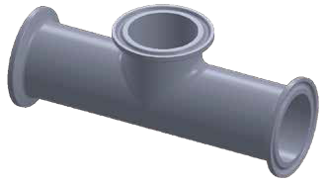
T
L1

L

BPE FITTINGS

Ød1
Ød

T
L

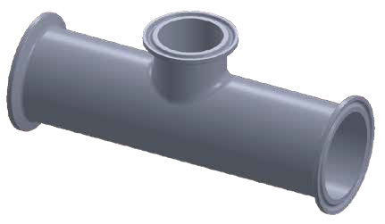
SHORT OUTLET TEE CLAMP END
SIZE
1/2"
3/4"
1"
11/ 2"
2"
21/ 2"
3"
4"
øD
in.
0.500
0.750
1.000
1.500
2.000
2.500
3.000
4.000
mm
12.7
19.05
25.4
38.1
50.8
63.5
76.2
101.6
øD1
in.
0.984
0.984
1.339/1.984
1.984
2.516
3.047
3.579
4.681
mm
25
25
34/50.4
50.4
63.9
77.4
90.9
118.9
L
in. mm
4.504 114.4
4.748 120.6
5.252 133.4
5.748 146
6.748 171.4
7.252 184.2
7.748 196.8
9.504 241.4
L1
in.
1.000
1.126
1.126
1.374
1.626
1.874
2.126
2.752
mm
25.4
28.6
28.6
34.9
41.3
47.6
54
69.9
T
in. mm
0.065 1.65
0.065 1.65
0.065 1.65
0.065 1.65
0.065 1.65
0.065 1.65
0.065 1.65
0.083 2.1
ØD1
ØD
T
L1

Ød1 Ød
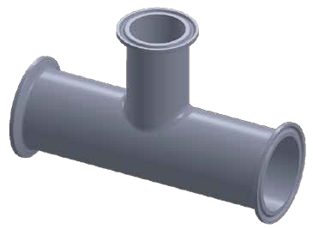
T
T

L
ØD1
ØD

(DT19) DT-4.1.2-8
SIZE | øD  in. mm |  | øD1  in. mm |  | ød  in. mm |  | ød1  in. mm |  | L  in. mm |  | L1  in. mm |  | T  in. mm |  | t  in. mm
3/4"*1/2" | 0.750 | 19.05 | 0.984 | 25 | 0.500 | 12.7 | 0.984 | 25 | 5.000 | 127 | 1.000 | 25.4 | 0.065 | 1.65 | 0.065 | 1.65
1"*1/2" | 1.000 | 25.4 | 1.339/1.984 | 34/50.4 | 0.500 | 12.7 | 0.984 | 25 | 5.252 | 133.4 | 1.125 | 28.6 | 0.065 | 1.65 | 0.065 | 1.65
1"*3/4" | 1.000 | 25.4 | 1.339/1.984 | 34/50.4 | 0.750 | 19.05 | 0.984 | 25 | 5.252 | 133.4 | 1.125 | 28.6 | 0.065 | 1.65 | 0.065 | 1.65
1 1/2"*1/2" | 1.500 | 38.1 | 1.984 | 50.4 | 0.500 | 12.7 | 0.984 | 25 | 5.748 | 146 | 1.375 | 34.9 | 0.065 | 1.65 | 0.065 | 1.65
1 1/2"*3/4" | 1.500 | 38.1 | 1.984 | 50.4 | 0.750 | 19.05 | 0.984 | 25 | 5.748 | 146 | 1.375 | 34.9 | 0.065 | 1.65 | 0.065 | 1.65
11/2"*1" | 1.500 | 38.1 | 1.984 | 50.4 | 1.000 | 25.4 | 1.339/1.984 | 34/50.4 | 5.748 | 146 | 1.375 | 34.9 | 0.065 | 1.65 | 0.065 | 1.65
2"*1" | 2.000 | 50.8 | 2.516 | 63.9 | 1.000 | 25.4 | 1.339/1.984 | 34/50.4 | 6.748 | 171.4 | 1.625 | 41.3 | 0.065 | 1.65 | 0.065 | 1.65
2"*11/ 2" | 2.000 | 50.8 | 2.516 | 63.9 | 1.500 | 38.1 | 1.984 | 50.4 | 6.748 | 171.4 | 1.625 | 41.3 | 0.065 | 1.65 | 0.065 | 1.65
2 1/2"*1" | 2.500 | 63.5 | 3.047 | 77.4 | 1.000 | 25.4 | 1.339/1.984 | 34/50.4 | 7.252 | 184.2 | 1.875 | 47.6 | 0.065 | 1.65 | 0.065 | 1.65
2 1/2"*11/2" | 2.500 | 63.5 | 3.047 | 77.4 | 1.500 | 38.1 | 1.984 | 50.4 | 7.252 | 184.2 | 1.875 | 47.6 | 0.065 | 1.65 | 0.065 | 1.65
2 1/2"*2" | 2.500 | 63.5 | 3.047 | 77.4 | 2.000 | 50.8 | 2.516 | 63.9 | 7.252 | 184.2 | 1.875 | 47.6 | 0.065 | 1.65 | 0.065 | 1.65
3"*1" | 3.000 | 76.2 | 3.579 | 90.9 | 1.000 | 25.4 | 1.339/1.984 | 34/50.4 | 7.748 | 196.8 | 2.125 | 54 | 0.065 | 1.65 | 0.065 | 1.65
3"*11/2" | 3.000 | 76.2 | 3.579 | 90.9 | 1.500 | 38.1 | 1.984 | 50.4 | 7.748 | 196.8 | 2.125 | 54 | 0.065 | 1.65 | 0.065 | 1.65
3"*2" | 3.000 | 76.2 | 3.579 | 90.9 | 2.000 | 50.8 | 2.516 | 63.9 | 7.748 | 196.8 | 2.125 | 54 | 0.065 | 1.65 | 0.065 | 1.65
3"*21/2" | 3.000 | 76.2 | 3.579 | 90.9 | 2.500 | 63.5 | 3.047 | 77.4 | 7.748 | 196.8 | 2.125 | 54 | 0.065 | 1.65 | 0.065 | 1.65
4"*1" | 4.000 | 101.6 | 4.681 | 118.9 | 1.000 | 25.4 | 1.339/1.984 | 34/50.4 | 9.504 | 241.4 | 2.625 | 66.7 | 0.083 | 2.1 | 0.065 | 1.65
4"*11/2" | 4.000 | 101.6 | 4.681 | 118.9 | 1.500 | 38.1 | 1.984 | 50.4 | 9.504 | 241.4 | 2.625 | 66.7 | 0.083 | 2.1 | 0.065 | 1.65
4"*2" | 4.000 | 101.6 | 4.681 | 118.9 | 2.000 | 50.8 | 2.516 | 63.9 | 9.504 | 241.4 | 2.625 | 66.7 | 0.083 | 2.1 | 0.065 | 1.65
4"*21/2" | 4.000 | 101.6 | 4.681 | 118.9 | 2.500 | 63.5 | 3.047 | 77.4 | 9.504 | 241.4 | 2.625 | 66.7 | 0.083 | 2.1 | 0.065 | 1.65
4"*3" | 4.000 | 101.6 | 4.681 | 118.9 | 3.000 | 76.2 | 3.579 | 90.9 | 9.504 | 241.4 | 2.625 | 66.7 | 0.083 | 2.1 | 0.065 | 1.65

(DT20) DT-4.1.2-9
L1
7RMP REDUCING TEE

REDUCING TEE CLAMP END
SIZE | øD  in. mm |  | øD1  in. mm |  | ød  in. mm |  | ød1  in. mm |  | L  in. mm |  | L1  in. mm |  | T  in. mm |  | t  in. mm
3/4"*1/2" | 0.750 | 19.05 | 0.984 | 25 | 0.500 | 12.7 | 0.984 | 25 | 5.000 | 127 | 2.500 | 63.5 | 0.065 | 1.65 | 0.065 | 1.65
1"*1/2" | 1.000 | 25.4 | 1.339/1.984 | 34/50.4 | 0.500 | 12.7 | 0.984 | 25 | 5.252 | 133.4 | 2.625 | 66.7 | 0.065 | 1.65 | 0.065 | 1.65
1"*3/4" | 1.000 | 25.4 | 1.339/1.984 | 34/50.4 | 0.750 | 19.05 | 0.984 | 25 | 5.252 | 133.4 | 2.625 | 66.7 | 0.065 | 1.65 | 0.065 | 1.65
1 1/2"*1/2" | 1.500 | 38.1 | 1.984 | 50.4 | 0.500 | 12.7 | 0.984 | 25 | 5.748 | 146 | 2.875 | 73 | 0.065 | 1.65 | 0.065 | 1.65
1 1/2"*3/4" | 1.500 | 38.1 | 1.984 | 50.4 | 0.750 | 19.05 | 0.984 | 25 | 5.748 | 146 | 2.875 | 73 | 0.065 | 1.65 | 0.065 | 1.65
11/2"*1" | 1.500 | 38.1 | 1.984 | 50.4 | 1.000 | 25.4 | 1.339/1.984 | 34/50.4 | 5.748 | 146 | 2.875 | 73 | 0.065 | 1.65 | 0.065 | 1.65
2"*1" | 2.000 | 50.8 | 2.516 | 63.9 | 1.000 | 25.4 | 1.339/1.984 | 34/50.4 | 6.748 | 171.4 | 3.125 | 79.4 | 0.065 | 1.65 | 0.065 | 1.65
2"*11/ 2" | 2.000 | 50.8 | 2.516 | 63.9 | 1.500 | 38.1 | 1.984 | 50.4 | 6.748 | 171.4 | 3.125 | 79.4 | 0.065 | 1.65 | 0.065 | 1.65
2 1/2"*1" | 2.500 | 63.5 | 3.047 | 77.4 | 1.000 | 25.4 | 1.339/1.984 | 34/50.4 | 7.252 | 184.2 | 3.375 | 85.7 | 0.065 | 1.65 | 0.065 | 1.65
2 1/2"*11/2" | 2.500 | 63.5 | 3.047 | 77.4 | 1.500 | 38.1 | 1.984 | 50.4 | 7.252 | 184.2 | 3.375 | 85.7 | 0.065 | 1.65 | 0.065 | 1.65
2 1/2"*2" | 2.500 | 63.5 | 3.047 | 77.4 | 2.000 | 50.8 | 2.516 | 63.9 | 7.252 | 184.2 | 3.375 | 85.7 | 0.065 | 1.65 | 0.065 | 1.65
3"*1" | 3.000 | 76.2 | 3.579 | 90.9 | 1.000 | 25.4 | 1.339/1.984 | 34/50.4 | 7.748 | 196.8 | 3.625 | 92.1 | 0.065 | 1.65 | 0.065 | 1.65
3"*11/2" | 3.000 | 76.2 | 3.579 | 90.9 | 1.500 | 38.1 | 1.984 | 50.4 | 7.748 | 196.8 | 3.625 | 92.1 | 0.065 | 1.65 | 0.065 | 1.65
3"*2" | 3.000 | 76.2 | 3.579 | 90.9 | 2.000 | 50.8 | 2.516 | 63.9 | 7.748 | 196.8 | 3.625 | 92.1 | 0.065 | 1.65 | 0.065 | 1.65
3"*21/2" | 3.000 | 76.2 | 3.579 | 90.9 | 2.500 | 63.5 | 3.047 | 77.4 | 7.748 | 196.8 | 3.625 | 92.1 | 0.065 | 1.65 | 0.065 | 1.65
4"*1" | 4.000 | 101.6 | 4.681 | 118.9 | 1.000 | 25.4 | 1.339/1.984 | 34/50.4 | 9.504 | 241.4 | 4.125 | 104.8 | 0.083 | 2.1 | 0.065 | 1.65
4"*11/2" | 4.000 | 101.6 | 4.681 | 118.9 | 1.500 | 38.1 | 1.984 | 50.4 | 9.504 | 241.4 | 4.125 | 104.8 | 0.083 | 2.1 | 0.065 | 1.65
4"*2" | 4.000 | 101.6 | 4.681 | 118.9 | 2.000 | 50.8 | 2.516 | 63.9 | 9.504 | 241.4 | 4.375 | 111.1 | 0.083 | 2.1 | 0.065 | 1.65
4"*21/2" | 4.000 | 101.6 | 4.681 | 118.9 | 2.500 | 63.5 | 3.047 | 77.4 | 9.504 | 241.4 | 4.375 | 111.1 | 0.083 | 2.1 | 0.065 | 1.65
4"*3" | 4.000 | 101.6 | 4.681 | 118.9 | 3.000 | 76.2 | 3.579 | 90.9 | 9.504 | 241.4 | 4.375 | 111.1 | 0.083 | 2.1 | 0.065 | 1.65

(DT18) DT-4.1.2-4C
t
L1
ØD1
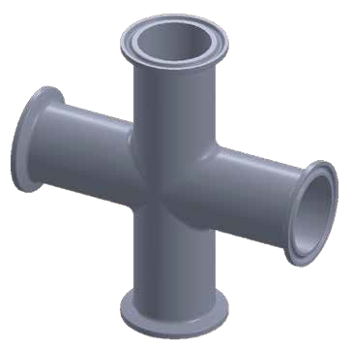
ØD
T
L1

L

ØD1

9MP CROSS CLAMP END
Ød
SIZE | øD  in. mm |  | øD1  in. mm |  | L  in. mm |  | L1  in. mm |  | T  in. mm
1/2" | 0.500 | 12.7 | 0.984 | 25 | 4.500 | 114.4 | 2.252 | 57.2 | 0.065 | 1.65
3/4" | 0.750 | 19.05 | 0.984 | 25 | 4.750 | 120.6 | 2.374 | 60.3 | 0.065 | 1.65
1" | 1.000 | 25.4 | 1.339/1.984 | 34/50.4 | 5.250 | 133.4 | 2.626 | 66.7 | 0.065 | 1.65
1 1/₂" | 1.500 | 38.1 | 1.339/1.984 | 34/50.4 | 5.750 | 146 | 2.874 | 73 | 0.065 | 1.65
2" | 2.000 | 50.8 | 2.516 | 63.9 | 6.750 | 171.4 | 3.374 | 85.7 | 0.065 | 1.65
2 1/₂" | 2.500 | 63.5 | 3.047 | 77.4 | 7.250 | 182.2 | 3.626 | 92.1 | 0.065 | 1.65
3" | 3.000 | 76.2 | 3.579 | 90.9 | 7.750 | 196.8 | 3.874 | 98.4 | 0.065 | 1.65
4" | 4.000 | 101.6 | 4.681 | 118.9 | 9.500 | 241.4 | 4.752 | 120.7 | 0.083 | 2.1
6" | 6.000 | 152.4 | 6.571 | 166.9 | 14.250 | 362 | 7.126 | 181 | 0.083 | 2.1

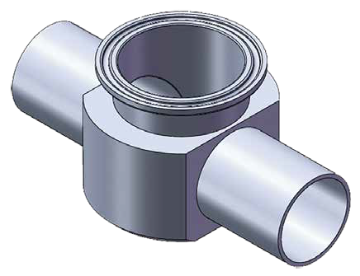
(DT28) DT-4.1.2-10
ØD

T
L
INSTRUMENT TEE WELD/CLAMP

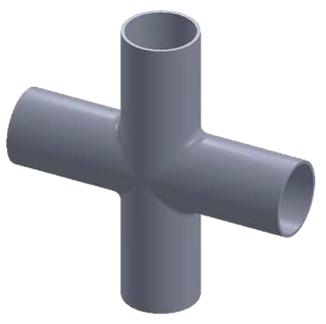
ØD
SIZE | øD  in. mm |  | øD1  in. mm |  | ød  in. mm |  | L  in. mm |  | L1  in. mm |  | T  in. mm |  | t  in. mm
1"*1/2" | 1.000 | 25.4 | 1.339/1.984 | 34/50.4 | 0.500 | 12.7 | 5.00 | 127 | 0.074 | 22.2 | 0.065 | 1.65 | 0.065 | 1.65
1"*3/4" | 1.000 | 25.4 | 1.339/1.984 | 34/50.4 | 0.750 | 19.05 | 5.00 | 127 | 1.000 | 25.4 | 0.065 | 1.65 | 0.065 | 1.65
1 1/2"*1/2" | 1.500 | 38.1 | 1.984 | 50.4 | 0.500 | 12.7 | 5.00 | 127 | 0.074 | 22.2 | 0.065 | 1.65 | 0.065 | 1.65
1 1/2"*3/4" | 1.500 | 38.1 | 1.984 | 50.4 | 0.750 | 19.05 | 5.00 | 127 | 1.000 | 25.4 | 0.065 | 1.65 | 0.065 | 1.65
1 1/2"*1" | 1.500 | 38.1 | 1.984 | 50.4 | 1.000 | 25.4 | 5.00 | 127 | 1.126 | 28.6 | 0.065 | 1.65 | 0.065 | 1.65
2"*1/2" | 2.000 | 50.8 | 2.516 | 63.9 | 0.500 | 12.7 | 5.504 | 139.8 | 1.000 | 25.4 | 0.065 | 1.65 | 0.065 | 1.65
2"*3/4" | 2.000 | 50.8 | 2.516 | 63.9 | 0.750 | 19.05 | 5.504 | 139.8 | 1.126 | 28.6 | 0.065 | 1.65 | 0.065 | 1.65
2"*1" | 2.000 | 50.8 | 2.516 | 63.9 | 1.000 | 25.4 | 5.504 | 139.8 | 1.252 | 31.8 | 0.065 | 1.65 | 0.065 | 1.65
2"*1 1/2" | 2.000 | 50.8 | 2.516 | 63.9 | 1.500 | 38.1 | 5.504 | 139.8 | 1.500 | 38.1 | 0.065 | 1.65 | 0.065 | 1.65
2 1/2"*1/2" | 2.500 | 63.5 | 3.047 | 77.4 | 0.500 | 12.7 | 6.693 | 170 | 1.378 | 35 | 0.065 | 1.65 | 0.065 | 1.65
2 1/2"*3/4" | 2.500 | 63.5 | 3.047 | 77.4 | 0.750 | 19.05 | 6.693 | 170 | 1.500 | 38.1 | 0.065 | 1.65 | 0.065 | 1.65
2 1/2"*1" | 2.500 | 63.5 | 3.047 | 77.4 | 1.000 | 25.4 | 6.693 | 170 | 1.626 | 41.3 | 0.065 | 1.65 | 0.065 | 1.65
2 1/2"*1 1/₂" | 2.500 | 63.5 | 3.047 | 77.4 | 1.500 | 38.1 | 6.693 | 170 | 1.752 | 44.5 | 0.065 | 1.65 | 0.065 | 1.65
2 1/2"*2" | 2.500 | 63.5 | 3.047 | 77.4 | 2.000 | 50.8 | 6.693 | 170 | 1.890 | 48 | 0.065 | 1.65 | 0.065 | 1.65
3"*1/2" | 3.000 | 76.2 | 3.579 | 90.9 | 0.500 | 12.7 | 7.087 | 180 | 1.500 | 38.1 | 0.065 | 1.65 | 0.065 | 1.65
3"*3/4" | 3.000 | 76.2 | 3.579 | 90.9 | 0.750 | 19.05 | 7.087 | 180 | 1.626 | 41.3 | 0.065 | 1.65 | 0.065 | 1.65
3"*1" | 3.000 | 76.2 | 3.579 | 90.9 | 1.000 | 25.4 | 7.087 | 180 | 1.752 | 44.5 | 0.065 | 1.65 | 0.065 | 1.65
3"*1 1/2" | 3.000 | 76.2 | 3.579 | 90.9 | 1.500 | 38.1 | 7.087 | 180 | 1.890 | 48 | 0.065 | 1.65 | 0.065 | 1.65
3"*2" | 3.000 | 76.2 | 3.579 | 90.9 | 2.000 | 50.8 | 7.087 | 180 | 2.000 | 50.8 | 0.065 | 1.65 | 0.065 | 1.65
3"*2 1/2" | 3.000 | 76.2 | 3.579 | 90.9 | 2.500 | 63.5 | 7.087 | 180 | 2.126 | 54 | 0.065 | 1.65 | 0.065 | 1.65
4"*1/2" | 4.000 | 101.6 | 4.681 | 118.9 | 0.500 | 12.7 | 8.661 | 220 | 3.126 | 79.4 | 0.065 | 1.65 | 0.065 | 1.65
4"*3/4" | 4.000 | 101.6 | 4.681 | 118.9 | 0.750 | 19.05 | 8.661 | 220 | 3.252 | 82.6 | 0.065 | 1.65 | 0.065 | 1.65
4"*1" | 4.000 | 101.6 | 4.681 | 118.9 | 1.000 | 25.4 | 8.661 | 220 | 3.374 | 85.7 | 0.083 | 2.1 | 0.065 | 1.65
4"*11/2" | 4.000 | 101.6 | 4.681 | 118.9 | 1.500 | 38.1 | 8.661 | 220 | 3.500 | 88.9 | 0.083 | 2.1 | 0.065 | 1.65
4"*2" | 4.000 | 101.6 | 4.681 | 118.9 | 2.000 | 50.8 | 8.661 | 220 | 3.748 | 95.2 | 0.083 | 2.1 | 0.065 | 1.65
4"*21/2" | 4.000 | 101.6 | 4.681 | 118.9 | 2.500 | 63.5 | 8.661 | 220 | 3.874 | 98.4 | 0.083 | 2.1 | 0.065 | 1.65
4"*3" | 4.000 | 101.6 | 4.681 | 118.9 | 3.000 | 76.2 | 8.661 | 220 | 4.000 | 101.6 | 0.083 | 2.1 | 0.065 | 1.65

T
L1

(DT9) DT-4.1.2-1C
9W CROSS WELD END
SIZE | øD  in. mm |  | L  in. mm |  | L1  in. mm |  | T  in. mm
1/2" | 0.500 | 12.7 | 3.748 | 95.2 | 1.874 | 47.6 | 0.065 | 1.65
3/4" | 0.750 | 19.05 | 4.000 | 101.6 | 2.000 | 50.8 | 0.065 | 1.65
1" | 1.000 | 25.4 | 4.252 | 108 | 2.126 | 54 | 0.065 | 1.65
1 1/₂" | 1.500 | 38.1 | 4.748 | 120.6 | 2.374 | 60.3 | 0.065 | 1.65
2" | 2.000 | 50.8 | 5.748 | 146 | 2.874 | 73 | 0.065 | 1.65
2 1/₂" | 2.500 | 63.5 | 6.252 | 158.8 | 3.126 | 79.4 | 0.065 | 1.65
3" | 3.000 | 76.2 | 6.748 | 171.4 | 3.374 | 85.7 | 0.065 | 1.65
4" | 4.000 | 101.6 | 8.252 | 209.6 | 4.126 | 104.8 | 0.083 | 2.1
6" | 6.000 | 152.4 | 11.252 | 285.8 | 5.625 | 142.9 | 0.109 | 2.77

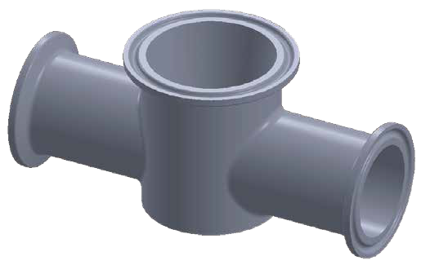
(DT29) DT-4.1.2-11
ØD1
ØD

T
L
Ød1
Ød
t
L1
INSTRUMENT TEE CLAMP END
SIZE | øD  in. mm |  | øD1  in. mm |  | ød  in. mm |  | ød1  in. mm |  | L  in. mm |  | L1  in. mm |  | T  in. mm |  | t  in. mm
1"*1/2" | 1.000 | 25.4 | 1.339/1.984 | 34/50.4 | 0.500 | 12.7 | 0.984 | 25 | 5.00 | 154 | 0.074 | 22.2 | 0.065 | 1.65 | 0.065 | 1.65
1"*3/4" | 1.000 | 25.4 | 1.339/1.984 | 34/50.4 | 0.750 | 19.05 | 0.984 | 25 | 5.00 | 154 | 1.000 | 25.4 | 0.065 | 1.65 | 0.065 | 1.65
1 1/2"*1/2" | 1.500 | 38.1 | 1.984 | 50.4 | 0.500 | 12.7 | 0.984 | 25 | 6.000 | 152.4 | 0.074 | 22.2 | 0.065 | 1.65 | 0.065 | 1.65
1 1/2"*3/4" | 1.500 | 38.1 | 1.984 | 50.4 | 0.750 | 19.05 | 0.984 | 25 | 6.000 | 152.4 | 1.000 | 25.4 | 0.065 | 1.65 | 0.065 | 1.65
1 1/2"*1" | 1.500 | 38.1 | 1.984 | 50.4 | 1.000 | 25.4 | 1.339/1.984 | 34/50.4 | 6.000 | 152.4 | 1.126 | 28.6 | 0.065 | 1.65 | 0.065 | 1.65
2"*1/2" | 2.000 | 50.8 | 2.516 | 63.9 | 0.500 | 12.7 | 0.984 | 25 | 6.504 | 165.2 | 1.000 | 25.4 | 0.065 | 1.65 | 0.065 | 1.65
2"*3/4" | 2.000 | 50.8 | 2.516 | 63.9 | 0.750 | 19.05 | 0.984 | 25 | 6.504 | 165.2 | 1.126 | 28.6 | 0.065 | 1.65 | 0.065 | 1.65
2"*1" | 2.000 | 50.8 | 2.516 | 63.9 | 1.000 | 25.4 | 1.339/1.984 | 34/50.4 | 6.504 | 165.2 | 1.252 | 31.8 | 0.065 | 1.65 | 0.065 | 1.65
2"*1 1/2" | 2.000 | 50.8 | 2.516 | 63.9 | 1.500 | 38.1 | 1.984 | 50.4 | 6.504 | 165.2 | 1.500 | 38.1 | 0.065 | 1.65 | 0.065 | 1.65
2 1/2"*1/2" | 2.500 | 63.5 | 3.047 | 77.4 | 0.500 | 12.7 | 0.984 | 25 | 7.638 | 194 | 1.378 | 35 | 0.065 | 1.65 | 0.065 | 1.65
2 1/2"*3/4" | 2.500 | 63.5 | 3.047 | 77.4 | 0.750 | 19.05 | 0.984 | 25 | 7.638 | 194 | 1.500 | 38.1 | 0.065 | 1.65 | 0.065 | 1.65
2 1/2"*1" | 2.500 | 63.5 | 3.047 | 77.4 | 1.000 | 25.4 | 1.339/1.984 | 34/50.4 | 7.638 | 194 | 1.626 | 41.3 | 0.065 | 1.65 | 0.065 | 1.65
2 1/2"*1 1/₂" | 2.500 | 63.5 | 3.047 | 77.4 | 1.500 | 38.1 | 1.984 | 50.4 | 7.638 | 194 | 1.752 | 44.5 | 0.065 | 1.65 | 0.065 | 1.65
2 1/2"*2" | 2.500 | 63.5 | 3.047 | 77.4 | 2.000 | 50.8 | 2.516 | 63.9 | 7.638 | 194 | 1.890 | 48 | 0.065 | 1.65 | 0.065 | 1.65
3"*1/2" | 3.000 | 76.2 | 3.579 | 90.9 | 0.500 | 12.7 | 0.984 | 25 | 8.031 | 204 | 1.500 | 38.1 | 0.065 | 1.65 | 0.065 | 1.65
3"*3/4" | 3.000 | 76.2 | 3.579 | 90.9 | 0.750 | 19.05 | 0.984 | 25 | 8.031 | 204 | 1.626 | 41.3 | 0.065 | 1.65 | 0.065 | 1.65
3"*1" | 3.000 | 76.2 | 3.579 | 90.9 | 1.000 | 25.4 | 1.339/1.984 | 34/50.4 | 8.031 | 204 | 1.752 | 44.5 | 0.065 | 1.65 | 0.065 | 1.65
3"*1 1/2" | 3.000 | 76.2 | 3.579 | 90.9 | 1.500 | 38.1 | 1.984 | 50.4 | 8.031 | 204 | 1.890 | 48 | 0.065 | 1.65 | 0.065 | 1.65
3"*2" | 3.000 | 76.2 | 3.579 | 90.9 | 2.000 | 50.8 | 2.516 | 63.9 | 8.031 | 204 | 2.000 | 50.8 | 0.065 | 1.65 | 0.065 | 1.65
3"*2 1/2" | 3.000 | 76.2 | 3.579 | 90.9 | 2.500 | 63.5 | 3.047 | 77.4 | 8.031 | 204 | 2.126 | 54 | 0.065 | 1.65 | 0.065 | 1.65
4"*1/2" | 4.000 | 101.6 | 4.681 | 118.9 | 0.500 | 12.7 | 0.984 | 25 | 9.606 | 244 | 3.126 | 79.4 | 0.065 | 1.65 | 0.065 | 1.65
4"*3/4" | 4.000 | 101.6 | 4.681 | 118.9 | 0.750 | 19.05 | 0.984 | 25 | 9.606 | 244 | 3.252 | 82.6 | 0.065 | 1.65 | 0.065 | 1.65
4"*1" | 4.000 | 101.6 | 4.681 | 118.9 | 1.000 | 25.4 | 1.339/1.984 | 34/50.4 | 9.606 | 244 | 3.374 | 85.7 | 0.083 | 2.1 | 0.065 | 1.65
4"*11/2" | 4.000 | 101.6 | 4.681 | 118.9 | 1.500 | 38.1 | 1.984 | 50.4 | 9.606 | 244 | 3.500 | 88.9 | 0.083 | 2.1 | 0.065 | 1.65
4"*2" | 4.000 | 101.6 | 4.681 | 118.9 | 2.000 | 50.8 | 2.516 | 63.9 | 9.606 | 244 | 3.748 | 95.2 | 0.083 | 2.1 | 0.065 | 1.65
4"*21/2" | 4.000 | 101.6 | 4.681 | 118.9 | 2.500 | 63.5 | 3.047 | 77.4 | 9.606 | 244 | 3.874 | 98.4 | 0.083 | 2.1 | 0.065 | 1.65
4"*3" | 4.000 | 101.6 | 4.681 | 118.9 | 3.000 | 76.2 | 3.579 | 90.9 | 9.606 | 244 | 4.000 | 101.6 | 0.083 | 2.1 | 0.065 | 1.65

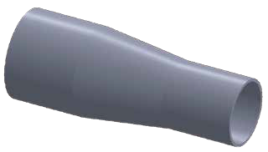
(DT11) DT-4.1.3-1AC

L
ØD
T
t
Ød
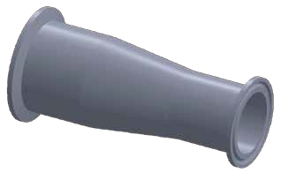 CONCENTRIC REDUCER
SIZE
3/4"*1/2"
1"*1/2"
1"*3/4"
11/2"*1/2"
11/2"*3/4"
11 /2"*1"
2"*1/2"
2"*3/4"
2"*1"
2"*1 1/2"
21/2"*1 1/2"
21/2"*2"
3"*11/2"
3"*2"
3"*21/2"
4"*11/2"
4"*2"
4"*21/2"
4"*3"
in.
0.750
1.000
1.000
1.500
1.500
1.500
2.000
2.000
2.000
2.000
2.500
2.500
3.000
3.000
3.000
4.000
4.000
4.000
4.000
øD
mm
19.05
25.4
25.4
38.1
38.1
38.1
50.8
50.8
50.8
50.8
63.5
63.5
76.2
76.2
76.2
101.6
101.6
101.6
101.6
in.
0.500
0.500
0.750
0.500
0.750
1.000
0.500
0.750
1.000
1.500
1.500
2.000
1.500
2.000
2.500
1.500
2.000
2.500
3.000
ød
mm
12.7
12.7
19.05
12.7
19.05
25.4
12.7
19.05
25.4
38.1
38.1
50.8
38.1
50.8
63.5
38.1
50.8
63.5
76.2
in.
4.000
4.500
4.000
5.500
5.000
5.000
7.752
7.252
7.252
5.252
7.252
5.000
9.252
7.500
5.500
13.500
11.752
9.634
7.752
L
mm
101.6
114.3
101.6
139.7
127
127
196.9
184.2
184.2
133.4
184.2
139.7
235
190.5
139.7
342.9
298.5
247.7
196.9
in.
0.065
0.065
0.065
0.065
0.065
0.065
0.065
0.065
0.065
0.065
0.065
0.065
0.065
0.065
0.065
0.083
0.083
0.083
0.083
T
mm
1.65
1.65
1.65
1.65
1.65
1.65
1.65
1.65
1.65
1.65
1.65
1.65
1.65
1.65
1.65
2.1
2.1
2.1
2.1
in.
0.065
0.065
0.065
0.065
0.065
0.065
0.065
0.065
0.065
0.065
0.065
0.065
0.065
0.065
0.065
0.065
0.065
0.065
0.083
t
mm
1.65
1.65
1.65
1.65
1.65
1.65
1.65
1.65
1.65
1.65
1.65
1.65
1.65
1.65
1.65
1.65
1.65
1.65
2.1

(DT21) DT-4.1.3-3AE

L
ØD1
ØD
T
t
Ød
Ød1
14MP

SIZE | øD  in. mm |  | øD1  in. mm |  | ød  in. mm |  | ød1  in. mm |  | L  in. mm |  | T  in. mm |  | t  in. mm
3/4"*1/2" | 0.750 | 19.05 | 0.984 | 25 | 0.500 | 12.7 | 0.984 | 25 | 2.000 | 50.8 | 0.065 | 1.65 | 0.065 | 1.65
1"*1/2" | 1.000 | 25.4 | 1.339/1.984 | 34/50.4 | 0.500 | 12.7 | 0.984 | 25 | 2.500 | 63.5 | 0.065 | 1.65 | 0.065 | 1.65
1"*3/4" | 1.000 | 25.4 | 1.339/1.984 | 34/50.4 | 0.750 | 19.05 | 0.984 | 25 | 2.000 | 50.8 | 0.065 | 1.65 | 0.065 | 1.65
11/2"*1/2" | 1.500 | 38.1 | 1.984 | 50.4 | 0.500 | 12.7 | 0.984 | 25 | 3.500 | 88.9 | 0.065 | 1.65 | 0.065 | 1.65
11/2"*3/4" | 1.500 | 38.1 | 1.984 | 50.4 | 0.750 | 19.05 | 0.984 | 25 | 3.000 | 76.2 | 0.065 | 1.65 | 0.065 | 1.65
11 /2"*1" | 1.500 | 38.1 | 1.984 | 50.4 | 1.000 | 25.4 | 1.339/1.984 | 34/50.4 | 3.000 | 76.2 | 0.065 | 1.65 | 0.065 | 1.65
2"*1/2" | 2.000 | 50.8 | 2.516 | 63.9 | 0.500 | 12.7 | 0.984 | 25 | 5.500 | 139.7 | 0.065 | 1.65 | 0.065 | 1.65
2"*3/4" | 2.000 | 50.8 | 2.516 | 63.9 | 0.750 | 19.05 | 0.984 | 25 | 5.000 | 127 | 0.065 | 1.65 | 0.065 | 1.65
2"*1" | 2.000 | 50.8 | 2.516 | 63.9 | 1.000 | 25.4 | 1.339/1.984 | 34/50.4 | 5.000 | 127 | 0.065 | 1.65 | 0.065 | 1.65
2"*1 1/2" | 2.000 | 50.8 | 2.516 | 63.9 | 1.500 | 38.1 | 1.984 | 50.4 | 3.000 | 76.2 | 0.065 | 1.65 | 0.065 | 1.65
21/2"*1 1/2" | 2.500 | 63.5 | 3.047 | 77.4 | 1.500 | 38.1 | 1.984 | 50.4 | 5.000 | 127 | 0.065 | 1.65 | 0.065 | 1.65
21/2"*2" | 2.500 | 63.5 | 3.047 | 77.4 | 2.000 | 50.8 | 2.516 | 63.9 | 3.000 | 76.2 | 0.065 | 1.65 | 0.065 | 1.65
3"*11/2" | 3.000 | 76.2 | 3.579 | 90.9 | 1.500 | 38.1 | 1.984 | 50.4 | 7.000 | 117.8 | 0.065 | 1.65 | 0.065 | 1.65
3"*2" | 3.000 | 76.2 | 3.579 | 90.9 | 2.000 | 50.8 | 2.516 | 63.9 | 5.000 | 127 | 0.065 | 1.65 | 0.065 | 1.65
3"*21/2" | 3.000 | 76.2 | 3.579 | 90.9 | 2.500 | 63.5 | 3.047 | 77.4 | 3.000 | 76.2 | 0.065 | 1.65 | 0.065 | 1.65
4"*11/2" | 4.000 | 101.6 | 4.681 | 118.9 | 1.500 | 38.1 | 1.984 | 50.4 | 11.126 | 282.6 | 0.083 | 2.1 | 0.065 | 1.65
4"*2" | 4.000 | 101.6 | 4.681 | 118.9 | 2.000 | 50.8 | 2.516 | 63.9 | 9.126 | 231.8 | 0.083 | 2.1 | 0.065 | 1.65
4"*21/2" | 4.000 | 101.6 | 4.681 | 118.9 | 2.500 | 63.5 | 3.047 | 77.4 | 7.126 | 181 | 0.083 | 2.1 | 0.065 | 1.65
4"*3" | 4.000 | 101.6 | 4.681 | 118.9 | 3.000 | 76.2 | 3.579 | 90.9 | 5.126 | 130.2 | 0.083 | 2.1 | 0.083 | 2.1

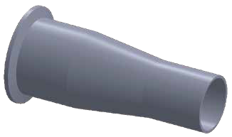
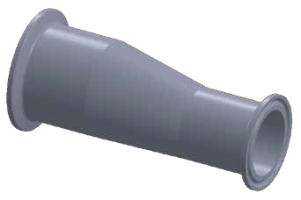
BPE FITTINGS BPE FITTINGS
T
t
T
t

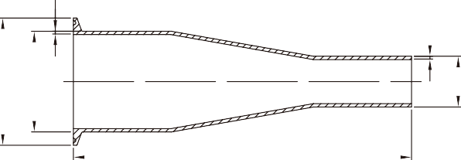
L
ØD1
ØD
Ød

(DT26) DT-4.1.3-2AC

L
ØD1
ØD
Ød
Ød1

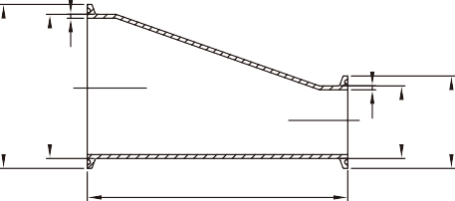
(DT21) DT-4.1.3-3AE

CONCENTRIC REDUCER 14MP ECCENTRIC REDUCER

SIZE
3/4"*1/2"

in.
0.750
øD
mm
19.05

in.
0.984
øD1
mm
25

in.
0.500
ød
mm
12.7

in.
3.000
L
mm
76.2

in.
0.065
T
mm
1.65

in.
0.065
t
mm
1.65
SIZE
3/4"*1/2"
øD
in.
0.750

mm
19.05

in.
0.984
øD1
mm
25

in.
0.500
ød
mm
12.7

in.
ød1
mm

in.
2.000
L
mm
50.8
T
in.
0.065

mm
1.65

in.
0.065
t
mm
1.65

1"*1/2"
1"*3/4"
11/2"*1/2"
11/2"*3/4"
11 /2"*1"
2"*1/2"
2"*3/4"
2"*1"
2"*1 1/2"
21/2"*1 1/2"
21/2"*2"
3"*11/2"
3"*2"
3"*21/2"
4"*11/2"
4"*2"
4"*21/2"
4"*3"
T
1.000
1.000
1.500
1.500
1.500
2.000
2.000
2.000
2.000
2.500
2.500
3.000
3.000
3.000
4.000
4.000
4.000
4.000
25.4
25.4
38.1
38.1
38.1
50.8
50.8
50.8
50.8
63.5
63.5
76.2
76.2
76.2
101.6
101.6
101.6
101.6
1.339/1.984
1.339/1.984
1.984
1.984
1.984
2.516
2.516
2.516
2.516
3.047
3.047
3.579
3.579
3.579
4.681
4.681
4.681
4.681
34/50.4
34/50.4
50.4
50.4
50.4
63.9
63.9
63.9
63.9
77.4
77.4
90.9
90.9
90.9
118.9
118.9
118.9
118.9
0.500
0.750
0.500
0.750
1.000
0.500
0.750
1.000
1.500
1.500
2.000
1.500
2.000
2.500
1.500
2.000
2.500
3.000
12.7
19.05
12.7
19.05
25.4
12.7
19.05
25.4
38.1
38.1
50.8
38.1
50.8
63.5
38.1
50.8
63.5
76.2
3.500
3.000
4.500
4.000
4.000
6.500
6.000
6.000
4.000
6.000
4.248
8.000
6.252
4.252
12.126
10.374
8.374
6.374
88.9
76.2
114.3
101.6
101.6
165.1
152.4
152.4
101.6
152.4
107.9
203.2
158.8
108
308
263.5
212.7
161.9
0.065
0.065
0.065
0.065
0.065
0.065
0.065
0.065
0.065
0.065
0.065
0.065
0.065
0.065
0.083
0.083
0.083
0.083
1.65
1.65
1.65
1.65
1.65
1.65
1.65
1.65
1.65
1.65
1.65
1.65
1.65
1.65
2.1
2.1
2.1
2.1
0.065
0.065
0.065
0.065
0.065
0.065
0.065
0.065
0.065
0.065
0.065
0.065
0.065
0.065
0.065
0.065
0.065
0.083
1.65
1.65
1.65
1.65
1.65
1.65
1.65
1.65
1.65
1.65
1.65
1.65
1.65
1.65
1.65
1.65
1.65
2.1
1"*1/2"
1"*3/4"
11/2"*1/2"
11/2"*3/4"
11 /2"*1"
2"*1/2"
2"*3/4"
2"*1"
2"*1 1/2"
21/2"*1 1/2"
21/2"*2"
3"*11/2"
3"*2"
3"*21/2"
4"*11/2"
4"*2"
4"*21/2"
4"*3"
1.000
1.000
1.500
1.500
1.500
2.000
2.000
2.000
2.000
2.500
2.500
3.000
3.000
3.000
4.000
4.000
4.000
4.000
25.4
25.4
38.1
38.1
38.1
50.8
50.8
50.8
50.8
63.5
63.5
76.2
76.2
76.2
101.6
101.6
101.6
101.6
T
1.339/1.984
1.339/1.984
1.984
1.984
1.984
2.516
2.516
2.516
2.516
3.047
3.047
3.579
3.579
3.579
4.681
4.681
4.681
4.681
34/50.4
34/50.4
50.4
50.4
50.4
63.9
63.9
63.9
63.9
77.4
77.4
90.9
90.9
90.9
118.9
118.9
118.9
118.9
0.500
0.750
0.500
0.750
1.000
0.500
0.750
1.000
1.500
1.500
2.000
1.500
2.000
2.500
1.500
2.000
2.500
3.000
12.7
19.05
12.7
19.05
25.4
12.7
19.05
25.4
38.1
38.1
50.8
38.1
50.8
63.5
38.1
50.8
63.5
76.2
0.984
0.984
0.984
0.984
1.339/1.984
0.984
0.984
1.339/1.984
1.984
1.984
2.516
1.984
2.516
3.047
1.984
2.516
3.047
3.579
25
25
25
25
34/50.4
25
25
34/50.4
50.4
50.4
63.9
50.4
63.9
77.4
50.4
63.9
77.4
90.9
2.500
2.000
3.500
3.000
3.000
5.500
5.000
5.000
3.000
5.000
3.000
7.000
5.000
3.000
11.126
9.126
7.126
5.126
63.5
50.8
88.9
76.2
76.2
139.7
127
127
76.2
127
76.2
117.8
127
76.2
282.6
231.8
181
130.2
0.065
0.065
0.065
0.065
0.065
0.065
0.065
0.065
0.065
0.065
0.065
0.065
0.065
0.065
0.083
0.083
0.083
0.083
1.65
1.65
1.65
1.65
1.65
1.65
1.65
1.65
1.65
1.65
1.65
1.65
1.65
1.65
2.1
2.1
2.1
2.1
0.065
0.065
0.065
0.065
0.065
0.065
0.065
0.065
0.065
0.065
0.065
0.065
0.065
0.065
0.065
0.065
0.065
0.083
1.65
1.65
1.65
1.65
1.65
1.65
1.65
1.65
1.65
1.65
1.65
1.65
1.65
1.65
1.65
1.65
1.65
2.1

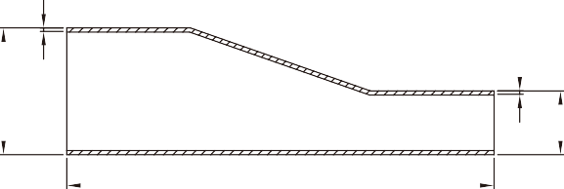 L
ØD
t
Ød
ØD1
ØD
t
Ød

(DT11) DT-4.1.3-1AE

L

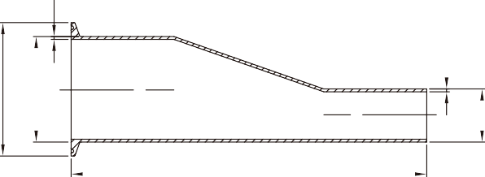(DT26) DT-4.1.3-2AE

ECCENTRIC REDUCER ECCENTRIC REDUCER
SIZE | øD  in. mm |  | ød  in. mm |  | L  in. mm |  | T  in. mm |  | t  in. mm
3/4"*1/2" | 0.750 | 19.05 | 0.500 | 12.7 | 4.000 | 101.6 | 0.065 | 1.65 | 0.065 | 1.65
1"*1/2" | 1.000 | 25.4 | 0.500 | 12.7 | 4.500 | 114.3 | 0.065 | 1.65 | 0.065 | 1.65
1"*3/4" | 1.000 | 25.4 | 0.750 | 19.05 | 4.000 | 101.6 | 0.065 | 1.65 | 0.065 | 1.65
11/2"*1/2" | 1.500 | 38.1 | 0.500 | 12.7 | 5.500 | 139.7 | 0.065 | 1.65 | 0.065 | 1.65
11/2"*3/4" | 1.500 | 38.1 | 0.750 | 19.05 | 5.000 | 127 | 0.065 | 1.65 | 0.065 | 1.65
11 /2"*1" | 1.500 | 38.1 | 1.000 | 25.4 | 5.000 | 127 | 0.065 | 1.65 | 0.065 | 1.65
2"*1/2" | 2.000 | 50.8 | 0.500 | 12.7 | 7.752 | 196.9 | 0.065 | 1.65 | 0.065 | 1.65
2"*3/4" | 2.000 | 50.8 | 0.750 | 19.05 | 7.252 | 184.2 | 0.065 | 1.65 | 0.065 | 1.65
2"*1" | 2.000 | 50.8 | 1.000 | 25.4 | 7.252 | 184.2 | 0.065 | 1.65 | 0.065 | 1.65
2"*1 1/2" | 2.000 | 50.8 | 1.500 | 38.1 | 5.252 | 133.4 | 0.065 | 1.65 | 0.065 | 1.65
21/2"*1 1/2" | 2.500 | 63.5 | 1.500 | 38.1 | 7.252 | 184.2 | 0.065 | 1.65 | 0.065 | 1.65
21/2"*2" | 2.500 | 63.5 | 2.000 | 50.8 | 5.000 | 139.7 | 0.065 | 1.65 | 0.065 | 1.65
3"*11/2" | 3.000 | 76.2 | 1.500 | 38.1 | 9.252 | 235 | 0.065 | 1.65 | 0.065 | 1.65
3"*2" | 3.000 | 76.2 | 2.000 | 50.8 | 7.500 | 190.5 | 0.065 | 1.65 | 0.065 | 1.65
3"*21/2" | 3.000 | 76.2 | 2.500 | 63.5 | 5.500 | 139.7 | 0.065 | 1.65 | 0.065 | 1.65
4"*11/2" | 4.000 | 101.6 | 1.500 | 38.1 | 13.500 | 342.9 | 0.083 | 2.1 | 0.065 | 1.65
4"*2" | 4.000 | 101.6 | 2.000 | 50.8 | 11.752 | 298.5 | 0.083 | 2.1 | 0.065 | 1.65
4"*21/2" | 4.000 | 101.6 | 2.500 | 63.5 | 9.634 | 247.7 | 0.083 | 2.1 | 0.065 | 1.65
4"*3" | 4.000 | 101.6 | 3.000 | 76.2 | 7.752 | 196.9 | 0.083 | 2.1 | 0.083 | 2.1

SIZE | øD  in. mm |  | øD1  in. mm |  | ød  in. mm |  | L  in. mm |  | T  in. mm |  | t  in. mm
3/4"*1/2" | 0.750 | 19.05 | 0.984 | 25 | 0.500 | 12.7 | 3.000 | 76.2 | 0.065 | 1.65 | 0.065 | 1.65
1"*1/2" | 1.000 | 25.4 | 1.339/1.984 | 34/50.4 | 0.500 | 12.7 | 3.500 | 88.9 | 0.065 | 1.65 | 0.065 | 1.65
1"*3/4" | 1.000 | 25.4 | 1.339/1.984 | 34/50.4 | 0.750 | 19.05 | 3.000 | 76.2 | 0.065 | 1.65 | 0.065 | 1.65
11/2"*1/2" | 1.500 | 38.1 | 1.984 | 50.4 | 0.500 | 12.7 | 4.500 | 114.3 | 0.065 | 1.65 | 0.065 | 1.65
11/2"*3/4" | 1.500 | 38.1 | 1.984 | 50.4 | 0.750 | 19.05 | 4.000 | 101.6 | 0.065 | 1.65 | 0.065 | 1.65
11 /2"*1" | 1.500 | 38.1 | 1.984 | 50.4 | 1.000 | 25.4 | 4.000 | 101.6 | 0.065 | 1.65 | 0.065 | 1.65
2"*1/2" | 2.000 | 50.8 | 2.516 | 63.9 | 0.500 | 12.7 | 6.500 | 165.1 | 0.065 | 1.65 | 0.065 | 1.65
2"*3/4" | 2.000 | 50.8 | 2.516 | 63.9 | 0.750 | 19.05 | 6.000 | 152.4 | 0.065 | 1.65 | 0.065 | 1.65
2"*1" | 2.000 | 50.8 | 2.516 | 63.9 | 1.000 | 25.4 | 6.000 | 152.4 | 0.065 | 1.65 | 0.065 | 1.65
2"*1 1/2" | 2.000 | 50.8 | 2.516 | 63.9 | 1.500 | 38.1 | 4.000 | 101.6 | 0.065 | 1.65 | 0.065 | 1.65
21/2"*1 1/2" | 2.500 | 63.5 | 3.047 | 77.4 | 1.500 | 38.1 | 6.000 | 152.4 | 0.065 | 1.65 | 0.065 | 1.65
21/2"*2" | 2.500 | 63.5 | 3.047 | 77.4 | 2.000 | 50.8 | 4.248 | 107.9 | 0.065 | 1.65 | 0.065 | 1.65
3"*11/2" | 3.000 | 76.2 | 3.579 | 90.9 | 1.500 | 38.1 | 8.000 | 203.2 | 0.065 | 1.65 | 0.065 | 1.65
3"*2" | 3.000 | 76.2 | 3.579 | 90.9 | 2.000 | 50.8 | 6.252 | 158.8 | 0.065 | 1.65 | 0.065 | 1.65
3"*21/2" | 3.000 | 76.2 | 3.579 | 90.9 | 2.500 | 63.5 | 4.252 | 108 | 0.065 | 1.65 | 0.065 | 1.65
4"*11/2" | 4.000 | 101.6 | 4.681 | 118.9 | 1.500 | 38.1 | 12.126 | 308 | 0.083 | 2.1 | 0.065 | 1.65
4"*2" | 4.000 | 101.6 | 4.681 | 118.9 | 2.000 | 50.8 | 10.374 | 263.5 | 0.083 | 2.1 | 0.065 | 1.65
4"*21/2" | 4.000 | 101.6 | 4.681 | 118.9 | 2.500 | 63.5 | 8.374 | 212.7 | 0.083 | 2.1 | 0.065 | 1.65
4"*3" | 4.000 | 101.6 | 4.681 | 118.9 | 3.000 | 76.2 | 6.374 | 161.9 | 0.083 | 2.1 | 0.083 | 2.1

BPE Items
NO. S3 PART NO SIZE DESCRIPTION
1 | A270S2.SF1-.50 | 1/2" 1.65mm | Auto Welded Tube L=6.1M SF1  ID Pol. Ra<0.5μm/ OD Pol. Ra<0.8μm
2 | A270S2.SF1-.75 | 3/4" 1.65mm
3 | A270S2.SF1-1 | 1" 1.65mm
4 | A270S2.SF1-15 | 1.5" 1.65mm
5 | A270S2.SF1-2 | 2" 1.65mm
6 | A270S2.SF1-25 | 2.5" 1.65mm
7 | A270S2.SF1-3 | 3" 1.65mm
8 | A270S2.SF1-4 | 4" 2.1mm
9 | A270S2.SF4-.50 | 1/2" 1.65mm | Auto Welded Tube L=6.1M SF4 ID EP Finished Ra<0.38μm/ OD Pol. Ra<0.8μm
10 | A270S2.SF4-.75 | 3/4" 1.65mm
11 | A270S2.SF4-1 | 1" 1.65mm
12 | A270S2.SF4-15 | 1.5" 1.65mm
13 | A270S2.SF4-2 | 2" 1.65mm
14 | A270S2.SF4-25 | 2.5" 1.65mm
15 | A270S2.SF4-3 | 3" 1.65mm
16 | A270S2.SF4-4 | 4" 2.1mm
17 | 4111.SF1-.50 | 1/2" 1.65mm | DT7 Elbow 90° Weld Ends SF1 ID  Pol. Ra<0.5μm/ OD Pol. Ra<0.8μm
18 | 4111.SF1-.75 | 3/4" 1.65mm
19 | 4111.SF1-1 | 1" 1.65mm
20 | 4111.SF1-15 | 1.5" 1.65mm
21 | 4111.SF1-2 | 2" 1.65mm
22 | 4111.SF1-25 | 2.5" 1.65mm
23 | 4111.SF1-3 | 3" 1.65mm
24 | 4111.SF1-4 | 4" 2.1mm
25 | 4111.SF4-.50 | 1/2" 1.65mm | DT7 Elbow 90° Weld Ends SF4 ID EP Finished Ra<0.38μm/ OD Pol. Ra<0.8μm
26 | 4111.SF4-.75 | 3/4" 1.65mm
27 | 4111.SF4-1 | 1" 1.65mm
28 | 4111.SF4-15 | 1.5" 1.65mm
29 | 4111.SF4-2 | 2" 1.65mm
30 | 4111.SF4-25 | 2.5" 1.65mm
31 | 4111.SF4-3 | 3" 1.65mm
32 | 4111.SF4-4 | 4" 2.1mm
33 | 4114.SF1-.50 | 1/2" 1.65mm | DT8 Elbow 45° Weld Ends SF1 ID  Pol. Ra<0.5μm/ OD Pol. Ra<0.8μm
34 | 4114.SF1-.75 | 3/4" 1.65mm
35 | 4114.SF1-1 | 1" 1.65mm
36 | 4114.SF1-15 | 1.5" 1.65mm
37 | 4114.SF1-2 | 2" 1.65mm
38 | 4114.SF1-25 | 2.5" 1.65mm
39 | 4114.SF1-3 | 3" 1.65mm
40 | 4114.SF1-4 | 4" 2.1mm
41 | 4114.SF4-.50 | 1/2" 1.65mm | DT8 Elbow 45° Weld Ends SF4 ID EP Finished Ra<0.38μm/ OD Pol. Ra<0.8μm
42 | 4114.SF4-.75 | 3/4" 1.65mm
43 | 4114.SF4-1 | 1" 1.65mm
44 | 4114.SF4-15 | 1.5" 1.65mm
45 | 4114.SF4-2 | 2" 1.65mm
46 | 4114.SF4-25 | 2.5" 1.65mm
47 | 4114.SF4-3 | 3" 1.65mm
48 | 4114.SF4-4 | 4" 2.1mm
49 | 4121T.SF1-.50 | 1/2" 1.65mm | DT9 Tee Equal Weld Ends SF1 ID  Pol. Ra<0.5μm/ OD Pol. Ra<0.8μm
50 | 4121T.SF1-.75 | 3/4" 1.65mm
51 | 4121T.SF1-1 | 1" 1.65mm
52 | 4121T.SF1-15 | 1.5" 1.65mm
53 | 4121T.SF1-2 | 2" 1.65mm
54 | 4121T.SF1-25 | 2.5" 1.65mm
55 | 4121T.SF1-3 | 3" 1.65mm
56 | 4121T.SF1-4 | 4" 2.1mm
57 | 4121T.SF4-.50 | 1/2" 1.65mm | DT9 Tee Equal Weld Ends SF4 ID EP Finished Ra<0.38μm/ OD Pol. Ra<0.8μm
58 | 4121T.SF4-.75 | 3/4" 1.65mm
59 | 4121T.SF4-1 | 1" 1.65mm
60 | 4121T.SF4-15 | 1.5" 1.65mm
61 | 4121T.SF4-2 | 2" 1.65mm
62 | 4121T.SF4-25 | 2.5" 1.65mm
63 | 4121T.SF4-3 | 3" 1.65mm
64 | 4121T.SF4-4 | 4" 2.1mm
65 | 4121C.SF1-.50 | 1/2" 1.65mm | DT9 Cross Equal Long Weld Ends SF1 ID Pol. Ra<0.5μm/ OD Pol. Ra<0.8μm
66 | 4121C.SF1-.75 | 3/4" 1.65mm
67 | 4121C.SF1-1 | 1" 1.65mm
68 | 4121C.SF1-15 | 1.5" 1.65mm
69 | 4121C.SF1-2 | 2" 1.65mm
70 | 4121C.SF1-25 | 2.5" 1.65mm
71 | 4121C.SF1-3 | 3" 1.65mm
72 | 4121C.SF1-4 | 4" 2.1mm
73 | 4121C.SF4-.50 | 1/2" 1.65mm | DT9 Cross Equal Long Weld Ends SF4 ID EP Finished Ra<0.38μm/ OD Pol. Ra<0.8μm
74 | 4121C.SF4-.75 | 3/4" 1.65mm
75 | 4121C.SF4-1 | 1" 1.65mm
76 | 4121C.SF4-15 | 1.5" 1.65mm
77 | 4121C.SF4-2 | 2" 1.65mm
78 | 4121C.SF4-25 | 2.5" 1.65mm
79 | 4121C.SF4-3 | 3" 1.65mm
80 | 4121C.SF4-4 | 4" 2.1mm
81 | 4126.SF1-7550 | 3/4"*1/2" 1.65mm | DT10 Tee Reducing Weld Ends SF1 ID Pol.  Ra<0.5μm/ OD Pol. Ra<0.8μm
82 | 4126.SF1-1050 | 1"*1/2" 1.65mm
83 | 4126.SF1-1075 | 1"*3/4" 1.65mm
84 | 4126.SF1-1550 | 1.5"*1/2" 1.65mm
85 | 4126.SF1-1575 | 1.5"*3/4" 1.65mm

NO. S3 PART NO SIZE DESCRIPTION
86 | 4126.SF1-1510 | 1.5"*1" 1.65mm | DT10 Tee Reducing Weld Ends SF1 ID Pol.  Ra<0.5μm/ OD Pol. Ra<0.8μm
87 | 4126.SF1-2050 | 2"*1/2" 1.65mm
88 | 4126.SF1-2075 | 2"*3/4" 1.65mm
89 | 4126.SF1-2010 | 2"*1" 1.65mm
90 | 4126.SF1-2015 | 2"*1.5" 1.65mm
91 | 4126.SF1-2550 | 2.5"*1/2" 1.65mm
92 | 4126.SF1-2575 | 2.5"*3/4" 1.65mm
93 | 4126.SF1-2510 | 2.5"*1" 1.65mm
94 | 4126.SF1-2515 | 2.5"*1.5" 1.65mm
95 | 4126.SF1-2520 | 2.5"*2" 1.65mm
96 | 4126.SF1-3050 | 3"*1/2" 1.65mm
97 | 4126.SF1-3075 | 3"*3/4" 1.65mm
98 | 4126.SF1-3010 | 3"*1" 1.65mm
99 | 4126.SF1-3015 | 3"*1.5" 1.65mm
100 | 4126.SF1-3020 | 3"*2" 1.65mm
101 | 4126.SF1-3025 | 3"*2.5" 1.65mm
102 | 4126.SF1-4050 | 4"*1/2" 2.1*1.65mm
103 | 4126.SF1-4075 | 4"*3/4" 2.1*1.65mm
104 | 4126.SF1-4010 | 4"*1" 2.1*1.65mm
105 | 4126.SF1-4015 | 4"*1.5" 2.1*1.65mm
106 | 4126.SF1-4020 | 4"*2" 2.1*1.65mm
107 | 4126.SF1-4025 | 4"*2.5" 2.1*1.65mm
108 | 4126.SF1-4030 | 4"*3" 2.1*1.65mm
109 | 4126.SF4-7550 | 3/4"*1/2" 1.65mm | DT10 Tee Reducing Weld Ends SF4 ID EP Finished Ra<0.38μm/ OD Pol. Ra<0.8μm
110 | 4126.SF4-1050 | 1"*1/2" 1.65mm
111 | 4126.SF4-1075 | 1"*3/4" 1.65mm
112 | 4126.SF4-1550 | 1.5"*1/2" 1.65mm
113 | 4126.SF4-1575 | 1.5"*3/4" 1.65mm
114 | 4126.SF4-1510 | 1.5"*1" 1.65mm
115 | 4126.SF4-2050 | 2"*1/2" 1.65mm
116 | 4126.SF4-2075 | 2"*3/4" 1.65mm
117 | 4126.SF4-2010 | 2"*1" 1.65mm
118 | 4126.SF4-2015 | 2"*1.5" 1.65mm
119 | 4126.SF4-2550 | 2.5"*1/2" 1.65mm
120 | 4126.SF4-2575 | 2.5"*3/4" 1.65mm
121 | 4126.SF4-2510 | 2.5"*1" 1.65mm
122 | 4126.SF4-2515 | 2.5"*1.5" 1.65mm
123 | 4126.SF4-2520 | 2.5"*2" 1.65mm
124 | 4126.SF4-3050 | 3"*1/2" 1.65mm
125 | 4126.SF4-3075 | 3"*3/4" 1.65mm
126 | 4126.SF4-3010 | 3"*1" 1.65mm
127 | 4126.SF4-3015 | 3"*1.5" 1.65mm
128 | 4126.SF4-3020 | 3"*2" 1.65mm
129 | 4126.SF4-3025 | 3"*2.5" 1.65mm
130 | 4126.SF4-4050 | 4"*1/2" 2.1*1.65mm
131 | 4126.SF4-4075 | 4"*3/4" 2.1*1.65mm
132 | 4126.SF4-4010 | 4"*1" 2.1*1.65mm
133 | 4126.SF4-4015 | 4"*1.5" 2.1*1.65mm
134 | 4126.SF4-4020 | 4"*2" 2.1*1.65mm
135 | 4126.SF4-4025 | 4"*2.5" 2.1*1.65mm
136 | 4126.SF4-4030 | 4"*3" 2.1*1.65mm
137 | 4131AC.SF1-7550 | 3/4"*1/2" 1.65mm | DT11 Concentric Reducer Weld Ends SF1 ID Pol. Ra<0.5μm/ OD Pol. Ra<0.8μm
138 | 4131AC.SF1-1050 | 1"*1/2" 1.65mm
139 | 4131AC.SF1-1075 | 1"*3/4" 1.65mm
140 | 4131AC.SF1-1550 | 1.5"*1/2" 1.65mm
141 | 4131AC.SF1-1575 | 1.5"*3/4" 1.65mm
142 | 4131AC.SF1-1510 | 1.5"*1" 1.65mm
143 | 4131AC.SF1-2050 | 2"*1/2" 1.65mm
144 | 4131AC.SF1-2075 | 2"*3/4" 1.65mm
145 | 4131AC.SF1-2010 | 2"*1" 1.65mm
146 | 4131AC.SF1-2015 | 2"*1.5" 1.65mm
147 | 4131AC.SF1-2550 | 2.5"*1/2" 1.65mm
148 | 4131AC.SF1-2575 | 2.5"*3/4" 1.65mm
149 | 4131AC.SF1-2510 | 2.5"*1" 1.65mm
150 | 4131AC.SF1-2515 | 2.5"*1.5" 1.65mm
151 | 4131AC.SF1-2520 | 2.5"*2" 1.65mm
152 | 4131AC.SF1-3010 | 3"*1" 1.65mm
153 | 4131AC.SF1-3015 | 3"*1.5" 1.65mm
154 | 4131AC.SF1-3020 | 3"*2" 1.65mm
155 | 4131AC.SF1-3025 | 3"*2.5" 1.65mm
156 | 4131AC.SF1-4010 | 4"*1" 2.1*1.65mm
157 | 4131AC.SF1-4015 | 4"*1.5" 2.1*1.65mm
158 | 4131AC.SF1-4020 | 4"*2" 2.1*1.65mm
159 | 4131AC.SF1-4025 | 4"*2.5" 2.1*1.65mm
160 | 4131AC.SF1-4030 | 4"*3" 2.1*1.65mm
161 | 4131AC.SF4-7550 | 3/4"*1/2" 1.65mm | DT11 Concentric Reducer Weld Ends SF4 ID EP Finished Ra<0.38μm/ OD Pol. Ra<0.8μm
162 | 4131AC.SF4-1050 | 1"*1/2" 1.65mm
163 | 4131AC.SF4-1075 | 1"*3/4" 1.65mm
164 | 4131AC.SF4-1550 | 1.5"*1/2" 1.65mm
165 | 4131AC.SF4-1575 | 1.5"*3/4" 1.65mm
166 | 4131AC.SF4-1510 | 1.5"*1" 1.65mm
167 | 4131AC.SF4-2050 | 2"*1/2" 1.65mm
168 | 4131AC.SF4-2075 | 2"*3/4" 1.65mm
169 | 4131AC.SF4-2010 | 2"*1" 1.65mm
170 | 4131AC.SF4-2015 | 2"*1.5" 1.65mm

BPE FITTINGS

TYPE A TYPE B

1/2" & 3/4" & 1.0" 1.0"~6.0"
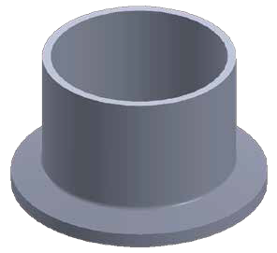
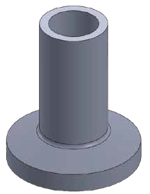
ØB ØB
ØA
ØD
L,L1,L2
ØA
L,L1,L2
ØD

(DT22) DT-4.1.4-1
AWF WELD FERRULE
SIZE | in. | øA |  | mm | in. | øB |  | mm | in. | øD |  | mm | in. | L |  | mm | in. | L1 |  | mm | in. | L2 |  | mm
1/2" | 0.370 |  | 9.4 |  | 0.500 |  | 12.7 |  | 0.984 |  | 25 |  | 0.500 |  | 12.7 |  | 1.130 |  | 28.7 |  | 1.752 |  | 44.5
3/4" | 0.618 |  | 15.75 |  | 0.750 |  | 19.05 |  | 0.984 |  | 25 |  | 0.500 |  | 12.7 |  | 1.130 |  | 28.7 |  | 1.752 |  | 44.5
1" | 0.870 |  | 22.1 |  | 1.000 |  | 1.000 |  | 1.339/1.984 |  | 34/50.4 |  | 0.500 |  | 12.7 |  | 1.130 |  | 28.7 |  | 1.752 |  | 44.5
1 1/₂" | 1.370 |  | 34.8 |  | 1.500 |  | 38.1 |  | 1.339/1.984 |  | 34/50.4 |  | 0.500 |  | 12.7 |  | 1.130 |  | 28.7 |  | 1.752 |  | 44.5
2" | 1.870 |  | 47.5 |  | 2.000 |  | 50.8 |  | 2.516 |  | 63.9 |  | 0.500 |  | 12.7 |  | 1.130 |  | 28.7 |  | 2.252 |  | 57.2
2 1/₂" | 2.370 |  | 60.2 |  | 2.500 |  | 63.5 |  | 3.047 |  | 77.4 |  | 0.500 |  | 12.7 |  | 1.130 |  | 28.7 |  | 2.252 |  | 57.2
3" | 2.870 |  | 72.9 |  | 3.000 |  | 76.2 |  | 3.579 |  | 90.9 |  | 0.500 |  | 12.7 |  | 1.130 |  | 28.7 |  | 2.252 |  | 57.2
4" | 3.835 |  | 97.4 |  | 4.000 |  | 101.6 |  | 4.681 |  | 118.9 |  | 0.626 |  | 15.9 |  | 1.130 |  | 28.7 |  | 2.252 |  | 57.2
6" | 5.780 |  | 146.9 |  | 5.000 |  | 152.4 |  | 6.571 |  | 166.9 |  | 0.752 |  | 19.1 |  | 1.500 |  | 38.1 |  | 3.000 |  | 76.2

(DT31) DT-4.1.5-2
SOLID END CAP
L
ØD
SIZE | øD  in. mm |  | L  in. mm
1/2" | 0.984 | 25 | 0.187 | 4.7
3/4" | 0.984 | 25 | 0.187 | 4.7
1" | 1.339/1.984 | 34/50.4 | 0.250 | 6.4
1 1/₂" | 1.339/1.984 | 34/50.4 | 0.250 | 6.4
2" | 2.516 | 63.9 | 0.250 | 6.4
2 1/₂" | 3.047 | 77.4 | 0.250 | 6.4
3" | 3.579 | 90.9 | 0.250 | 6.4
4" | 4.681 | 118.9 | 0.312 | 7.9
6" | 6.571 | 166.9 | 0.437 | 11.1

NO. S3 PART NO SIZE DESCRIPTION
171 | 4131AC.SF4-2550 | 2.5"*1/2" 1.65mm | DT11 Concentric Reducer Weld Ends SF4 ID EP Finished Ra<0.38μm/ OD Pol. Ra<0.8μm
172 | 4131AC.SF4-2575 | 2.5"*3/4" 1.65mm
173 | 4131AC.SF4-2510 | 2.5"*1" 1.65mm
174 | 4131AC.SF4-2515 | 2.5"*1.5" 1.65mm
175 | 4131AC.SF4-2520 | 2.5"*2" 1.65mm
176 | 4131AC.SF4-3010 | 3"*1" 1.65mm
177 | 4131AC.SF4-3015 | 3"*1.5" 1.65mm
178 | 4131AC.SF4-3020 | 3"*2" 1.65mm
179 | 4131AC.SF4-3025 | 3"*2.5" 1.65mm
180 | 4131AC.SF4-4010 | 4"*1" 2.1*1.65mm
181 | 4131AC.SF4-4015 | 4"*1.5" 2.1*1.65mm
182 | 4131AC.SF4-4020 | 4"*2" 2.1*1.65mm
183 | 4131AC.SF4-4025 | 4"*2.5" 2.1*1.65mm
184 | 4131AC.SF4-4030 | 4"*3" 2.1*1.65mm
185 | 4131AE.SF1-7550 | 3/4"*1/2" 1.65mm | DT11 Eccentric Reducer Weld Ends SF1 ID Pol. Ra<0.5μm/ OD Pol. Ra<0.8μm
186 | 4131AE.SF1-1050 | 1"*1/2" 1.65mm
187 | 4131AE.SF1-1075 | 1"*3/4" 1.65mm
188 | 4131AE.SF1-1550 | 1.5"*1/2" 1.65mm
189 | 4131AE.SF1-1575 | 1.5"*3/4" 1.65mm
190 | 4131AE.SF1-1510 | 1.5"*1" 1.65mm
191 | 4131AE.SF1-2050 | 2"*1/2" 1.65mm
192 | 4131AE.SF1-2075 | 2"*3/4" 1.65mm
193 | 4131AE.SF1-2010 | 2"*1" 1.65mm
194 | 4131AE.SF1-2015 | 2"*1.5" 1.65mm
195 | 4131AE.SF1-2550 | 2.5"*1/2" 1.65mm
196 | 4131AE.SF1-2575 | 2.5"*3/4" 1.65mm
197 | 4131AE.SF1-2510 | 2.5"*1" 1.65mm
198 | 4131AE.SF1-2515 | 2.5"*1.5" 1.65mm
199 | 4131AE.SF1-2520 | 2.5"*2" 1.65mm
200 | 4131AE.SF1-3010 | 3"*1" 1.65mm
201 | 4131AE.SF1-3015 | 3"*1.5" 1.65mm
202 | 4131AE.SF1-3020 | 3"*2" 1.65mm
203 | 4131AE.SF1-3025 | 3"*2.5" 1.65mm
204 | 4131AE.SF1-4010 | 4"*1" 2.1*1.65mm
205 | 4131AE.SF1-4015 | 4"*1.5" 2.1*1.65mm
206 | 4131AE.SF1-4020 | 4"*2" 2.1*1.65mm
207 | 4131AE.SF1-4025 | 4"*2.5" 2.1*1.65mm
208 | 4131AE.SF1-4030 | 4"*3" 2.1*1.65mm
209 | 4131AE.SF4-7550 | 3/4"*1/2" 1.65mm | DT11 Eccentric Reducer Weld Ends SF4 ID EP Finished Ra<0.38 μm/ OD Pol. Ra<0.8μm
210 | 4131AE.SF4-1050 | 1"*1/2" 1.65mm
211 | 4131AE.SF4-1075 | 1"*3/4" 1.65mm
212 | 4131AE.SF4-1550 | 1.5"*1/2" 1.65mm
213 | 4131AE.SF4-1575 | 1.5"*3/4" 1.65mm
214 | 4131AE.SF4-1510 | 1.5"*1" 1.65mm
215 | 4131AE.SF4-2050 | 2"*1/2" 1.65mm
216 | 4131AE.SF4-2075 | 2"*3/4" 1.65mm
217 | 4131AE.SF4-2010 | 2"*1" 1.65mm
218 | 4131AE.SF4-2015 | 2"*1.5" 1.65mm
219 | 4131AE.SF4-2550 | 2.5"*1/2" 1.65mm
220 | 4131AE.SF4-2575 | 2.5"*3/4" 1.65mm
221 | 4131AE.SF4-2510 | 2.5"*1" 1.65mm
222 | 4131AE.SF4-2515 | 2.5"*1.5" 1.65mm
223 | 4131AE.SF4-2520 | 2.5"*2" 1.65mm
224 | 4131AE.SF4-3010 | 3"*1" 1.65mm
225 | 4131AE.SF4-3015 | 3"*1.5" 1.65mm
226 | 4131AE.SF4-3020 | 3"*2" 1.65mm
227 | 4131AE.SF4-3025 | 3"*2.5" 1.65mm
228 | 4131AE.SF4-4010 | 4"*1" 2.1*1.65mm
229 | 4131AE.SF4-4015 | 4"*1.5" 2.1*1.65mm
230 | 4131AE.SF4-4020 | 4"*2" 2.1*1.65mm
231 | 4131AE.SF4-4025 | 4"*2.5" 2.1*1.65mm
232 | 4131AE.SF4-4030 | 4"*3" 2.1*1.65mm
233 | 4112.SF1-.50 | 1/2" 1.65mm | DT12 Elbow 90° Clamp/Weld End SF1 ID Pol. Ra<0.5μm/ OD Pol. Ra<0.8μm
234 | 4112.SF1-.75 | 3/4" 1.65mm
235 | 4112.SF1-1 | 1" 1.65mm
236 | 4112.SF1-15 | 1.5" 1.65mm
237 | 4112.SF1-2 | 2" 1.65mm
238 | 4112.SF1-25 | 2.5" 1.65mm
239 | 4112.SF1-3 | 3" 1.65mm
240 | 4112.SF1-4 | 4" 2.1mm
241 | 4112.SF4-.50 | 1/2" 1.65mm | DT12 Elbow 90° Clamp/  Weld End SF4 ID EP Finished  Ra<0.38μm/ OD Pol. Ra<0.8μm
242 | 4112.SF4-.75 | 3/4" 1.65mm
243 | 4112.SF4-1 | 1" 1.65mm
244 | 4112.SF4-15 | 1.5" 1.65mm
245 | 4112.SF4-2 | 2" 1.65mm
246 | 4112.SF4-25 | 2.5" 1.65mm
247 | 4112.SF4-3 | 3" 1.65mm
248 | 4112.SF4-4 | 4" 2.1mm
249 | 4115.SF1-.50 | 1/2" 1.65mm | DT13 Elbow 45° Clamp/ Weld End SF1 ID Pol.  Ra<0.5μm/ OD Pol. Ra<0.8μm
250 | 4115.SF1-.75 | 3/4" 1.65mm
251 | 4115.SF1-1 | 1" 1.65mm
252 | 4115.SF1-15 | 1.5" 1.65mm
253 | 4115.SF1-2 | 2" 1.65mm
254 | 4115.SF1-25 | 2.5" 1.65mm
255 | 4115.SF1-3 | 3" 1.65mm
256 | 4115.SF1-4 | 4" 2.1mm

NO. S3 PART NO SIZE DESCRIPTION
257 | 4115.SF4-.50 | 1/2" 1.65mm | DT13 Elbow 45° Clamp/Weld End SF4 ID EP Finished Ra<0.38μm/ OD Pol. Ra<0.8μm
258 | 4115.SF4-.75 | 3/4" 1.65mm
259 | 4115.SF4-1 | 1" 1.65mm
260 | 4115.SF4-15 | 1.5" 1.65mm
261 | 4115.SF4-2 | 2" 1.65mm
262 | 4115.SF4-25 | 2.5" 1.65mm
263 | 4115.SF4-3 | 3" 1.65mm
264 | 4115.SF4-4 | 4" 2.1mm
265 | 4127.SF1-7550 | 3/4"*1/2" 1.65mm | DT14 Tee Reducing Short Outlet Clamp/ Run Body Weld Ends SF1 ID Pol. Ra<0.5μm/ OD Pol.  Ra<0.8μm
266 | 4127.SF1-1050 | 1"*1/2" 1.65mm
267 | 4127.SF1-1075 | 1"*3/4" 1.65mm
268 | 4127.SF1-1550 | 1.5"*1/2" 1.65mm
269 | 4127.SF1-1575 | 1.5"*3/4" 1.65mm
270 | 4127.SF1-1510 | 1.5"*1" 1.65mm
271 | 4127.SF1-2050 | 2"*1/2" 1.65mm
272 | 4127.SF1-2075 | 2"*3/4" 1.65mm
273 | 4127.SF1-2010 | 2"*1" 1.65mm
274 | 4127.SF1-2015 | 2"*1.5" 1.65mm
275 | 4127.SF1-2550 | 2.5"*1/2" 1.65mm
276 | 4127.SF1-2575 | 2.5"*3/4" 1.65mm
277 | 4127.SF1-2510 | 2.5"*1" 1.65mm
278 | 4127.SF1-2515 | 2.5"*1.5" 1.65mm
279 | 4127.SF1-2520 | 2.5"*2" 1.65mm
280 | 4127.SF1-3050 | 3"*1/2" 1.65mm
281 | 4127.SF1-3075 | 3"*3/4" 1.65mm
282 | 4127.SF1-3010 | 3"*1" 1.65mm
283 | 4127.SF1-3015 | 3"*1.5" 1.65mm
284 | 4127.SF1-3020 | 3"*2" 1.65mm
285 | 4127.SF1-3025 | 3"*2.5" 1.65mm
286 | 4127.SF1-4050 | 4"*1/2" 2.1*1.65mm
287 | 4127.SF1-4075 | 4"*3/4" 2.1*1.65mm
288 | 4127.SF1-4010 | 4"*1" 2.1*1.65mm
289 | 4127.SF1-4015 | 4"*1.5" 2.1*1.65mm
290 | 4127.SF1-4020 | 4"*2" 2.1*1.65mm
291 | 4127.SF1-4025 | 4"*2.5" 2.1*1.65mm
292 | 4127.SF1-4030 | 4"*3" 2.1*1.65mm
293 | 4127.SF4-7550 | 3/4"*1/2" 1.65mm | DT14 Tee Reducing Short Outlet Clamp/ Run Body Weld Ends SF4 ID EP Finished Ra<0.38μm/ OD Pol. Ra<0.8μm
294 | 4127.SF4-1050 | 1"*1/2" 1.65mm
295 | 4127.SF4-1075 | 1"*3/4" 1.65mm
296 | 4127.SF4-1550 | 1.5"*1/2" 1.65mm
297 | 4127.SF4-1575 | 1.5"*3/4" 1.65mm
298 | 4127.SF4-1510 | 1.5"*1" 1.65mm
299 | 4127.SF4-2050 | 2"*1/2" 1.65mm
300 | 4127.SF4-2075 | 2"*3/4" 1.65mm
301 | 4127.SF4-2010 | 2"*1" 1.65mm
302 | 4127.SF4-2015 | 2"*1.5" 1.65mm
303 | 4127.SF4-2550 | 2.5"*1/2" 1.65mm
304 | 4127.SF4-2575 | 2.5"*3/4" 1.65mm
305 | 4127.SF4-2510 | 2.5"*1" 1.65mm
306 | 4127.SF4-2515 | 2.5"*1.5" 1.65mm
307 | 4127.SF4-2520 | 2.5"*2" 1.65mm
308 | 4127.SF4-3050 | 3"*1/2" 1.65mm
309 | 4127.SF4-3075 | 3"*3/4" 1.65mm
310 | 4127.SF4-3010 | 3"*1" 1.65mm
311 | 4127.SF4-3015 | 3"*1.5" 1.65mm
312 | 4127.SF4-3020 | 3"*2" 1.65mm
313 | 4127.SF4-3025 | 3"*2.5" 1.65mm
314 | 4127.SF4-4050 | 4"*1/2" 2.1*1.65mm
315 | 4127.SF4-4075 | 4"*3/4" 2.1*1.65mm
316 | 4127.SF4-4010 | 4"*1" 2.1*1.65mm
317 | 4127.SF4-4015 | 4"*1.5" 2.1*1.65mm
318 | 4127.SF4-4020 | 4"*2" 2.1*1.65mm
319 | 4127.SF4-4025 | 4"*2.5" 2.1*1.65mm
320 | 4127.SF4-4030 | 4"*3" 2.1*1.65mm
321 | 4122.SF1-.50 | 1/2" 1.65mm | DT15 Tee Equal Outlet Short Clamp End/ Run Body Weld Ends SF1 ID Pol. Ra<0.5μm/ OD Pol. Ra<0.8μm
322 | 4122.SF1-.75 | 3/4" 1.65mm
323 | 4122.SF1-1 | 1" 1.65mm
324 | 4122.SF1-15 | 1.5" 1.65mm
325 | 4122.SF1-2 | 2" 1.65mm
326 | 4122.SF1-25 | 2.5" 1.65mm
327 | 4122.SF1-3 | 3" 1.65mm
328 | 4122.SF1-4 | 4" 2.1mm
329 | 4122.SF4-.50 | 1/2" 1.65mm | DT15 Tee Equal Outlet Short Clamp End/ Run Body Weld Ends SF4 ID EP Finished Ra<0.38μm/ OD Pol. Ra<0.8μm
330 | 4122.SF4-.75 | 3/4" 1.65mm
331 | 4122.SF4-1 | 1" 1.65mm
332 | 4122.SF4-15 | 1.5" 1.65mm
333 | 4122.SF4-2 | 2" 1.65mm
334 | 4122.SF4-25 | 2.5" 1.65mm
335 | 4122.SF4-3 | 3" 1.65mm
336 | 4122.SF4-4 | 4" 2.1mm
337 | 4113.SF1-.50 | 1/2" 1.65mm | DT16 Elbow 90° Clamp Ends SF1  ID Pol. Ra<0.5μm/ OD Pol. Ra<0.8μm
338 | 4113.SF1-.75 | 3/4" 1.65mm
339 | 4113.SF1-1 | 1" 1.65mm
340 | 4113.SF1-15 | 1.5" 1.65mm
341 | 4113.SF1-2 | 2" 1.65mm
342 | 4113.SF1-25 | 2.5" 1.65mm

NO. S3 PART NO SIZE DESCRIPTION
343 | 4113.SF1-3 | 3" 1.65mm | DT16 Elbow 90° Clamp Ends SF1 ID Pol.  Ra<0.5μm/ OD Pol. Ra<0.8μm
344 | 4113.SF1-4 | 4" 2.1mm
345 | 4113.SF4-.50 | 1/2" 1.65mm | DT16 Elbow 90° Clamp Ends SF4 ID EP Finished Ra<0.38μm/ OD Pol. Ra<0.8μm
346 | 4113.SF4-.75 | 3/4" 1.65mm
347 | 4113.SF4-1 | 1" 1.65mm
348 | 4113.SF4-15 | 1.5" 1.65mm
349 | 4113.SF4-2 | 2" 1.65mm
350 | 4113.SF4-25 | 2.5" 1.65mm
351 | 4113.SF4-3 | 3" 1.65mm
352 | 4113.SF4-4 | 4" 2.1mm
353 | 4116.SF1-.50 | 1/2" 1.65mm | DT17 Elbow 45° Clamp Ends SF1  ID Pol. Ra<0.5μm/ OD Pol. Ra<0.8μm
354 | 4116.SF1-.75 | 3/4" 1.65mm
355 | 4116.SF1-1 | 1" 1.65mm
356 | 4116.SF1-15 | 1.5" 1.65mm
357 | 4116.SF1-2 | 2" 1.65mm
358 | 4116.SF1-25 | 2.5" 1.65mm
359 | 4116.SF1-3 | 3" 1.65mm
360 | 4116.SF1-4 | 4" 2.1mm
361 | 4116.SF4-.50 | 1/2" 1.65mm | DT17 Elbow 45° Clamp Ends SF4 ID EP Finished Ra<0.38μm/ OD Pol. Ra<0.8μm
362 | 4116.SF4-.75 | 3/4" 1.65mm
363 | 4116.SF4-1 | 1" 1.65mm
364 | 4116.SF4-15 | 1.5" 1.65mm
365 | 4116.SF4-2 | 2" 1.65mm
366 | 4116.SF4-25 | 2.5" 1.65mm
367 | 4116.SF4-3 | 3" 1.65mm
368 | 4116.SF4-4 | 4" 2.1mm
369 | 4124T.SF1-.50 | 1/2" 1.65mm | DT18 Tee Equal Clamp Ends SF1  ID Pol. Ra<0.5μm/ OD Pol. Ra<0.8μm
370 | 4124T.SF1-.75 | 3/4" 1.65mm
371 | 4124T.SF1-1 | 1" 1.65mm
372 | 4124T.SF1-15 | 1.5" 1.65mm
373 | 4124T.SF1-2 | 2" 1.65mm
374 | 4124T.SF1-25 | 2.5" 1.65mm
375 | 4124T.SF1-3 | 3" 1.65mm
376 | 4124T.SF1-4 | 4" 2.1mm
377 | 4124T.SF4-.50 | 1/2" 1.65mm | DT18 Tee Equal Clamp Ends SF4 ID EP Finished Ra<0.38μm/ OD Pol. Ra<0.8μm
378 | 4124T.SF4-.75 | 3/4" 1.65mm
379 | 4124T.SF4-1 | 1" 1.65mm
380 | 4124T.SF4-15 | 1.5" 1.65mm
381 | 4124T.SF4-2 | 2" 1.65mm
382 | 4124T.SF4-25 | 2.5" 1.65mm
383 | 4124T.SF4-3 | 3" 1.65mm
384 | 4124T.SF4-4 | 4" 2.1mm
385 | 4124C.SF1-.50 | 1/2" 1.65mm | DT18 Cross Equal Long Clamp Ends SF1 ID Pol. Ra<0.5μm/ OD Pol. Ra<0.8μm
386 | 4124C.SF1-.75 | 3/4" 1.65mm
387 | 4124C.SF1-1 | 1" 1.65mm
388 | 4124C.SF1-15 | 1.5" 1.65mm
389 | 4124C.SF1-2 | 2" 1.65mm
390 | 4124C.SF1-25 | 2.5" 1.65mm
391 | 4124C.SF1-3 | 3" 1.65mm
392 | 4124C.SF1-4 | 4" 2.1mm
393 | 4124C.SF4-.50 | 1/2" 1.65mm | DT18 Cross Equal Long Clamp Ends SF4 ID EP Finished Ra<0.38μm/ OD Pol. Ra<0.8μm
394 | 4124C.SF4-.75 | 3/4" 1.65mm
395 | 4124C.SF4-1 | 1" 1.65mm
396 | 4124C.SF4-15 | 1.5" 1.65mm
397 | 4124C.SF4-2 | 2" 1.65mm
398 | 4124C.SF4-25 | 2.5" 1.65mm
399 | 4124C.SF4-3 | 3" 1.65mm
400 | 4124C.SF4-4 | 4" 2.1mm
401 | 4128.SF1-7550 | 3/4"*1/2" 1.65mm | DT19 Tee Reducing Clamp Ends SF1 ID Pol. Ra<0.5μm/ OD Pol. Ra<0.8μm
402 | 4128.SF1-1050 | 1"*1/2" 1.65mm
403 | 4128.SF1-1075 | 1"*3/4" 1.65mm
404 | 4128.SF1-1550 | 1.5"*1/2" 1.65mm
405 | 4128.SF1-1575 | 1.5"*3/4" 1.65mm
406 | 4128.SF1-1510 | 1.5"*1" 1.65mm
407 | 4128.SF1-2050 | 2"*1/2" 1.65mm
408 | 4128.SF1-2075 | 2"*3/4" 1.65mm
409 | 4128.SF1-2010 | 2"*1" 1.65mm
410 | 4128.SF1-2015 | 2"*1.5" 1.65mm
411 | 4128.SF1-2550 | 2.5"*1/2" 1.65mm
412 | 4128.SF1-2575 | 2.5"*3/4" 1.65mm
413 | 4128.SF1-2510 | 2.5"*1" 1.65mm
414 | 4128.SF1-2515 | 2.5"*1.5" 1.65mm
415 | 4128.SF1-2520 | 2.5"*2" 1.65mm
416 | 4128.SF1-3050 | 3"*1/2" 1.65mm
417 | 4128.SF1-3075 | 3"*3/4" 1.65mm
418 | 4128.SF1-3010 | 3"*1" 1.65mm
419 | 4128.SF1-3015 | 3"*1.5" 1.65mm
420 | 4128.SF1-3020 | 3"*2" 1.65mm
421 | 4128.SF1-3025 | 3"*2.5" 1.65mm
422 | 4128.SF1-4050 | 4"*1/2" 2.1*1.65mm
423 | 4128.SF1-4075 | 4"*3/4" 2.1*1.65mm
424 | 4128.SF1-4010 | 4"*1" 2.1*1.65mm
425 | 4128.SF1-4015 | 4"*1.5" 2.1*1.65mm
426 | 4128.SF1-4020 | 4"*2" 2.1*1.65mm
427 | 4128.SF1-4025 | 4"*2.5" 2.1*1.65mm
428 | 4128.SF1-4030 | 4"*3" 2.1*1.65mm

NO. S3 PART NO SIZE DESCRIPTION
429 | 4128.SF4-7550 | 3/4"*1/2" 1.65mm | DT19 Tee Reducing Clamp Ends SF4 ID EP Finished Ra<0.38μm/ OD Pol. Ra<0.8μm
430 | 4128.SF4-1050 | 1"*1/2" 1.65mm
431 | 4128.SF4-1075 | 1"*3/4" 1.65mm
432 | 4128.SF4-1550 | 1.5"*1/2" 1.65mm
433 | 4128.SF4-1575 | 1.5"*3/4" 1.65mm
434 | 4128.SF4-1510 | 1.5"*1" 1.65mm
435 | 4128.SF4-2050 | 2"*1/2" 1.65mm
436 | 4128.SF4-2075 | 2"*3/4" 1.65mm
437 | 4128.SF4-2010 | 2"*1" 1.65mm
438 | 4128.SF4-2015 | 2"*1.5" 1.65mm
439 | 4128.SF4-2550 | 2.5"*1/2" 1.65mm
440 | 4128.SF4-2575 | 2.5"*3/4" 1.65mm
441 | 4128.SF4-2510 | 2.5"*1" 1.65mm
442 | 4128.SF4-2515 | 2.5"*1.5" 1.65mm
443 | 4128.SF4-2520 | 2.5"*2" 1.65mm
444 | 4128.SF4-3050 | 3"*1/2" 1.65mm
445 | 4128.SF4-3075 | 3"*3/4" 1.65mm
446 | 4128.SF4-3010 | 3"*1" 1.65mm
447 | 4128.SF4-3015 | 3"*1.5" 1.65mm
448 | 4128.SF4-3020 | 3"*2" 1.65mm
449 | 4128.SF4-3025 | 3"*2.5" 1.65mm
450 | 4128.SF4-4050 | 4"*1/2" 2.1*1.65mm
451 | 4128.SF4-4075 | 4"*3/4" 2.1*1.65mm
452 | 4128.SF4-4010 | 4"*1" 2.1*1.65mm
453 | 4128.SF4-4015 | 4"*1.5" 2.1*1.65mm
454 | 4128.SF4-4020 | 4"*2" 2.1*1.65mm
455 | 4128.SF4-4025 | 4"*2.5" 2.1*1.65mm
456 | 4128.SF4-4030 | 4"*3" 2.1*1.65mm
457 | 4129.SF1-7550 | 3/4"*1/2" 1.65mm | DT20 Tee Reducing Short Outlet Clamp Ends SF1 ID Pol. Ra<0.5μ m/ OD Pol. Ra<0.8μm
458 | 4129.SF1-1050 | 1"*1/2" 1.65mm
459 | 4129.SF1-1075 | 1"*3/4" 1.65mm
460 | 4129.SF1-1550 | 1.5"*1/2" 1.65mm
461 | 4129.SF1-1575 | 1.5"*3/4" 1.65mm
462 | 4129.SF1-1510 | 1.5"*1" 1.65mm
463 | 4129.SF1-2050 | 2"*1/2" 1.65mm
464 | 4129.SF1-2075 | 2"*3/4" 1.65mm
465 | 4129.SF1-2010 | 2"*1" 1.65mm
466 | 4129.SF1-2015 | 2"*1.5" 1.65mm
467 | 4129.SF1-2550 | 2.5"*1/2" 1.65mm
468 | 4129.SF1-2575 | 2.5"*3/4" 1.65mm
469 | 4129.SF1-2510 | 2.5"*1" 1.65mm
470 | 4129.SF1-2515 | 2.5"*1.5" 1.65mm
471 | 4129.SF1-2520 | 2.5"*2" 1.65mm
472 | 4129.SF1-3050 | 3"*1/2" 1.65mm
473 | 4129.SF1-3075 | 3"*3/4" 1.65mm
474 | 4129.SF1-3010 | 3"*1" 1.65mm
475 | 4129.SF1-3015 | 3"*1.5" 1.65mm
476 | 4129.SF1-3020 | 3"*2" 1.65mm
477 | 4129.SF1-3025 | 3"*2.5" 1.65mm
478 | 4129.SF1-4050 | 4"*1/2" 2.1*1.65mm
479 | 4129.SF1-4075 | 4"*3/4" 2.1*1.65mm
480 | 4129.SF1-4010 | 4"*1" 2.1*1.65mm
481 | 4129.SF1-4015 | 4"*1.5" 2.1*1.65mm
482 | 4129.SF1-4020 | 4"*2" 2.1*1.65mm
483 | 4129.SF1-4025 | 4"*2.5" 2.1*1.65mm
484 | 4129.SF1-4030 | 4"*3" 2.1*1.65mm
485 | 4129.SF4-7550 | 3/4"*1/2" 1.65mm | DT20 Tee Reducing Short Outlet Clamp Ends SF4 ID EP Finished Ra<0.38μm/ OD Pol. Ra<0.8μm
486 | 4129.SF4-1050 | 1"*1/2" 1.65mm
487 | 4129.SF4-1075 | 1"*3/4" 1.65mm
488 | 4129.SF4-1550 | 1.5"*1/2" 1.65mm
489 | 4129.SF4-1575 | 1.5"*3/4" 1.65mm
490 | 4129.SF4-1510 | 1.5"*1" 1.65mm
491 | 4129.SF4-2050 | 2"*1/2" 1.65mm
492 | 4129.SF4-2075 | 2"*3/4" 1.65mm
493 | 4129.SF4-2010 | 2"*1" 1.65mm
494 | 4129.SF4-2015 | 2"*1.5" 1.65mm
495 | 4129.SF4-2550 | 2.5"*1/2" 1.65mm
496 | 4129.SF4-2575 | 2.5"*3/4" 1.65mm
497 | 4129.SF4-2510 | 2.5"*1" 1.65mm
498 | 4129.SF4-2515 | 2.5"*1.5" 1.65mm
499 | 4129.SF4-2520 | 2.5"*2" 1.65mm
500 | 4129.SF4-3050 | 3"*1/2" 1.65mm
501 | 4129.SF4-3075 | 3"*3/4" 1.65mm
502 | 4129.SF4-3010 | 3"*1" 1.65mm
503 | 4129.SF4-3015 | 3"*1.5" 1.65mm
504 | 4129.SF4-3020 | 3"*2" 1.65mm
505 | 4129.SF4-3025 | 3"*2.5" 1.65mm
506 | 4129.SF4-4050 | 4"*1/2" 2.1*1.65mm
507 | 4129.SF4-4075 | 4"*3/4" 2.1*1.65mm
508 | 4129.SF4-4010 | 4"*1" 2.1*1.65mm
509 | 4129.SF4-4015 | 4"*1.5" 2.1*1.65mm
510 | 4129.SF4-4020 | 4"*2" 2.1*1.65mm
511 | 4129.SF4-4025 | 4"*2.5" 2.1*1.65mm
512 | 4129.SF4-4030 | 4"*3" 2.1*1.65mm

NO. S3 PART NO SIZE DESCRIPTION
513 | 4133AC.SF1-7550 | 3/4"*1/2" 1.65mm | DT21 Concentric Reducer Clamp Ends SF1 ID Pol. Ra<0.5μm/ OD Pol. Ra<0.8μm
514 | 4133AC.SF1-1050 | 1"*1/2" 1.65mm
515 | 4133AC.SF1-1075 | 1"*3/4" 1.65mm
516 | 4133AC.SF1-1550 | 1.5"*1/2" 1.65mm
517 | 4133AC.SF1-1575 | 1.5"*3/4" 1.65mm
518 | 4133AC.SF1-1510 | 1.5"*1" 1.65mm
519 | 4133AC.SF1-2050 | 2"*1/2" 1.65mm
520 | 4133AC.SF1-2075 | 2"*3/4" 1.65mm
521 | 4133AC.SF1-2010 | 2"*1" 1.65mm
522 | 4133AC.SF1-2015 | 2"*1.5" 1.65mm
523 | 4133AC.SF1-2550 | 2.5"*1/2" 1.65mm
524 | 4133AC.SF1-2575 | 2.5"*3/4" 1.65mm
525 | 4133AC.SF1-2510 | 2.5"*1" 1.65mm
526 | 4133AC.SF1-2515 | 2.5"*1.5" 1.65mm
527 | 4133AC.SF1-2520 | 2.5"*2" 1.65mm
528 | 4133AC.SF1-3010 | 3"*1" 1.65mm
529 | 4133AC.SF1-3015 | 3"*1.5" 1.65mm
530 | 4133AC.SF1-3020 | 3"*2" 1.65mm
531 | 4133AC.SF1-3025 | 3"*2.5" 1.65mm
532 | 4133AC.SF1-4010 | 4"*1" 2.1*1.65mm
533 | 4133AC.SF1-4015 | 4"*1.5" 2.1*1.65mm
534 | 4133AC.SF1-4020 | 4"*2" 2.1*1.65mm
535 | 4133AC.SF1-4025 | 4"*2.5" 2.1*1.65mm
536 | 4133AC.SF1-4030 | 4"*3" 2.1*1.65mm
537 | 4133AC.SF4-7550 | 3/4"*1/2" 1.65mm | DT21 Concentric Reducer Clamp Ends SF4 ID EP Finished Ra<0.38μm/ OD Pol. Ra<0.8μm
538 | 4133AC.SF4-1050 | 1"*1/2" 1.65mm
539 | 4133AC.SF4-1075 | 1"*3/4" 1.65mm
540 | 4133AC.SF4-1550 | 1.5"*1/2" 1.65mm
541 | 4133AC.SF4-1575 | 1.5"*3/4" 1.65mm
542 | 4133AC.SF4-1510 | 1.5"*1" 1.65mm
543 | 4133AC.SF4-2050 | 2"*1/2" 1.65mm
544 | 4133AC.SF4-2075 | 2"*3/4" 1.65mm
545 | 4133AC.SF4-2010 | 2"*1" 1.65mm
546 | 4133AC.SF4-2015 | 2"*1.5" 1.65mm
547 | 4133AC.SF4-2550 | 2.5"*1/2" 1.65mm
548 | 4133AC.SF4-2575 | 2.5"*3/4" 1.65mm
549 | 4133AC.SF4-2510 | 2.5"*1" 1.65mm
550 | 4133AC.SF4-2515 | 2.5"*1.5" 1.65mm
551 | 4133AC.SF4-2520 | 2.5"*2" 1.65mm
552 | 4133AC.SF4-3010 | 3"*1" 1.65mm
553 | 4133AC.SF4-3015 | 3"*1.5" 1.65mm
554 | 4133AC.SF4-3020 | 3"*2" 1.65mm
555 | 4133AC.SF4-3025 | 3"*2.5" 1.65mm
556 | 4133AC.SF4-4010 | 4"*1" 2.1*1.65mm
557 | 4133AC.SF4-4015 | 4"*1.5" 2.1*1.65mm
558 | 4133AC.SF4-4020 | 4"*2" 2.1*1.65mm
559 | 4133AC.SF4-4025 | 4"*2.5" 2.1*1.65mm
560 | 4133AC.SF4-4030 | 4"*3" 2.1*1.65mm
561 | 4133AE.SF1-7550 | 3/4"*1/2" 1.65mm | DT21 Eccentric Reducer Clamp Ends SF1 ID Pol. Ra<0.5μm/ OD Pol. Ra<0.8μm
562 | 4133AE.SF1-1050 | 1"*1/2" 1.65mm
563 | 4133AE.SF1-1075 | 1"*3/4" 1.65mm
564 | 4133AE.SF1-1550 | 1.5"*1/2" 1.65mm
565 | 4133AE.SF1-1575 | 1.5"*3/4" 1.65mm
566 | 4133AE.SF1-1510 | 1.5"*1" 1.65mm
567 | 4133AE.SF1-2050 | 2"*1/2" 1.65mm
568 | 4133AE.SF1-2075 | 2"*3/4" 1.65mm
569 | 4133AE.SF1-2010 | 2"*1" 1.65mm
570 | 4133AE.SF1-2015 | 2"*1.5" 1.65mm
571 | 4133AE.SF1-2550 | 2.5"*1/2" 1.65mm
572 | 4133AE.SF1-2575 | 2.5"*3/4" 1.65mm
573 | 4133AE.SF1-2510 | 2.5"*1" 1.65mm
574 | 4133AE.SF1-2515 | 2.5"*1.5" 1.65mm
575 | 4133AE.SF1-2520 | 2.5"*2" 1.65mm
576 | 4133AE.SF1-3010 | 3"*1" 1.65mm
577 | 4133AE.SF1-3015 | 3"*1.5" 1.65mm
578 | 4133AE.SF1-3020 | 3"*2" 1.65mm
579 | 4133AE.SF1-3025 | 3"*2.5" 1.65mm
580 | 4133AE.SF1-4010 | 4"*1" 2.1*1.65mm
581 | 4133AE.SF1-4015 | 4"*1.5" 2.1*1.65mm
582 | 4133AE.SF1-4020 | 4"*2" 2.1*1.65mm
583 | 4133AE.SF1-4025 | 4"*2.5" 2.1*1.65mm
584 | 4133AE.SF1-4030 | 4"*3" 2.1*1.65mm
585 | 4133AE.SF4-7550 | 3/4"*1/2" 1.65mm | DT21 Eccentric Reducer Clamp Ends SF4 ID EP Finished Ra<0.38μm/ OD Pol. Ra<0.8μm
586 | 4133AE.SF4-1050 | 1"*1/2" 1.65mm
587 | 4133AE.SF4-1075 | 1"*3/4" 1.65mm
588 | 4133AE.SF4-1550 | 1.5"*1/2" 1.65mm
589 | 4133AE.SF4-1575 | 1.5"*3/4" 1.65mm
590 | 4133AE.SF4-1510 | 1.5"*1" 1.65mm
591 | 4133AE.SF4-2050 | 2"*1/2" 1.65mm
592 | 4133AE.SF4-2075 | 2"*3/4" 1.65mm
593 | 4133AE.SF4-2010 | 2"*1" 1.65mm
594 | 4133AE.SF4-2015 | 2"*1.5" 1.65mm
595 | 4133AE.SF4-2550 | 2.5"*1/2" 1.65mm
596 | 4133AE.SF4-2575 | 2.5"*3/4" 1.65mm
597 | 4133AE.SF4-2510 | 2.5"*1" 1.65mm

NO. S3 PART NO SIZE DESCRIPTION
598 | 4133AE.SF4-2515 | 2.5"*1.5" 1.65mm | DT21 Eccentric Reducer Clamp Ends SF4 ID EP Finished Ra<0.38μm/ OD Pol. Ra<0.8μm
599 | 4133AE.SF4-2520 | 2.5"*2" 1.65mm
600 | 4133AE.SF4-3010 | 3"*1" 1.65mm
601 | 4133AE.SF4-3015 | 3"*1.5" 1.65mm
602 | 4133AE.SF4-3020 | 3"*2" 1.65mm
603 | 4133AE.SF4-3025 | 3"*2.5" 1.65mm
604 | 4133AE.SF4-4010 | 4"*1" 2.1*1.65mm
605 | 4133AE.SF4-4015 | 4"*1.5" 2.1*1.65mm
606 | 4133AE.SF4-4020 | 4"*2" 2.1*1.65mm
607 | 4133AE.SF4-4025 | 4"*2.5" 2.1*1.65mm
608 | 4133AE.SF4-4030 | 4"*3" 2.1*1.65mm
609 | 4141.SF1-.50 | 1/2" | DT22 Welding Ferrule L=44.5mm SF1 ID Pol. Ra<0.5μm/ OD Pol. Ra<0.8μm
610 | 4141.SF1-.75 | 3/4"
611 | 4141.SF1-1 | 1"
612 | 4141.SF1-15 | 1.5"
613 | 4141.SF1-2 | 2"
614 | 4141.SF1-25 | 2.5"
615 | 4141.SF1-3 | 3"
616 | 4141.SF1-4 | 4"
617 | 4141.SF4-.50 | 1/2" | DT22 Welding Ferrule L=44.5mm SF4 ID EP Finished Ra<0.38μm/ OD Pol. Ra<0.8μm
618 | 4141.SF4-.75 | 3/4"
619 | 4141.SF4-1 | 1"
620 | 4141.SF4-15 | 1.5"
621 | 4141.SF4-2 | 2"
622 | 4141.SF4-25 | 2.5"
623 | 4141.SF4-3 | 3"
624 | 4141.SF4-4 | 4"
625 | 4117.SF1-.50 | 1/2" 1.65mm | DT23 Elbow 180° Weld Ends SF1  ID Pol. Ra<0.5μm/ OD Pol. Ra<0.8μm
626 | 4117.SF1-.75 | 3/4" 1.65mm
627 | 4117.SF1-1 | 1" 1.65mm
628 | 4117.SF1-15 | 1.5" 1.65mm
629 | 4117.SF1-2 | 2" 1.65mm
630 | 4117.SF1-25 | 2.5" 1.65mm
631 | 4117.SF1-3 | 3" 1.65mm
632 | 4117.SF1-4 | 4" 2.1mm
633 | 4117.SF4-.50 | 1/2" 1.65mm | DT23 Elbow 180° Weld Ends SF4 ID EP Finished Ra<0.38μm/ OD Pol. Ra<0.8μm
634 | 4117.SF4-.75 | 3/4" 1.65mm
635 | 4117.SF4-1 | 1" 1.65mm
636 | 4117.SF4-15 | 1.5" 1.65mm
637 | 4117.SF4-2 | 2" 1.65mm
638 | 4117.SF4-25 | 2.5" 1.65mm
639 | 4117.SF4-3 | 3" 1.65mm
640 | 4117.SF4-4 | 4" 2.1mm
641 | 4118.SF1-.50 | 1/2" 1.65mm | DT24 Elbow 180° Clamp Ends SF1 ID Pol. Ra<0.5μm/ OD Pol. Ra<0.8μm
642 | 4118.SF1-.75 | 3/4" 1.65mm
643 | 4118.SF1-1 | 1" 1.65mm
644 | 4118.SF1-15 | 1.5" 1.65mm
645 | 4118.SF1-2 | 2" 1.65mm
646 | 4118.SF1-25 | 2.5" 1.65mm
647 | 4118.SF1-3 | 3" 1.65mm
648 | 4118.SF1-4 | 4" 2.1mm
649 | 4118.SF4-.50 | 1/2" 1.65mm | DT24 Elbow 180° Clamp Ends SF4 ID EP Finished Ra<0.38μm/ OD Pol. Ra<0.8μm
650 | 4118.SF4-.75 | 3/4" 1.65mm
651 | 4118.SF4-1 | 1" 1.65mm
652 | 4118.SF4-15 | 1.5" 1.65mm
653 | 4118.SF4-2 | 2" 1.65mm
654 | 4118.SF4-25 | 2.5" 1.65mm
655 | 4118.SF4-3 | 3" 1.65mm
656 | 4118.SF4-4 | 4" 2.1mm
657 | 4123.SF1-.50 | 1/2" 1.65mm | DT25 Tee Run Short Outlet Clamp/Weld Ends SF1 ID Pol. Ra<0.5μm/ OD Pol. Ra<0.8μm
658 | 4123.SF1-.75 | 3/4" 1.65mm
659 | 4123.SF1-1 | 1" 1.65mm
660 | 4123.SF1-15 | 1.5" 1.65mm
661 | 4123.SF1-2 | 2" 1.65mm
662 | 4123.SF1-25 | 2.5" 1.65mm
663 | 4123.SF1-3 | 3" 1.65mm
664 | 4123.SF1-4 | 4" 2.1mm
665 | 4123.SF4-.50 | 1/2" 1.65mm | DT25 Tee Run Short Outlet Clamp/Weld Ends SF4 ID EP Finished Ra<0.38μm/ OD Pol. Ra<0.8μm
666 | 4123.SF4-.75 | 3/4" 1.65mm
667 | 4123.SF4-1 | 1" 1.65mm
668 | 4123.SF4-15 | 1.5" 1.65mm
669 | 4123.SF4-2 | 2" 1.65mm
670 | 4123.SF4-25 | 2.5" 1.65mm
671 | 4123.SF4-3 | 3" 1.65mm
672 | 4123.SF4-4 | 4" 2.1mm
673 | 4132AC.SF1-7550 | 3/4"*1/2" 1.65mm | DT26 Concentric Reducer Clamp/Weld End SF1 ID Pol. Ra<0.5μm/ OD Pol. Ra<0.8μm
674 | 4132AC.SF1-1050 | 1"*1/2" 1.65mm
675 | 4132AC.SF1-1075 | 1"*3/4" 1.65mm
676 | 4132AC.SF1-1550 | 1.5"*1/2" 1.65mm
677 | 4132AC.SF1-1575 | 1.5"*3/4" 1.65mm
678 | 4132AC.SF1-1510 | 1.5"*1" 1.65mm
679 | 4132AC.SF1-2050 | 2"*1/2" 1.65mm
680 | 4132AC.SF1-2075 | 2"*3/4" 1.65mm
681 | 4132AC.SF1-2010 | 2"*1" 1.65mm
682 | 4132AC.SF1-2015 | 2"*1.5" 1.65mm

NO. S3 PART NO SIZE DESCRIPTION
683 | 4132AC.SF1-2550 | 2.5"*1/2" 1.65mm | DT26 Concentric Reducer Clamp/Weld End SF1 ID Pol. Ra<0.5μm/ OD Pol. Ra<0.8μm
684 | 4132AC.SF1-2575 | 2.5"*3/4" 1.65mm
685 | 4132AC.SF1-2510 | 2.5"*1" 1.65mm
686 | 4132AC.SF1-2515 | 2.5"*1.5" 1.65mm
687 | 4132AC.SF1-2520 | 2.5"*2" 1.65mm
688 | 4132AC.SF1-3010 | 3"*1" 1.65mm
689 | 4132AC.SF1-3015 | 3"*1.5" 1.65mm
690 | 4132AC.SF1-3020 | 3"*2" 1.65mm
691 | 4132AC.SF1-3025 | 3"*2.5" 1.65mm
692 | 4132AC.SF1-4010 | 4"*1" 2.1*1.65mm
693 | 4132AC.SF1-4015 | 4"*1.5" 2.1*1.65mm
694 | 4132AC.SF1-4020 | 4"*2" 2.1*1.65mm
695 | 4132AC.SF1-4025 | 4"*2.5" 2.1*1.65mm
696 | 4132AC.SF1-4030 | 4"*3" 2.1*1.65mm
697 | 4132AC.SF4-7550 | 3/4"*1/2" 1.65mm | DT26 Concentric Reducer Clamp/Weld End SF4 ID EP Finished Ra<0.38μm/ OD Pol. Ra<0.8μm
698 | 4132AC.SF4-1050 | 1"*1/2" 1.65mm
699 | 4132AC.SF4-1075 | 1"*3/4" 1.65mm
700 | 4132AC.SF4-1550 | 1.5"*1/2" 1.65mm
701 | 4132AC.SF4-1575 | 1.5"*3/4" 1.65mm
702 | 4132AC.SF4-1510 | 1.5"*1" 1.65mm
703 | 4132AC.SF4-2050 | 2"*1/2" 1.65mm
704 | 4132AC.SF4-2075 | 2"*3/4" 1.65mm
705 | 4132AC.SF4-2010 | 2"*1" 1.65mm
706 | 4132AC.SF4-2015 | 2"*1.5" 1.65mm
707 | 4132AC.SF4-2550 | 2.5"*1/2" 1.65mm
708 | 4132AC.SF4-2575 | 2.5"*3/4" 1.65mm
709 | 4132AC.SF4-2510 | 2.5"*1" 1.65mm
710 | 4132AC.SF4-2515 | 2.5"*1.5" 1.65mm
711 | 4132AC.SF4-2520 | 2.5"*2" 1.65mm
712 | 4132AC.SF4-3010 | 3"*1" 1.65mm
713 | 4132AC.SF4-3015 | 3"*1.5" 1.65mm
714 | 4132AC.SF4-3020 | 3"*2" 1.65mm
715 | 4132AC.SF4-3025 | 3"*2.5" 1.65mm
716 | 4132AC.SF4-4010 | 4"*1" 2.1*1.65mm
717 | 4132AC.SF4-4015 | 4"*1.5" 2.1*1.65mm
718 | 4132AC.SF4-4020 | 4"*2" 2.1*1.65mm
719 | 4132AC.SF4-4025 | 4"*2.5" 2.1*1.65mm
720 | 4132AC.SF4-4030 | 4"*3" 2.1*1.65mm
721 | 4132AE.SF1-7550 | 3/4"*1/2" 1.65mm | DT26 Eccentric Reducer Clamp/Weld End SF1 ID Pol. Ra<0.5μm/ OD Pol. Ra<0.8μm
722 | 4132AE.SF1-1050 | 1"*1/2" 1.65mm
723 | 4132AE.SF1-1075 | 1"*3/4" 1.65mm
724 | 4132AE.SF1-1550 | 1.5"*1/2" 1.65mm
725 | 4132AE.SF1-1575 | 1.5"*3/4" 1.65mm
726 | 4132AE.SF1-1510 | 1.5"*1" 1.65mm
727 | 4132AE.SF1-2050 | 2"*1/2" 1.65mm
728 | 4132AE.SF1-2075 | 2"*3/4" 1.65mm
729 | 4132AE.SF1-2010 | 2"*1" 1.65mm
730 | 4132AE.SF1-2015 | 2"*1.5" 1.65mm
731 | 4132AE.SF1-2550 | 2.5"*1/2" 1.65mm
732 | 4132AE.SF1-2575 | 2.5"*3/4" 1.65mm
733 | 4132AE.SF1-2510 | 2.5"*1" 1.65mm
734 | 4132AE.SF1-2515 | 2.5"*1.5" 1.65mm
735 | 4132AE.SF1-2520 | 2.5"*2" 1.65mm
736 | 4132AE.SF1-3010 | 3"*1" 1.65mm
737 | 4132AE.SF1-3015 | 3"*1.5" 1.65mm
738 | 4132AE.SF1-3020 | 3"*2" 1.65mm
739 | 4132AE.SF1-3025 | 3"*2.5" 1.65mm
740 | 4132AE.SF1-4010 | 4"*1" 2.1*1.65mm
741 | 4132AE.SF1-4015 | 4"*1.5" 2.1*1.65mm
742 | 4132AE.SF1-4020 | 4"*2" 2.1*1.65mm
743 | 4132AE.SF1-4025 | 4"*2.5" 2.1*1.65mm
744 | 4132AE.SF1-4030 | 4"*3" 2.1*1.65mm
745 | 4132AE.SF4-7550 | 3/4"*1/2" 1.65mm | DT26 Eccentric Reducer Clamp/Weld End SF4 ID EP Finished Ra<0.38μm/ OD Pol. Ra<0.8μm
746 | 4132AE.SF4-1050 | 1"*1/2" 1.65mm
747 | 4132AE.SF4-1075 | 1"*3/4" 1.65mm
748 | 4132AE.SF4-1550 | 1.5"*1/2" 1.65mm
749 | 4132AE.SF4-1575 | 1.5"*3/4" 1.65mm
750 | 4132AE.SF4-1510 | 1.5"*1" 1.65mm
751 | 4132AE.SF4-2050 | 2"*1/2" 1.65mm
752 | 4132AE.SF4-2075 | 2"*3/4" 1.65mm
753 | 4132AE.SF4-2010 | 2"*1" 1.65mm
754 | 4132AE.SF4-2015 | 2"*1.5" 1.65mm
755 | 4132AE.SF4-2550 | 2.5"*1/2" 1.65mm
756 | 4132AE.SF4-2575 | 2.5"*3/4" 1.65mm
757 | 4132AE.SF4-2510 | 2.5"*1" 1.65mm
758 | 4132AE.SF4-2515 | 2.5"*1.5" 1.65mm
759 | 4132AE.SF4-2520 | 2.5"*2" 1.65mm
760 | 4132AE.SF4-3010 | 3"*1" 1.65mm
761 | 4132AE.SF4-3015 | 3"*1.5" 1.65mm
762 | 4132AE.SF4-3020 | 3"*2" 1.65mm
763 | 4132AE.SF4-3025 | 3"*2.5" 1.65mm
764 | 4132AE.SF4-4010 | 4"*1" 2.1*1.65mm
765 | 4132AE.SF4-4015 | 4"*1.5" 2.1*1.65mm
766 | 4132AE.SF4-4020 | 4"*2" 2.1*1.65mm
767 | 4132AE.SF4-4025 | 4"*2.5" 2.1*1.65mm
768 | 4132AE.SF4-4030 | 4"*3" 2.1*1.65mm

NO. S3 PART NO SIZE DESCRIPTION
769 | 4125.SF1-.50 | 1/2" 1.65mm | DT27 Tee Equal Short Outlet Clamp Ends SF1 ID Pol. Ra<0.5μ m/ OD Pol. Ra<0.8μm
770 | 4125.SF1-.75 | 3/4" 1.65mm
771 | 4125.SF1-1 | 1" 1.65mm
772 | 4125.SF1-15 | 1.5" 1.65mm
773 | 4125.SF1-2 | 2" 1.65mm
774 | 4125.SF1-25 | 2.5" 1.65mm
775 | 4125.SF1-3 | 3" 1.65mm
776 | 4125.SF1-4 | 4" 2.1mm
777 | 4125.SF4-.50 | 1/2" 1.65mm | DT27 Tee Equal Short Outlet Clamp Ends SF4 ID EP Finished Ra<0.38μm/ OD Pol. Ra<0.8μm
778 | 4125.SF4-.75 | 3/4" 1.65mm
779 | 4125.SF4-1 | 1" 1.65mm
780 | 4125.SF4-15 | 1.5" 1.65mm
781 | 4125.SF4-2 | 2" 1.65mm
782 | 4125.SF4-25 | 2.5" 1.65mm
783 | 4125.SF4-3 | 3" 1.65mm
784 | 4125.SF4-4 | 4" 2.1mm
785 | 41210.SF1-1050 | 1"*1/2" 1.65mm | DT28 Instrument Tee Weld Ends SF1 ID Pol. Ra<0.5μm/ OD Pol. Ra<0.8μm
786 | 41210.SF1-1075 | 1"*3/4" 1.65mm
787 | 41210.SF1-1550 | 1.5"*1/2" 1.65mm
788 | 41210.SF1-1575 | 1.5"*3/4" 1.65mm
789 | 41210.SF1-1510 | 1.5"*1" 1.65mm
790 | 41210.SF1-2050 | 2"*1/2" 1.65mm
791 | 41210.SF1-2075 | 2"*3/4" 1.65mm
792 | 41210.SF1-2010 | 2"*1" 1.65mm
793 | 41210.SF1-2015 | 2"*1.5" 1.65mm
794 | 41210.SF4-1050 | 1"*1/2" 1.65mm | DT28 Instrument Tee Weld Ends SF4 ID EP Finished Ra<0.38μm/ OD Pol. Ra<0.8μm
795 | 41210.SF4-1075 | 1"*3/4" 1.65mm
796 | 41210.SF4-1550 | 1.5"*1/2" 1.65mm
797 | 41210.SF4-1575 | 1.5"*3/4" 1.65mm
798 | 41210.SF4-1510 | 1.5"*1" 1.65mm
799 | 41210.SF4-2050 | 2"*1/2" 1.65mm
800 | 41210.SF4-2075 | 2"*3/4" 1.65mm
801 | 41210.SF4-2010 | 2"*1" 1.65mm
802 | 41210.SF4-2015 | 2"*1.5" 1.65mm
803 | 41211.SF1-1150 | 1"*1/2" 1.65mm | DT29 Instrument Tee Clamp Ends SF1 ID Pol. Ra<0.5μm/ OD Pol. Ra<0.8μm
804 | 41211.SF1-1175 | 1"*3/4" 1.65mm
805 | 41211.SF1-1550 | 1.5"*1/2" 1.65mm
806 | 41211.SF1-1575 | 1.5"*3/4" 1.65mm
807 | 41211.SF1-1510 | 1.5"*1" 1.65mm
808 | 41211.SF1-2050 | 2"*1/2" 1.65mm
809 | 41211.SF1-2075 | 2"*3/4" 1.65mm
810 | 41211.SF1-2010 | 2"*1" 1.65mm
811 | 41211.SF1-2015 | 2"*1.5" 1.65mm
812 | 41211.SF4-1150 | 1"*1/2" 1.65mm | DT29 Instrument Tee Clamp Ends SF4 ID EP Finished Ra<0.38μm/ OD Pol. Ra<0.8μm
813 | 41211.SF4-1175 | 1"*3/4" 1.65mm
814 | 41211.SF4-1550 | 1.5"*1/2" 1.65mm
815 | 41211.SF4-1575 | 1.5"*3/4" 1.65mm
816 | 41211.SF4-1510 | 1.5"*1" 1.65mm
817 | 41211.SF4-2050 | 2"*1/2" 1.65mm
818 | 41211.SF4-2075 | 2"*3/4" 1.65mm
819 | 41211.SF4-2010 | 2"*1" 1.65mm
820 | 41211.SF4-2015 | 2"*1.5" 1.65mm
821 | 4151.SF1-.50 | 1/2" 1.65mm | DT30 Automatic Tube Weld Cap SF1 ID Pol. Ra<0.5μm/ OD Pol. Ra<0.8μm
822 | 4151.SF1-.75 | 3/4" 1.65mm
823 | 4151.SF1-1 | 1" 1.65mm
824 | 4151.SF1-15 | 1.5" 1.65mm
825 | 4151.SF1-2 | 2" 1.65mm
826 | 4151.SF1-25 | 2.5" 1.65mm
827 | 4151.SF1-3 | 3" 1.65mm
828 | 4151.SF1-4 | 4" 2.1mm
829 | 4151.SF4-.50 | 1/2" 1.65mm | DT30 Automatic Tube Weld Cap SF4 ID EP Finished Ra<0.38μm/ OD Pol. Ra<0.8μm
830 | 4151.SF4-.75 | 3/4" 1.65mm
831 | 4151.SF4-1 | 1" 1.65mm
832 | 4151.SF4-15 | 1.5" 1.65mm
833 | 4151.SF4-2 | 2" 1.65mm
834 | 4151.SF4-25 | 2.5" 1.65mm
835 | 4151.SF4-3 | 3" 1.65mm
836 | 4151.SF4-4 | 4" 2.1mm
837 | 4152.SF1-.75 | 1/2"~3/4" | DT31 Solid End Cap Hygienic Clamp Joint SF1 ID Pol. Ra<0.5μ m/ OD Pol. Ra<0.8μm
838 | 4152.SF1-15 | 1"~1.5"
839 | 4152.SF1-2 | 2"
840 | 4152.SF1-25 | 2.5"
841 | 4152.SF1-3 | 3"
842 | 4152.SF1-4 | 4"
843 | 4152.SF1-6 | 6"
844 | 4152.SF4-.75 | 1/2"~3/4" | DT31 Solid End Cap Hygienic Clamp Joint SF4 ID EP Finished Ra<0.38μm/ OD Pol. Ra<0.8μm
845 | 4152.SF4-15 | 1"~1.5"
846 | 4152.SF4-2 | 2"
847 | 4152.SF4-25 | 2.5"
848 | 4152.SF4-3 | 3"
849 | 4152.SF4-4 | 4"
850 | 4152.SF4-6 | 6"

